NAU Senior Capstone – 486C Spring
To: Professor David Willy
From: Northrop Grumman Umbilical
Re: Project Management

Reflection
Project Management – Successes:
- Strong presentations – Everyone contributed to content and was engaging when presenting.
- Did not submit any team assignments late
- Good communication within the team – we created a group chat for updates and planning meetings.
- Preliminary planning and designing were good.
- Individual research and Self Learning added value to the project.
- Agreeable discussions – the team did not need to pull out the pool noodles.
Project Management – Room for Improvements:
- Schedule organization and planning
  - Further utilization of the Gantt Chart and other planning tools. Clearly list the sub due dates and ensure assignments have a proper plan of action.
- Quality of CAD design
  - Analyze functionality of parts and assembly in SolidWorks and see if/where improvements and adjustments can be made
- Communication with client
  - Ask more specific questions and ask for clarifications on aspects of the design
- Better distribution of workload
  - Have more input from all team members about design aspects
  - Delegate some of the CAD modeling to other team members
- Finalize manufacturing plan
  - Finalize the build process

Remaining Design Efforts:
- Finalize the design of the base of the system
  - Completion timeframe: 1/17
- Decide on actuation system
  - Completion timeframe: 1/21
- Finalized design of actuation system
  - Completion timeframe: End of January

Scheduling
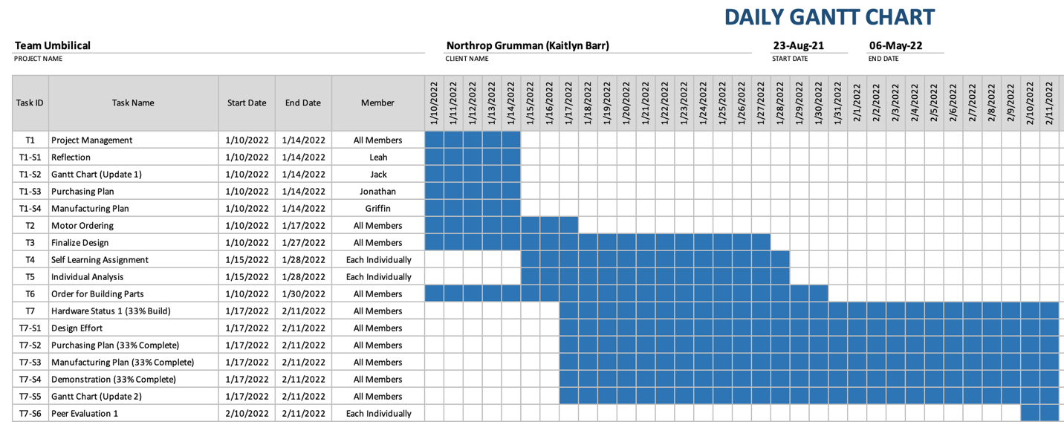
Figure 1 : Daily Gantt Chart

- ME486C starts out with Project Management where the team was able to split the work amongst the team members.
- The second task is to find a motor for our project that meets the specifications and budget.
- The third task is to finalize our design to begin the hardware testing.
- The next two assignments are self-focused. Each group members will choose a point of improvement or learning a new engineering tool.
- The sixth task will be very time sensitive because it can greatly affect our ability to have a device for the first hardware status.
- The hardware status will be spread over the team but will be completed as a team to meet the time requirements best.

Purchasing Plan
Table 1 below displays the parts of our design that need to be purchased. To ensure that we are meeting our deadlines, we have decided on dates that we want to have our parts purchased by and what time frame we expect them to arrive.
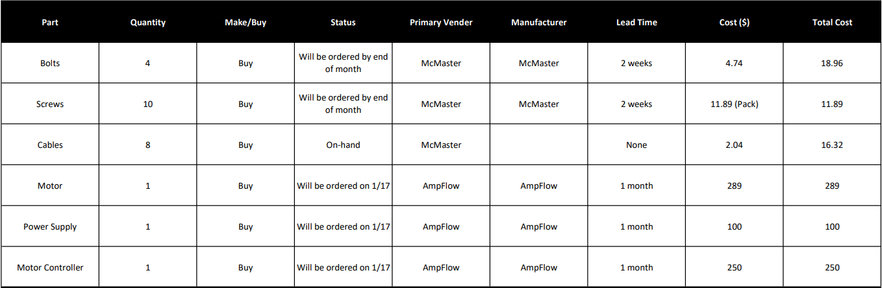
Table 1: BOM, Purchasing List

Some main points of action that we will have to consider in the very near future are:
- Purchasing of the motor components including the motor, power supply and controller which will be taking place on 1/17
  - Final checks for motor size taking place this weekend 1/15 – 1/16
- Finalization of the design of the base which will give us the amount of steel needed
- Hardware will be ordered towards the end of the month so that we can begin assembly by mid-February
- Cable testing will begin to see if our ordered cable will withstand our load
- Once design of actuation system is complete, parts will have to be ordered by the end of January so implementation and testing can have enough time

Manufacturing Plan
Below in Table 2 is an outline of the parts that are needed to complete the project build. The manufactured parts are drawn from the last prototype at the end of ME 476C. During the last prototype there were many parts created that did not have an exact purpose and added complications to the design that were undesirable. Over the next couple weeks these parts will be finalized in Solid Works and a request for construction will be sent to the NAU machine shop. The material used will be from whatever is available in the machine shop during the time of construction, ideally steel is available as it would have better properties against heat. The design moving forward over the next couple weeks will need to be
- Easily manufacturable
- Low weight/ material usage
- Designed using Weldments in Solid works

Table 2: BOM, Manufactured List
Part Name | Manufacture | Quantity | Order Date | Expected Arrival | Material
Base Plate | NAU Machine Shop Part Request | 1 | 1/28/22 | 2/4/22 | Steel from Shop
Side Plate | NAU Machine Shop Part Request | 1 | 1/28/22 | 2/4/22 | Steel from Shop
Opp. Side Plate | NAU Machine Shop Part Request | 1 | 1/28/22 | 2/4/22 | Steel from Shop
Spindle | NAU Machine Shop Part Request | 1 | 1/28/22 | 2/4/22 | Steel from Shop
Center Rod | NAU Machine Shop Part Request | 1 | 1/28/22 | 2/4/22 | Steel from Shop
Heat Shield | NAU Machine Shop Part Request | 1 | 2/14/22 | 2/25/22 | Steel from Shop

- Work orders need to be put in ASAP once the design is finalized
- Need to determine if machine shop available steel will be enough for our needs. If not, Home Depot sells some bars that can be welded or Grainger has good prices for sheets

