Northrop Grumman Umbilical

Preliminary Proposal

Jonathan Armijo
Leah Blakney
Griffin Brandt
William Shields

2020-2021




Project Sponsor: Northrop Grumman; Kaitlyn Barr
Faculty Advisor: David Willy
Instructor: David Willy

DISCLAIMER
This report was prepared by students as part of a university course requirement. While considerable effort has been put into the project, it is not the work of licensed engineers and has not undergone the extensive verification that is common in the profession. The information, data, conclusions, and content of this report should not be relied on or utilized without thorough, independent testing and verification. University faculty members may have been associated with this project as advisors, sponsors, or course instructors, but as such they are not responsible for the accuracy of results or conclusions.

TABLE OF CONTENTS
DISCLAIMER 2
TABLE OF CONTENTS 3
TABLE OF FIGURES 5
TABLE OF TABLES 6
1 BACKGROUND 1
1.1 Introduction 1
1.2 Project Description 1
1.3 Original System - 1
1.3.1 Original System Structure 1
1.3.2 Original System Operation 2
1.3.3 Original System Performance 2
1.3.4 Original System Deficiencies 3
2 REQUIREMENTS 4
2.1 Customer Requirements (CRs) 4
2.2 Engineering Requirements (ERs) 4
2.2.1 House of Quality (HoQ) 4
3 DESIGN SPACE RESEARCH 6
3.1 Literature Review 6
3.1.1 Literature Reviews – Griffin Brandt 6
3.1.2 Literature Reviews – Leah Blakney 7
3.1.3 Literature Reviews – Jonathan Armijo 9
3.1.4 Literature Reviews – William Shields 10
3.2 Benchmarking 11
3.2.1 System Level Benchmarking 11
3.2.2 Subsystem Level Benchmarking 14
3.3 Functional Decomposition 16
3.3.1 Black Box Model 17
3.3.2 Functional Model/Work-Process Diagram/Hierarchical Task Analysis 17
4 CONCEPT GENERATION 19
4.1 Full System Concepts 19
4.1.1 Full System Design #1: Piston 19
4.1.2 Full System Design #2: Swing Arm 19
4.1.3 Full System Design #3: Crossbow 19
4.1.4 Full System Design #5: Slingshot 20
4.1.5 Full System Design #6: Two Arms 21
4.1.6 Full System Design #7: Dog Leash 21
4.1.7 Full System Design #8: Dead Weight 21
4.1.8 Full System Design #9: Two Tower 22
4.2 Subsystem Concepts 22
4.2.1 Subsystem #1: Piston 22
4.2.2 24
5 DESIGNS SELECTED – First Semester 26
5.1 Technical Selection Criteria 26
5.1.1 Decision Matrix 26
5.1.2 Pugh Chart 26
5.2 Rationale for Design Selection 27
6 REFERENCES 28
7 APPENDICES 29
7.1 Appendix A: Full QFD 29
7.2 Appendix B: Full Decision Matrix 29
4.1.7 Full System Design #8: Spring Coil Error! Bookmark not defined.

TABLE OF FIGURES

Figure 1: Northrop Grumman Umbilical Retraction System Structure 2
Figure 2: Umbilical Diagram 2
Figure 3: Propellent Umbilical Contraption 7
Figure 4: Rolling Beam Umbilical System 8
Figure 5:Tilt Up Umbilical Arm (TUUA) 9
Figure 6: NASA Kennedy 12
Figure 7: German V2 13
Figure 8: Blue Origin New Shephard 13
Figure 9: Pneumatic Piston 14
Figure 10: Motorized Winch 15
Figure 11: Spring Loaded 15
Figure 12: Black Box Model 17
Figure 13: Functional Model 18
Figure 14: Swing Arm Design Concept 19
Figure 15: Crossbow Design Concept Before Actuation 20
Figure 16: Crossbow Design After Actuation 20
Figure 17: Slingshot Design Concept 21
Figure 18: Collapsing Arm 21
Figure 19: Dead Weight Design Concept 22
Figure 20: Two Tower Design Concept 22
Figure 21: Vacuum Piston 23
Figure 22: Spring Piston Design Concept 24
Figure 23: Spring Assisted Leash 24
Figure 24: Motor Assisted Leash 25

TABLE OF TABLES

Table 1: Engineering Requirements Compared Against Themselves 5
Table 2: Legend for Customer Option Survey 5
Table 3: Lower Section of Quality Function Deployment 5
Table 4: Decision Matrix 26
Table 5: Pugh Chart 27

BACKGROUND

Introduction
Northrop Grumman tasked our team with designing, prototyping, testing, and delivering a new umbilical retraction system. We were given engineering requirements and customer specifications our design must meet upon completion. The current technology Northrop Grumman is using is a tension loaded bungee cord. This current design has room for improvement and redesign due to the life cycle of the system being a one-time use. This leads to increased costs caused by the replacement need for the system. This project is important to Northrop Grumman and the aerospace and defense industries because umbilicals provide many different things, such as electrical power, communications, or pressurized gases, to vehicles before launch. Consequently, it is imperative the umbilical is retracted to avoid becoming damaged under launch conditions.

Project Description
Our client representative, Kaitlyn Barr, presented the following project description to our team:
“The objective of this project is to design an umbilical retraction system. The umbilical retraction system will be designed to pull cables/hoses away from the vehicle after they are released to avoid damage to the launch vehicle. The retraction system needs to be easily installed and removable. It cannot exert excessive force on the umbilical prior to separation with the launch vehicle. In addition, it needs to be reliable for mission success and durable to withstand launch environments. Further improvements may also be made to the system at the discretion of the team such as protection of the umbilical against thermal and shock environments.”

Original System -
[If your project was a re-engineering project, that is, one to redesign, improve, or add onto an existing system, use this chapter to describe, in detail, the original system, that is, the system as it existed at the time your project began.
The original system has been in use for many years and is the standard for Northrop Grumman umbilical release devices. The system is a bungee cord loaded in tension which is released upon launch. The specifications are not widely let out. Most companies, including Northrop Grumman, our team's client, do not allow information outside of their building due to it being classified. Given this, in-depth understanding will not be possible, but the overview of the system can be broken down.

Original System Structure
The original system structure consists of an umbilical cable which is detached from the vehicle. The cable is detached by the retraction bungee which separates from the vehicle at launch. The umbilical cable is attached to an umbilical boom, but for Northrop Grumman’s larger scale vehicles, the umbilical cable will be attached to a tower. During launch, the umbilical cable will be detached and retracted out of the way to prevent any permanent damage from the launch conditions. The retraction bungee will incinerate and will need to be replaced for the next launch. The figure below illustrates Northrop Grumman’s current umbilical retraction system design.
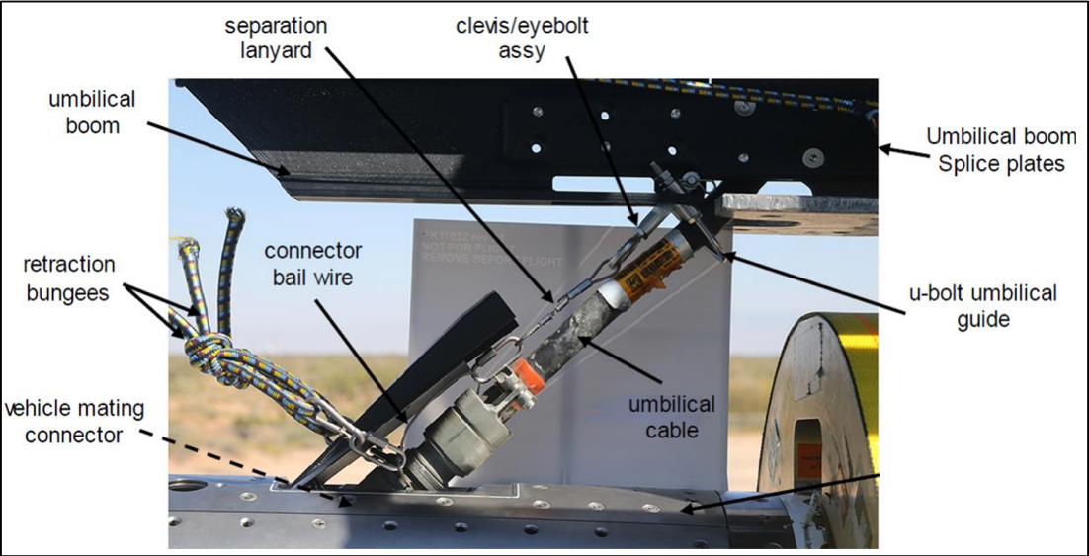
Figure 1: Northrop Grumman Umbilical Retraction System Structure

Original System Operation
The original system of the umbilical cable is illustrated in the figure below. The umbilical cable is attached to the right of the image, while the umbilical cable goes to the left. The attachment process is where the lanyard release connector is linked to the receptacle. The retraction bungee is pulled at an angle which creates a side force on the rocket. This is all the information given to the team from Northrop Grumman that describes the design aspects.
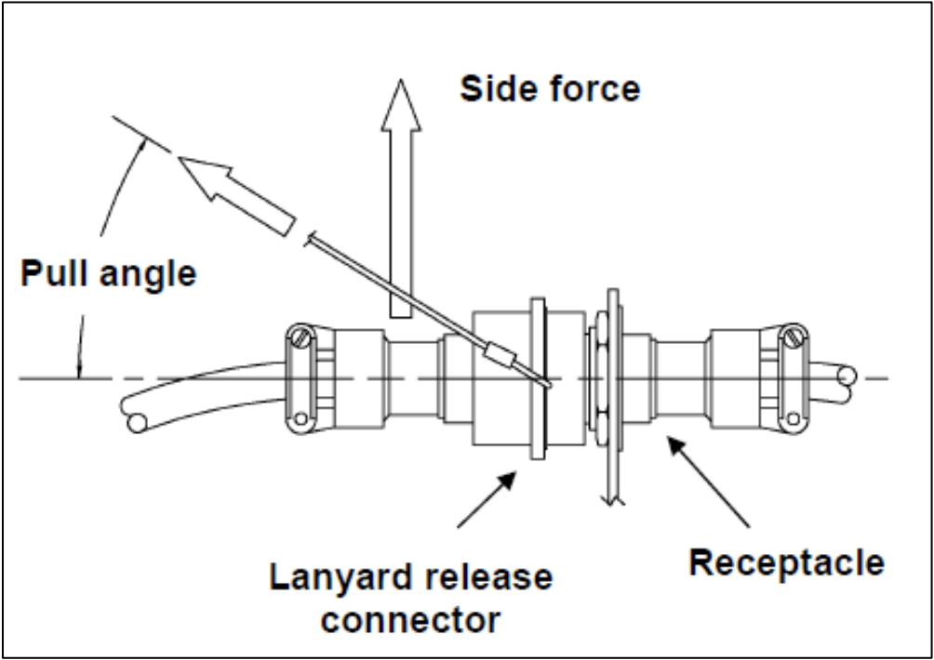
Figure 2: Umbilical Diagram

Original System Performance
The performance of the bungee retraction system used for most umbilical cable applications is highly successful. Information about umbilical cables is limited due to the secrecy associated with the defense industry. So, any exact details on the launch vehicle along with the umbilical cables are low. Further, because the launches are not easily replicated, gathering data as a team is not practical. So, at this point our performance understanding of the original system is low.

Original System Deficiencies
The design of an original system made of a bungee retraction system is a consistent design that has low deficiencies. The most important deficiency is the side force. The side force is emphasized by our client, which returns an important customer requirement. The original system is currently reliable but would not meet the one-hundred percent success rate. Creating a design that will minimize the side force will lead to a higher success rate due to a near minimal side force caused by the bungee attachment. The failure analysis performed on unsuccessful umbilical releases, done by the companies themselves and released to the public, found the side force initiated the failure. The other customer requirements would be highly rated and would not carry a need for improvement due to its low correlation. An engineering requirement that could be improved from the original system is the success rate. The success rate is an issue due to the minor part of the retraction cable which melts away during each launch, that becomes lessened by the cost.

REQUIREMENTS
The requirements set for this project were given by the client at the start of our project development: a new design that would improve upon the deficiencies of the current design.

Customer Requirements (CRs)
The customer requirements given to us during the client meetings follow as such. The design must have a low-cost while being durable. The cost must be less than the current system, which is around $12000 per launch. The durability of the system, at a minimum, must withstand two launches, whereas the current system is single use. Therefore, the design will save the company $24000 for every couple of launches. Our client expects the umbilical retraction system to have a one-hundred percent success rate. This means our design needs to be extremely reliable with no possibility of malfunctioning because then the vehicle could become damaged and worst-case result in a vehicle explosion. Other customer needs given to our team were to have a design that could be easily removed and installed to varying in size vehicles. Further, our design needs to be electrostatically discharged safe (ESD), so the vehicle does not short circuit during disconnection.

Engineering Requirements (ERs)
The following engineering requirements were provided to us by the client. Ideally, the design will remove all force acting on the side of the vehicle (side force) before and during liftoff, but we are allotted to have a side force that does not exceed ten pounds of force. As the current standard puts a hefty side force on the vehicle, our model must eliminate this aspect as much as possible and ideally, all together. The speed of retraction is the next crucial factor of the design. In detaching from the vehicle, the umbilical must move six feet in one second, which is comfortably obtainable through bungee cords, but designs that do not use this system may be more difficult to create and may result in a higher cost to manufacture. Another requirement is our design must not cost over five thousand dollars because this is the budget sponsored by Northrop Grumman to the team for this project. Weight is an important aspect of the design because our design must be easily removable and have a quick installation. If it is heavy and awkward to move, then the installation process will be slower. The device must be able to withstand brief moments of extreme temperature and must not change its reliability due to different air temperatures. As stated above, ensuring our device has a one-hundred percent success rate is of the utmost importance.

House of Quality (HoQ)
The House of Quality is split up into different tables. Table 1 depicts a comparison between the engineering requirements against themselves. This table will show the reader how each engineering requirement will be affected by the others and is rated on a qualitative scale ranging from 0, 1, 3, and 9. Intuitively, a weak relationship is given a zero and a strong relationship is given a nine. Shown in Table 3, is the rest of the Quality Function Deployment which compares the engineering requirements to the customer requirements along with the customer requirements to the benchmarking discussed down below in Section 3.2: Benchmarking. The engineering requirements against customer requirements show the most important aspects of the design are the success rate, speed of retraction and side force acting on the vehicle. Additionally, these were the most important aspects discussed with the client. The other aspects, although important, were not raised to the highest concern of the client. These include the weight, length, cost, and temperature rating of the design. The benchmarking in the customer option survey is defined by the legend shown in Table 2 where it was decided that the NASA Kennedy tower and the WWII German V2 tower were the most adept design to what the team was looking to compare against. This is justified as the Blue Origin design seemed overly bulky and from literature reviews did not seem to be the best design. Later in the report the decision matrix will be discussed, the ratings from the absolute technical importance row comes into play here where the designs were added up and placed out of one hundred and divided by the total to make a comparable rating system to rate against the concept generations.
Table 1: Engineering Requirements Compared Against Themselves
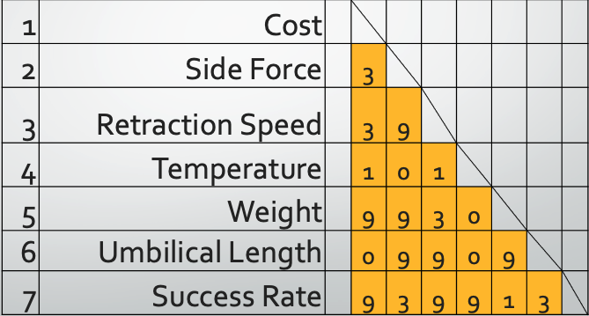
Table 2: Legend for Customer Option Survey
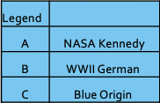
Table 3: Lower Section of Quality Function Deployment
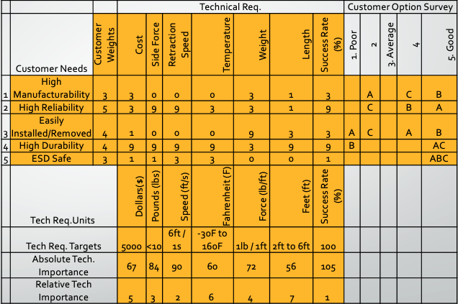

DESIGN SPACE RESEARCH
The literature review portion of the report will detail five sources found by each team member. These sources provide valuable information to assist our team in understanding more about our project. Also, included in this section is our team’s benchmarking analysis of what umbilical retraction systems have been used in the past and what systems are currently in use in industry today. Once we had a basic understanding of our project and the technology formerly used and currently used, we were able to generate our Black Box Model and Functional Model.

Literature Review

Literature Reviews – Griffin Brandt

Inductive Wireless Power and Data Transfer [1] [1]
Smit proposed in this article that it may be possible to wirelessly transmit data from a n umbilical to a shell of the rocket. To further detail this procedure, it would roughly look like the device that wirelessly charger phones. Smit says that the device would use “magnetically coupled coils, or inductors, to transfer power and data.” [Smit, Wireless Power] This device would be incredibly effective for the scope of the project, but it is extremely theoretical and has not been done in industry before. If the device were to exist some problems that could occur in the use of our project is an imperfect data transfer from umbilical to rocket, and it would be hard to make the device ESD safe as there are magnetic coils and electric charge offered between the plates. The other aspect of this is that it needs to lay on the section where it needs to transfer the data, but there would be no side force on the rocket in the first place so there could be many different mechanisms to control how it would ‘detach’ from the rocket. In all this article provides a different look at the problem at hand which would help the team with out of the box ideas.

Static and Dynamic Modeling and Simulation [2] [2]
Sina Doroudgar presents an article about the mathematical modeling of an umbilical system that is used during in flight transfer. The model works on predicting both static and dynamic reactions while also considering external forces that could be applied to the umbilical such as wind. This article will help the team by showing how much stress and strain the umbilical might be placed under which could have changes on the overall results of the system designed by the team.

Umbilical System for Propellent Loading [3] [3]
The next article by Han Tao and Dacheng Cong dives into a new umbilical type that uses multiple degrees of freedom to move the umbilical out of the way of the rocket. The system uses multiple different pistons to move and articulate the umbilical to load propellent into the vehicle. In the team’s case electrical cables will need to be retracted, but in the article propellent is used. This would obviously change the dynamics of the systems as a fluid pipe could be expanded and retracted but an electrical wire is not as easily retracted. But the system can be modeled the same. Inspiration for the vacuum piston discussed in the concept generation portion of this report came from this model. The scope of the device shown in the article as well as in Error! Reference source not found. is out of the scope from the project the team is presenting, but still gives very good inspiration to the team.
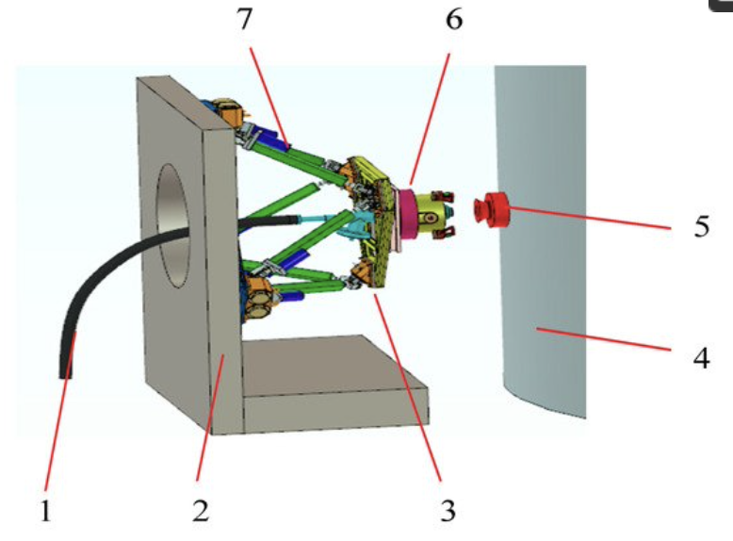
Figure 33: Propellent Umbilical Contraption

Automated Ground Umbilical System Reference [4] [4]
This article by Armand Gosselin goes into details about the subsystems involved in an umbilical retractor. It proposes that the main subsystems that are involved include alignment, electrical/ propellent loading, and mating systems. The article discusses these subsystems and umbilical used in many modern rockets including those such as Saturn V, X-33, Atlas V, and Shuttle programs. This article reviews how each one works within the rocket to have a successful detach for a successful launch. The article details all the subsystems listed along with the reason they are involved in the process and why they are important. In reading about the different subsystems and mechanisms involved in the process, the team has a much better understanding of how our device must perform and move to clear the area in time for the launch.

41st Mechanism Symposiums [5] [5]
This aerospace symposium is presented by JPL and Lockheed Martin, and it goes into details and reviews many different subsystems involved in a rocket, and importantly a brief section about umbilical used in the Ares 1 vehicle. The results from the article discussed that the system did not run as clear and efficiently as the client wanted, and although it did not fail, it needed to be replaced over time. For the team, knowing how this umbilical fails and where it can be changed and improved upon gives us hope that we can find a much better and efficient solution to the project given.

Literature Reviews – Leah Blakney

Design, Development, And Testing of Umbilical System Mechanisms for the X-33 Advanced Technology Demonstrator [6]
This paper describes and evaluates the umbilical systems mechanisms for the X-33 Advanced Technology Demonstrator. The X-33 incorporates umbilical systems which are attached to the vehicle in the horizontal position and then rotated to the vertical position for launch. The umbilical utilize a “rise-off” type of disconnect, meaning they are actuated by the launch of the vehicle. This paper goes into detail about the requirements needed to be met and the basic functionality of each mechanism. A brief section explaining the results of testing the umbilical system mechanisms in the horizontal and vertical positions and the lessons learned is included. This reference is valuable to the team because our design needs to function in the horizontal and vertical positions as well to meet the needs of our client’s current vehicle launches. Further, an analysis of how each mechanism would fail to ensure detachment from the X-33 if it were to experience an actuation malfunction is described. This gave our team the realization that our design should have a fail-safe actuation too in case of a design malfunction.

Rolling Beam Umbilical System [7]
This source goes into detail about one umbilical retraction system used on the Centaur vehicle. The main components of the Rolling Beam Umbilical System (RBUS) are the carrier plate which the umbilical is attached to, the tapered truss rolling beam, and the drop weight actuator. Each component and subsystem in the RBUS are explained thoroughly. This reference includes very detailed drawings including labels of each component and subsystem and a table listing of all the design criteria. This source provided our team with background information of what type of retraction system has been used in industry. The design requirements for the Rolling Beam Umbilical System are much larger than the requirements for our design, but this system could be scaled down to our needs to be a design concept possibility.
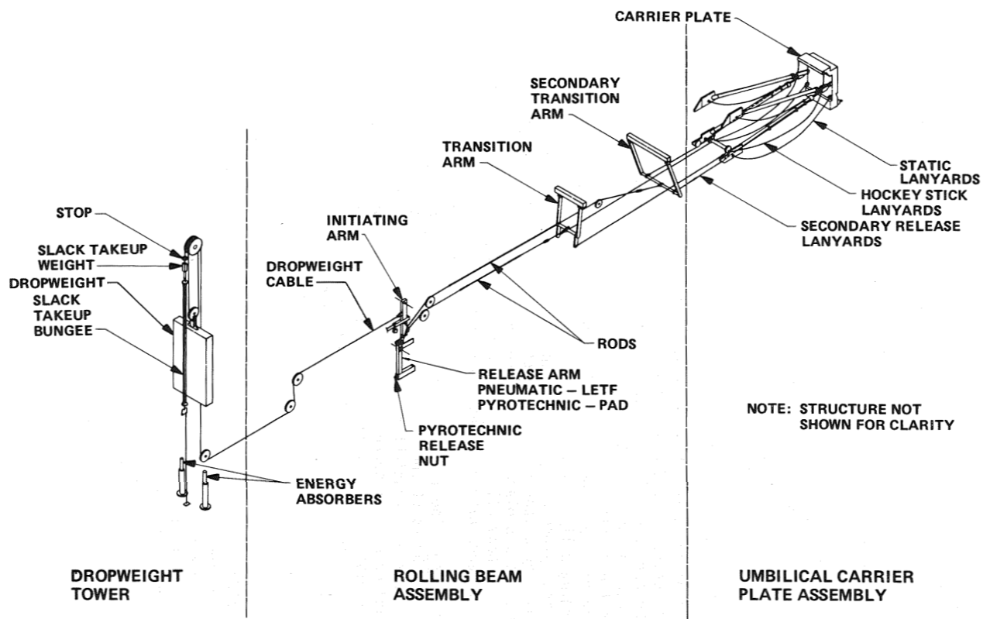
Figure 4: Rolling Beam Umbilical System

ARES14BI “Hydra” - a two-stage experimental rocket project within the PERSEUS program [8]
This paper describes the pneumatic interstage separation system, the umbilical management system and the pyrotechnic sequencer in the two-stage developer project, Hydra, developed and tested by the PERSEUS program. Our team focused on the portions pertaining to the umbilical management system since those portions are relevant to our project. One of the concerns faced by the PERSEUS umbilical management team was to keep the cables of the upper stage from colliding with the fins on the lower stage during launch sequence. Explanations paired with figures of the stages of how the umbilical retraction system operated were including in the qualifications and tests portion of the paper. They achieved these images by placing a camera with high-speed capture capabilities on the launch track. This gave our team ideas of how to test and review our design during the prototyping stage of our design process.

Ares I Linear Mate Umbilical Plate and Collet [9]
The umbilical connection system, umbilical retraction system, and solenoid actuated collet for the Ares I are discussed in this reference. Again, our team mainly focused on the umbilical retraction system portions of the paper since those are relevant to our project. The Ares I vehicle implements a Tilt Up Umbilical Arm (TUUA) mechanism to retract the umbilical. Once the umbilical connection system is released from the vehicle, the force supplied by the launch of the vehicle retracts the TUUA into the upright position into the protective casing to prevent damage from launch zone conditions. A full-scale prototype of the TUUA was developed and tested to verify the functionality of the design and pinpoint where improvements could be implemented. This source provided our team with another umbilical retraction system design used in industry and relayed the benefits and importance of prototyping our design.
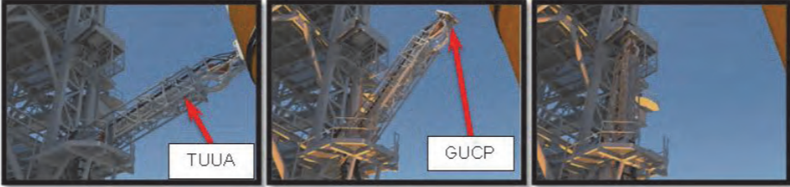
Figure 55:Tilt Up Umbilical Arm (TUUA)

Umbilical Arms for the Saturn V Vehicle [10]
This source details four portions of the arm mechanism used on the Saturn V vehicle. They are the hinged, truss structure, the arm retraction system, the withdrawal mechanism, and the extension platform. Our team focused on the arm retraction system portion of this paper. Included in the arm retraction portion is the criteria, description, and operation of the system. The criteria portion had good information of what they expected and required the arm retraction system to do, and the description portion gave dimensions of the design. Within the operation portion, the paper discussed how the system is meant to operate and what would cause the system to fail and how they remedied the issue. This showed the team the importance of understanding the design criteria and requirements and how completing a Failure Mode Analysis throughout the design development and prototyping stages of concept generation and manufacturing is beneficial to create the best design.

Literature Reviews – Jonathan Armijo
For our preliminary presentation, my research centered around benchmarking and finding systems that were currently in use by different companies. Due to the sensitive nature of rockets, much of the information regarding them is not readily available. Therefore, I instead analyzed various launches and deduced what types of retraction mechanisms they used. Once we moved into the designing face, I began to focus on researching motor specifications since this seemed to be a promising concept for our system.

Kennedy Space Center Launch Complex 39 [11]
This short publication is all about the different umbilical cables and their retraction systems used at the Kennedy Space Center Launch Complex. This article details that the umbilical retraction system mostly consists of swing arms that extend out towards the rocket when the umbilical cables are connected then swing away once takeoff is initiated. Also, this article details the many different types of fluids running through these umbilical cables as well as where they are stored within the launch complex.

Blue Origin New Shepard Rocket [12]
This website details the Blue Origin launch of their New Shephard rocket. From this source, I was able to determine what type of umbilical retraction system that Blue Origin uses for their rockets. Based off their launches, it appears that they pull the umbilical cable back to the launch tower via a motorized cable. This cable is connected to the tower at one end and the umbilical at the other end.

Flat Coil Springs [13]
One of the designs that we had come up with included the use of flat coil springs. These springs can be found within everyday items such as a tape measure and retractable dog leashes. This source details the necessary calculations needed to determine what loads and retraction speeds that a flat coil spring can handle. By learning more about this type of spring, we were able to better analyze the design concept and make more informed decisions.

Proper Sizing of Motors [14]
Like the flat coil spring concept, we also thought of using a motorized retraction system like a winch. To further analyze this idea, we thoroughly researched how to properly size a motor. This is important because if you undersize your motor, then you can cause overheating and poor performance, and if you oversize your motor then you run the risk of paying too much or causing damage to other parts of your system. This manufacturer’s website includes all the necessary equations to determine torque, rotational speeds, and power.

Mechanical Engineering Design Chapter 13-16: Gears [15]
These chapters within the Mechanical Engineering Design textbook covered everything we needed to know with gears. This information may prove to be useful especially if we move forward with a motorized design. Should we take this route, we may need to add in a gear box to reach the desired speeds and torques required for our system.

Literature Reviews – William Shields

Mechanical Engineering Design [16]
Understanding material selection will be vital in this project. Mechanical Engineering Design section 2-22 is about material selection. It will give us the information needed to breakdown the understanding of the material we choose for our design. The material will be a metal for the design because they have a high machinability while maintaining the needed material properties. The book focuses on the density and the young’s modulus. Both of those properties are high for metals. The ratio of those properties is the specific modulus or stiffness, which is useful when looking to minimize the weight while maintaining properties like deflection or stiffness. Our current material we are going forward at this point is steel and an additional option is aluminum. The steel will be denser from Figure 2-27. Having a metal seems to be the best option from a material breakdown and furthermore steel.

Launch Umbilical Tower Records [17]
This article by the US Department of Energy goes on an overview of the numerous umbilical installations. Most of the installations include a crane and rigging to employ the umbilical tower that are modular with several umbilical cables. Being the financial manager, understanding the possible processes for creating a budget is important. The module umbilical is for the larger rockets and is located at the highest point of the tower to transport liquid coolant and air to support the critical systems.

Launch Umbilical Tower Drawing [18]
This next report includes the drawing for a launch umbilical tower or mobile launcher. The mobile launcher is a steel structure that is transportable but can become a permanent structure. The mobile launcher interacts with vehicle to ground interfaces. The drawings are for the Saturn V mobile launcher which is a very larger scale. This project will be a smaller scale structure, but practicality will still be useful. The material used for the mobile structure is steel, which can withstand the launching sequence damage. The umbilical retracts for eight seconds. And the reconnect time takes five minutes. Those timings can be used when creating estimates for prototyping.

Design of a Winch Structure
This source is a breakdown for winches with a focus on O-rings. O-rings can generally withstand rotational dynamic pressure less than 1.5 MPa with a line speed of rotating shaft of 3.5 m/s. When the shaft rotates at high speed the friction heats the rings and increases the aging process along with creating grooves on the shaft, which can cause leaks. The information can be useful for creating our device and the possibility when we need seals for our device. Our design that includes a piston will include O-rings.

ASTM Standards [19]
The next article is an ASTM standard that goes into form and style. Uniformity will be an important aspect while in the designing phase of this project. The standard includes test methods that are intended for buying materials to correct specifications. The subsequent test is performed by an operator who will find it satisfactory for the material with specified specifications. Another step is while creating a standard the cost must be considered.

Benchmarking
To establish a better idea of what we were trying to accomplish, we studied some of the other umbilical retraction systems which are currently in use by other organizations. Through this research, we hoped to better understand our problem at hand, and we hoped our research would help us create a more conclusive designs that would not only improve upon our client’s current system, but also fix many of the other issues found in other space system vehicles.
One of the issues we encountered when researching these systems was many details are not publicly available. Initially, our search results only brought up umbilical retractions systems from much older programs such as WWII rockets and the Apollo program. Therefore, we resorted to watching videos of more recent launches such as those achieved by NASA and Blue Origin and attempted to deduce what types of mechanisms were in use on their umbilical retraction systems. Furthermore, we researched other cable retraction systems that were not necessarily used for rocket umbilical cables, but instead are used in various other industries. The following sections highlight our findings.

System Level Benchmarking
As previously stated, details on current umbilical retraction systems are not readily available online. Because of this, we studied videos of various rocket launches from different companies and did our best to determine what kind of system was in use based on the mechanism that was visible, as well as the behavior of the umbilical. We analyzed three different systems, one used by the NASA Kennedy Launch Complex, one used by old German WWII V2 missiles, and one used by the Blue Origin rocket New Shephard.

Existing Design #1: NASA Kennedy Launch Complex [20]
The first design that we looked at was the system that is in place at the NASA Kennedy Space Center’s Launch Complex in Florida seen in Figure 66.
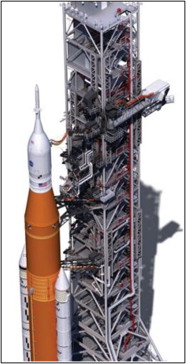
Figure 66: NASA Kennedy
Here, they utilize a series of swing arms and secondary retraction systems to not only pull their umbilical cables, but also walkways. Whilst the swing arms are quite self-explanatory, the secondary retraction systems seemed to include a motorized system that would pull away the connection from the launch vehicle which afterwards would get pulled away by the swing arm it was attached to. Recent videos showcasing the Artemis mission’s umbilical retraction systems [21] give an excellent view of this system in action.
Relating this to our project, we determined this type of system would not meet the requirements of having high manufacturability and being easily installed. Despite these systems being more complex than what we hope to achieve, they allow us to observe different methods of cable retraction for space systems.

Existing Design #2: German V2 Missile [22]
This second design was used on the German A4-V2 rockets back in WWII. This design was very simple and included a tall tower that would fall over away from the missile pulling the retraction cable with it. This is pictured in Figure 7 where the tower can be seen to the left of the V2 rocket holding the umbilical cable suspended. This cable was detached using explosive bolts which would then allow gravity to pull down the tower. Despite the simplicity of the design, many complications arose from this system. Few fail-safes were put in place so if the explosive bolts failed to go off, then the tower would pull the rocket into a dangerous trajectory.
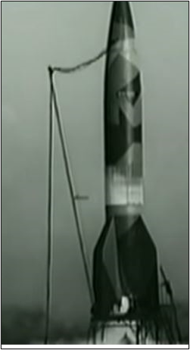
Figure 77: German V2
The review of this design proved to be less useful since we would be unable to design a tower that would work for both the large and small Northrop Grumman launch vehicles. In fact, for the Antares rocket used by Northrop Grumman, it makes use of a “falling” tower that pulls the umbilical cable and tower away after launch once the umbilical cables are pulled by some other secondary retraction system.

Existing Design #3: Blue Origin New Shephard [23]
One of the last systems we reviewed was the recent launch of the New Shephard rocket. By watching the many videos of Blue Origin’s recent launch, we were able to deduce that the umbilical cables are pulled back to the tower via chords which are attached to a motorized winch. Looking at Figure 8 we can see the umbilical attached towards the top of the rocket with multiple chords going up from the bottom of the tower to the umbilical.
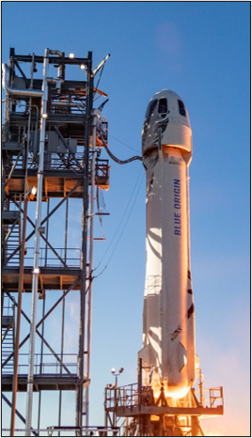
Figure 88: Blue Origin New Shephard
Once the launch begins, these chords are retracted which in turn pulls the umbilical downwards and back towards the tower. This system seemed the most feasible for our project and would go on to be one of the inspirations for our designs.

Subsystem Level Benchmarking
After analyzing the three existing designs mentioned above, we broke down our umbilical retraction system into three main components: cable retraction, connection, and actuation. Cable retraction is the mechanism that will be used to impose a force onto the umbilical and get it away from the launch vehicle. Connection is how our device will attach to the umbilical. Actuation is what will tell our system to begin retracting the umbilical. For this part, it is crucial that whatever actuating device we use be reliable and near instant.

Subsystem #1: Cable Retraction
This subsystem focuses on the mechanism that will impose a force onto our umbilical to pull it away from the launch vehicle. Our main problem to solve with this section was how could we store up enough potential energy to pull the umbilical without having an initial tensile force. Three concepts we produced that could solve this issue were a pneumatic system, a motorized system, and a spring-loaded system.

Existing Design #1: Pneumatic Piston
This subsystem design features a pneumatic piston that relies on air pressure differentials to move a piston rod within a cylinder. Figure 9 shows an example of this design that can be found on the market [24].
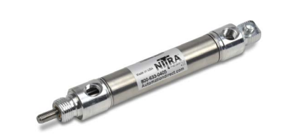
Figure 99: Pneumatic Piston
This design would allow for high-speed retraction depending on how well we could seal off the inside and how high of a pressure differential we could accomplish. One of the key issues we predicted with this subsystem concept was the range of motion of the piston rod. To move our umbilical, the necessary six feet, we would need a very long and heavy cylinder and piston rod. Furthermore, designing a product of this size that would be able to hold a vacuum would also be very difficult and could possibly lead to complicated maintenance or constant failures.

Existing Design #2: Motorized System/ Winch
This design heavily resembles a winch you would find on the front end of an off-roading vehicle. The main difference being that most winches emphasize high torque but slower speeds. Since our pulling weight will be so low, we had to focus on designs that put retraction speed over torque. Figure 10 showcases a product we found similar to what we were looking for [25].
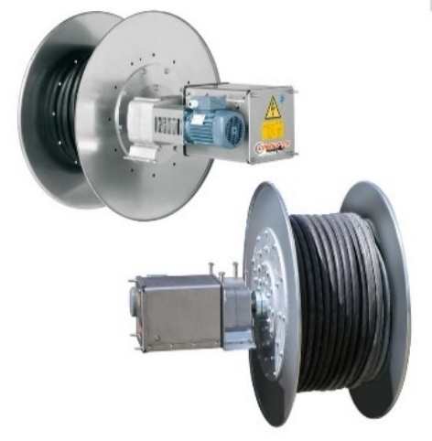
Figure 1010: Motorized Winch
This product uses a motor to wind and unwind a spool of cable very quickly. With this concept, we would have to determine how we would actuate the system as well as what size motor or subsequent gear ratio we would need. Some issues we foresee with this subsystem design mostly originate from installation issues which may include difficulty attaching to preexisting launch surroundings or the fact that the system will require power in the form of electricity.

Existing Design #3: Spring Loaded System
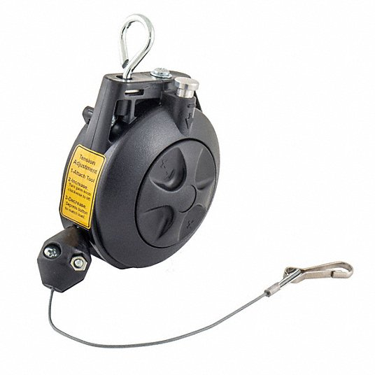
This subsystem design utilizes a coil spring to retract the cable. This is very similar to what one would find within a tape measure or retractable dog leash. Besides these two examples, applications of this design do exist within the industrial setting. Figure 11 shown below is one example that is available for purchase [26].
Figure 1111: Spring Loaded
While these products meet the retraction speeds we are looking for, they are unable to handle heavier loads. Although the weight we will be moving is not particularly heavy, it still is too high for all the products that we have found that use this subsystem design. This is mostly due to the coil springs themselves which are unable to pull back heavier loads.

Subsystem #2: Attaching Chord to Umbilical
This subsystem focuses on how we will attach our retraction mechanism to the umbilical itself. This is a crucial component as without proper attachment, our system could fail and not pull the umbilical away from the launch vehicle.

Existing Design #1: Carabiner
One option for this subsystem is to use a simple carabiner to attach our retraction system to the umbilical. The carabiner would be placed on the end of the chord of our system then attached to the umbilical via a mounting point. According to our client, such a thing exists currently although we were not able to obtain details.

Existing Design #2: Knot
This option would have us simply tie a knot around the umbilical cable. This option has the potential for failure if we do not properly secure the knot. Furthermore, tying the knot may prove to be difficult depending on the flexibility of our chosen cable. Another idea would be to have a type of slip knot at the end of our cable that could then be wrapped around the umbilical and tightened.

Existing Design #3: Clamp
A clamp is a possible candidate for properly securing our retraction system to the umbilical. The clamp would be fastened at the end of our retracting cable and would clamp around the umbilical itself. This option is similar to the carabiner but may prove to be less secure.

Subsystem #3: Actuation
The actuating subsystem will be responsible for starting and possible stopping our design. This portion of the design is crucial as we will need something that is near instantaneous and highly reliable. Since we are not simply relying on an initial tensile force like the current design, this actuation will also be responsible for starting the system which will apply this force.

Existing Design #1: Arduino
By using an Arduino board, we could easily actuate our device both on and off and do it wirelessly if needed. There are plenty of systems which use Arduino as an actuating device so getting started would not be too difficult. One foreseeable issue would be that we would have to somehow match the retraction of the umbilical cable with the detachment/launch of the vehicle. This would either require a fast trigger finger or some sort of sensor that will tell the system when detachment has occurred.

Existing Design #2: Raspberry Pi
This iteration of our actuation subsystem is very similar to the Arduino board mentioned in the previous section. Instead of using an Arduino board, we would replace it with a Raspberry Pi computer. While this option is a bit more expensive than the Arduino option, Raspberry Pi computers are far more powerful. A Raspberry Pi computer would allow for further expansion of our system into things such as force and temperature sensors or better automation.

Existing Design #3: Pull-pin
This iteration is much simpler than the previous two and simply has a pull pin being used to actuate our system. This pull pin would be used to either disengage a brake or in the case of the pneumatic piston, release a piston. The main issue with this design is that it would require manual operation which may be impossible due to the conditions surrounding the launch. Furthermore, timing could be an issue as both an early and a late actuation can lead to catastrophic failure.

Functional Decomposition
The Function Decomposition section is used to picture the flow of energy sources within the system the team will be designing. Below are the Black Box Model along with the Functional Model which are both described and discussed in their own sections.

Black Box Model
The purpose of creating a Black Box Model is to identify the main function of the umbilical retraction system. Our team decided the main function is to retract the umbilical. Once the main function is identified, the team evaluated the overall material, energy, and signal flows into and out of the system. The materials that flow into and out of the main function are depicted with a bolded line. The energy flows are represented by a normal font size line and the signal flows are represented by a thin line. Our team identified the material flows into and out of the main function to be a human hand and the umbilical cord. The energy flows into the main function are human energy and electrical energy. After the main function has been completed, thermal energy and mechanical energy are released. Our design will need to be actuated therefore, the main function will have an on/off signal into and out of the system. Creating this Black Box Model helped our team scale back and focus on what materials, energies, and signals would need to be initially implemented to create a functioning umbilical retraction system. This led to critical thinking about what outputs would stem from our inputs after the system had completed its main function.
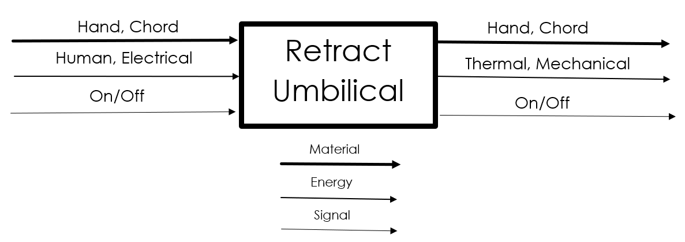
Figure 1212: Black Box Model

Functional Model/Work-Process Diagram/Hierarchical Task Analysis
Our functional model shown in Figure 13 took the inputs from our Black Box Model shown above and analyzed the paths each input would take throughout our system. On the left of the model shown below, we have the inputs from our Black Box Model each being imported to the system. Next, these inputs are either transported or manipulated to accomplish our final goal of retracting the umbilical.
This model allowed us to better analyze and create our design concepts. By further understanding the material, energies, and signals going through our system, we were able to better visualize how these pieces would interact with each other.
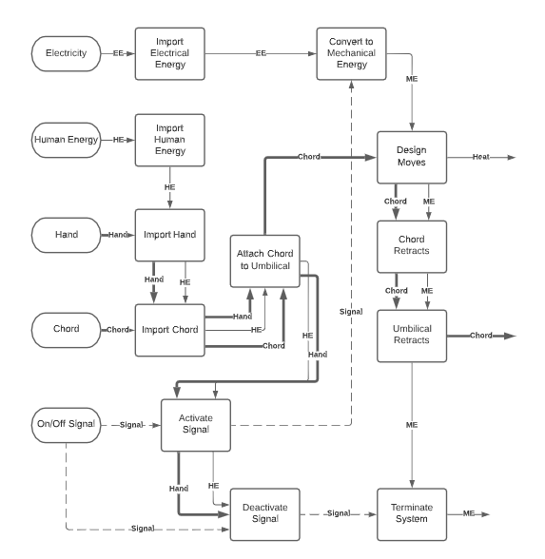
Figure 1313: Functional Model

CONCEPT GENERATION

Full System Concepts

Full System Design #1: Piston
The piston design will be split into two different subsections which is discussed in a later portion of this report. The piston will use some form of mechanism to remove the umbilical. It will be split into a vacuum or spring-loaded system to retract the umbilical.

Full System Design #2: Swing Arm
The swinging arm design utilizes a boom as the mechanism to hold the umbilical, this design is shown in Figure 1414. The boom will be placed into tension by ropes connected to both sides of the boom, the ropes to one side of the boom will be stretched in tension whereas the other side will be pulled by the opposite rope in tension. As the mechanism will start, the ropes that are being pulled in tension will release or cut, and the ropes on the other side will pull the boom away ripping out the umbilical out of the rocket and moving out of the path of the rocket swiftly. The advantage of this design is that it would work very well at moving out of the way quickly and keeping a steady hold on the umbilical. There are many faults with the design though in that it might be heavy, hard to install, but most importantly it is only feasible to larger rocket designs.
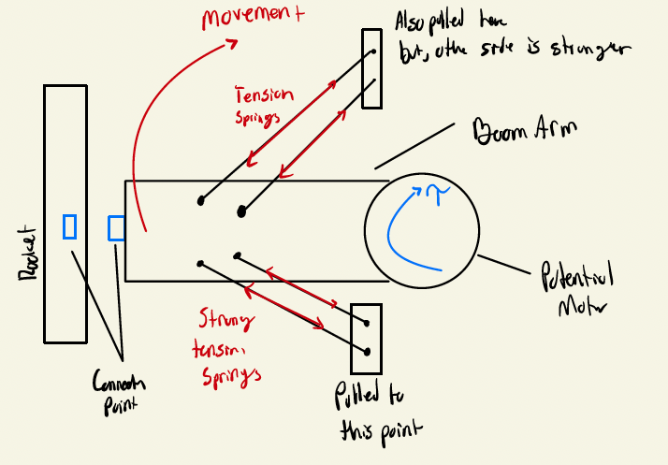
Figure 1414: Swing Arm Design Concept

Full System Design #3: Crossbow
The crossbow design acts as a reverse draw crossbow as the mechanism that pulls the umbilical cord. A compound crossbow works by adding potential energy to a string by pulling it back to a locking mechanism. The string that it is connected to is attached to limbs at the front of the device, these limbs are pulled into the device creating large amount of potential energy that is stored in the string. The locking mechanism can then be released which allows the string to move freely and the limbs of the crossbow to extend launching the string with extreme velocities. A reverse draw crossbow works in the same manner but instead of the limbs being pulled into the back of the device while being attached at the front, they are instead attached at the end of the device and pulled in towards the front end. This same mechanism could potentially be used in the umbilical retraction system. It would work with immense speed and power, but it has a major default in the amount of moving parts in the device that could very much fail over time and cause extreme damage to the rocket and nearby structures. Figure 1515 and Figure 1616 show the crossbow design before and after the mechanism is released showing the transfer of energy through the system.
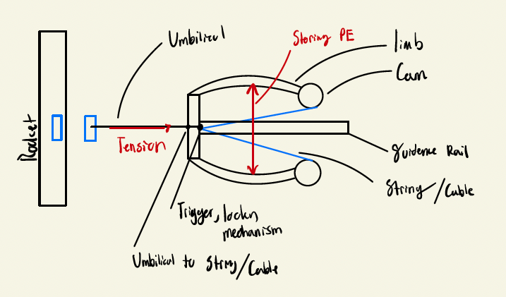
Figure 1515: Crossbow Design Concept Before Actuation
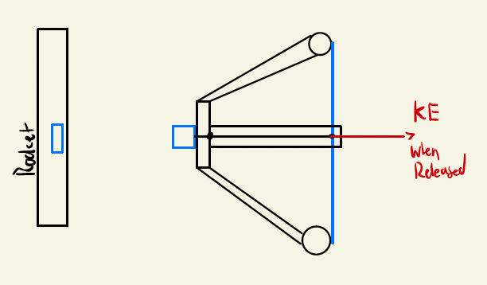
Figure 1616: Crossbow Design After Actuation

Full System Design #5: Slingshot
The slingshot design incorporates two bungee cables connected to a spring positioned on the other side of a flat plate. The bungee cables are fed through the flat plate to attach to either side of the umbilical, which loads them in tension. Since the bungee cables are connected to the spring when pulled to the umbilical, the spring becomes compressed against the flat plate toward the vehicle. When actuated, the spring and bungee cables will revert to their unloaded positions retracting the umbilical away from the launch zone. This design will meet the retraction speed requirement due to the tension and compression forces supplied by the bungee cables and spring, but there is a possibility the umbilical becomes damaged from the collision with the flat plate after retraction. Another consideration is the variability of the force provided by the spring due to the variation of the spring constant based on launch conditions, such as temperature and weather.
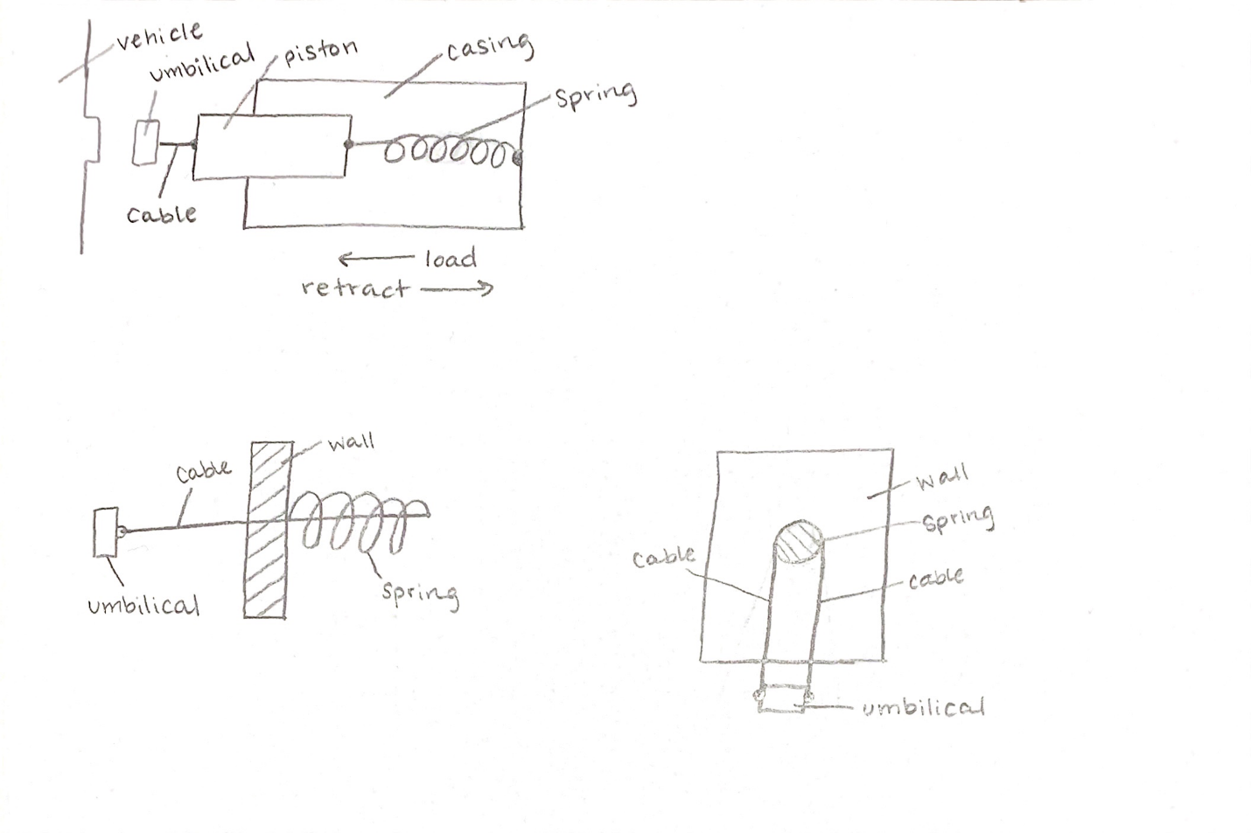
Figure 17: Slingshot Design Concept

Full System Design #6: Two Arms
This design features two parallel arms that when actuated collapse which pulls the umbilical back with them. These arms fold by the joints placed between them as shown in Figure 18 below. This design is similar to the retraction systems found in the Artemis system although this system does not have them retract this far. Due to the high range of motion, we need for our system, this design may lose stability and begin to slouch whilst extended. Furthermore, in order to reach our desired retraction speed, we would have to get the joints to move very quickly, which may not be easy.
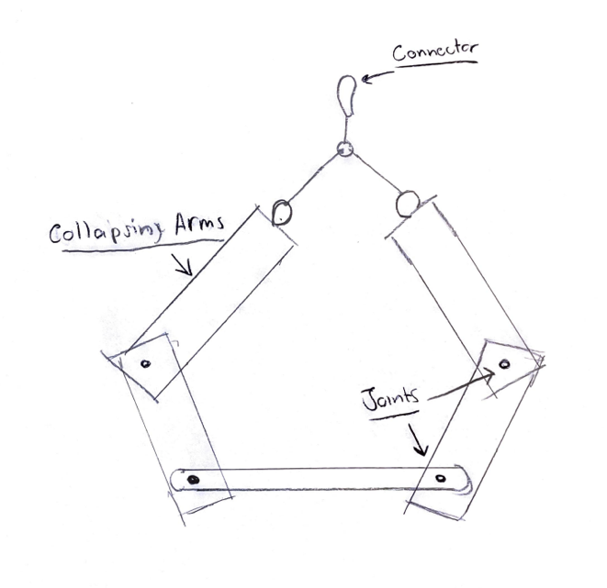
Figure 18: Collapsing Arm

Full System Design #7: Dog Leash
The dog leash concept features two separate designs which use different subsystem concepts. The main idea behind both is a reel of chord will be extended and retracted to first, hook onto the umbilical, then, pull it back.

Full System Design #8: Dead Weight
This concept utilizes a pulley system to retract the umbilical. On one end of the pulley, the chord is attached to the umbilical. On the other end, the chord is attached to a weight suspended by a trapdoor. When actuated, this trap door will open thus dropping the weight and pulling the umbilical back. Due to the many moving parts of this system, it may be too bulky to implement. Furthermore, since we are relying on gravity for our acceleration, there may be a delay in the time between the weight beginning to fall and the chord being in tension.
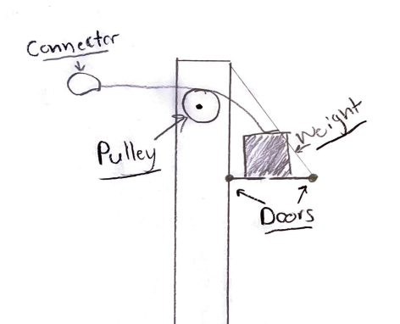
Figure 1919: Dead Weight Design Concept

Full System Design #9: Two Tower
The next concept was a two-tower retraction design. The focus was to pull the umbilical cables away from the rocket but from different points. Having more retraction points for a single umbilical cable will allow for a more successful retraction.
Figure 2020: Two Tower Design Concept

Subsystem Concepts

Subsystem #1: Piston
The piston concept will be split into the two subsystem concepts of a vacuum piston and spring piston. Both designs have their pros and cons which will be discussed in their individual sections.

Design #1: Vacuum Piston
The vacuum piston design utilizes a vacuumed as the working motion to retract the umbilical; it is shown below in Figure 2121. The system would consist of a pump, piston rod, and a piston cylinder along with various other parts to control flow rates. The piston rod will be placed inside of the canister such that when fully extended, a seal would create from the piston rod to the end of the canister. Air will then be vacuumed out from the free space of the canister such that when the umbilical needs to retract, back pressure will be applied to the piston rod, and a pin mechanism will release collapsing the piston down retracting the umbilical. With this design a form of air will need to be entered into the opposite side of the piston rod such that the pressure does not equalize in the canister preventing the full actuation. This design would be extremely fast and efficient, but there are many areas that will cause the design to fail such that as the seals not working properly, the bumper on the piston rod failing over time causing a system malfunction, bad disconnections, and inefficient pressure outtake from a vacuum.
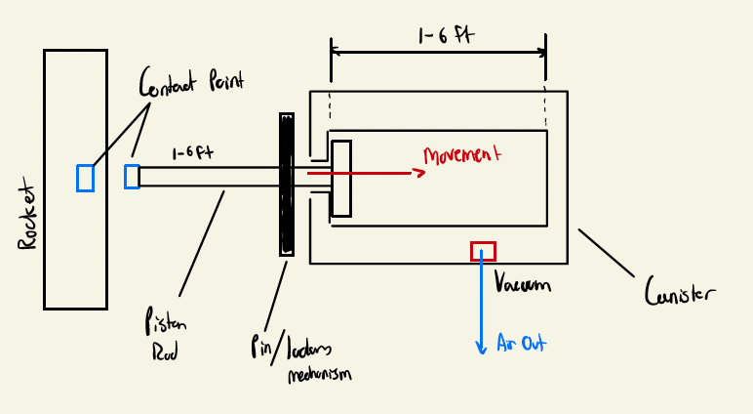
Figure 2121: Vacuum Piston

Design #2: Spring Piston
The spring piston design relies on a spring attached to a shaft. The shaft extends to the umbilical where they are connected by a cable. The spring is loaded in tension toward the vehicle so when actuated the spring will recoil away from the launch zone. The spring and shaft would be incased in a protective shell to reduce the launch zone effects on the spring. This casing would be implemented to reduce variation in performance due to the spring constant varying based on temperature and weather. The need to regulate the launch conditions as much as possible to normalize the spring constant to ensure functionality is a downside to this design. Another thing to consider with this design is the life cycle of the spring. A new spring will retract faster than a spring used multiple times, so to meet the retraction speed and one-hundred percent success rate requirements, eventually the spring will need to be replaced, especially under varying launch conditions.
Figure 2222: Spring Piston Design Concept

Subsystem #2: Dog Leash
Below are the different subsystem design concepts for the Dog Leash. There is both a spring assisted, and motor assisted ‘leash’ discussed in this sections below.

Design #1: Spring Assisted
The spring assisted dog leash features a flat coil spring within a housing that will be used to extend and retract a chord. This idea is similar to the mechanism found within a tape measure or a retractable dog leash. Based on some preliminary calculations we did; the flat coil spring may not be strong enough for the weight of the umbilical. Further research into more powerful flat coil springs will be needed before this concept can be proven or disproven for our needs.
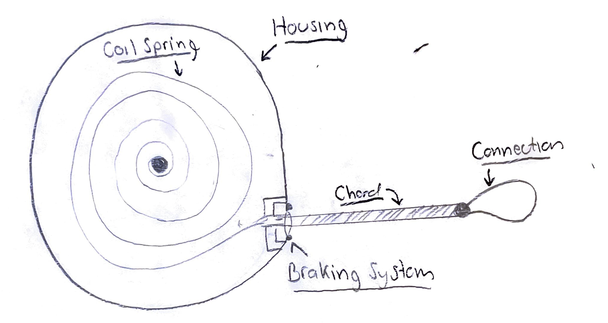
Figure 23: Spring Assisted Leash

Design #2: Motor Assisted
The motor assisted dog leash utilizes a motor to extend and retract a reel of chord. This concept is similar to that of a winch but instead of pulling with a high torque, we plan to spec ours out to pull at a high speed. As of now, this is one of our higher rated concepts due to its simplicity and the fact that it would meet all of our requirements so long as we choose the correct motor.
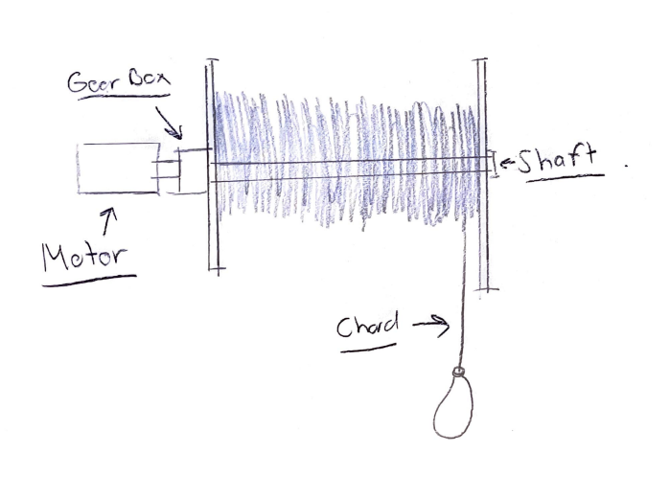
Figure 24: Motor Assisted Leash

DESIGNS SELECTED – First Semester

Chapter 5 of this document compiled all the concept generation, data from the Quality Function Deployment, and benchmarking to tell the team what designs are most probable and overall, the best fit for the client. The Decision Matrix in Table 4 shows the top designs compiled against the engineering requirements, whereas the entirety of the designs against engineering requirements are shown in the appendix. Table 5 will show the Pugh Chart which takes the top designs from the Decision Matrix and compares it to a datum along with the customer requirements. The design chosen will come out of the Pugh Chart.

Technical Selection Criteria

Decision Matrix
The Decision Matrix below in Table 4 is an abbreviated version of the full decision matrix which is placed in the appendix. The abbreviated version covers the top choice designs which were the Vacuum Piston, the Spring Piston, the Dog Leash, and the Two Arms designs. The designs were scored against the engineering requirements discussed in Section 2.2. The weights in the matrix come from the Quality Function Deployment where each engineering requirement was weighted and placed out of a sum of one hundred and divided to get its proper weight. All the scoring was based off light calculations along with which designs had the most realistic working probability. For instance, the crossbow design scored low in the decision matrix because the mechanism is extremely complicated and has many sources of error compared to the other designs. The results show that the Vacuum Piston fit the requirements the most with the Dog Leash and Two arms design coming next. The reason the Spring Piston did not score as closely to the Vacuum Piston is because the mechanism can vary greatly on temperature and size of umbilical needed.
Table 4: Decision Matrix
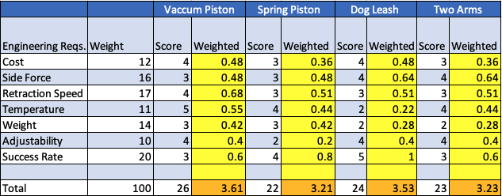

Pugh Chart
The completion of the Decision Matrix helped our team narrow our ten design concepts to the top five. We set the current technology Northrop Grumman is using, the bungee cord retraction system, as the datum our five designs would be compared against. As a team, we discussed whether our design would perform better than, worse than, or the same as the datum based on specific criteria. Better was denoted by a green box and plus sign, worse was denoted by a red box and minus sign, and the same was denoted by a blue box and capitalized s. The criteria for comparison were pulled from our House of Quality combining the most important customer and engineering requirements representing qualitative and quantitative specifications. The results of our analysis were not as helpful as we would have liked. As shown in Table 5; Design 1: Vacuum Piston, Design 2: Spring Piston, and Design 4: Dog Leash, have the same total of better, worse, and same marks. Because of this, our team evaluated each design concept against each other to see what aspects of the designs could be implemented or combined to improve the comparison against the datum.
Table 5: Pugh Chart
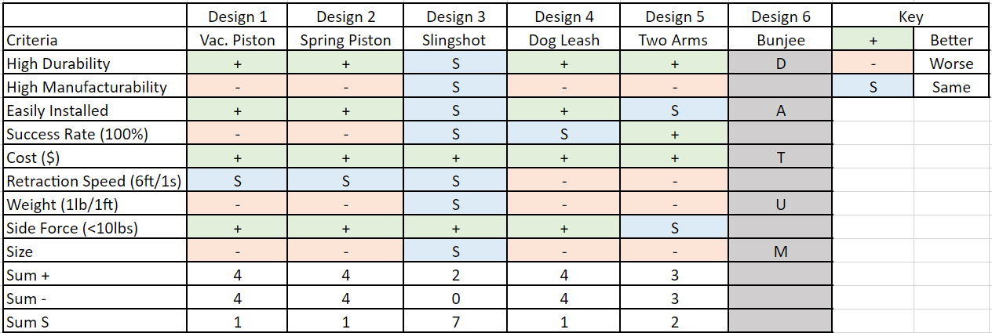

Rationale for Design Selection
The top two designs the team decided to go with were the Vacuum Piston along with the Dog Leash in variations. The Vacuum Piston was chosen due to the ability it has to work under temperature which the Spring Piston would change depending on the temperature due to the spring constant changing. Also, the Vacuum Piston would be able to adapt to multiple lengths and have many different adjustable settings in how the pressure difference will work. It would be able to speed up or slow down the retraction depending on how fast the client needs it to be while at the same time change how far it will have to retract. The only other failure that would be common in the Vacuum Piston would be the fact the seals may wear over time and could potentially be difficult to replace, and if there was a leak in the system there could be dire consequences as the vehicle could explode during launch. The Dog leash was the next top design. Like the Vacuum Piston it would be easily adjustable if a motor would be used to retract the umbilical. If a spring coil variation were used in this, then there could be changes in the retraction spring just like the Spring Piston. In conclusion, because the Dog leash has less errors than the Vacuum Piston, the Dog Leash will be the design pursued by the team. The client is happy with the Dog Leash design and the team believes it would be able to make a successful system involving this mechanism.

REFERENCES

[1] | S. E.P., "The use of INductive Wireless Power and Data Transfer System as Sounding Rocket Umbilical," Delft University , 2011. [Online]. Available: https://oatd.org/oatd/record?record=oai%5C%3Atudelft.nl%5C%3Auuid%5C%3A3321bfbe-f792-4a3d-b341-5ea9a492a1a8. [Accessed September 2021].
[2] | S. Doroudgar, "Static and Dynamic Modeling and Simulation of the Umbilical Cable in a Tethered Unmanned Aerial System," Simon Fraser University , 17 June 2016. [Online]. Available: https://summit.sfu.ca/item/16604. [Accessed September 2021].
[3] | D. C. Han Tao, "Adaptive Impredence Control of a Novel Automated Umbilical System for Propellent Loading," Harbin Institute of Technology , 11 August 2021. [Online]. Available: https://www.mdpi.com/1996-1073/14/16/4900/htm. [Accessed September 2021].
[4] | A. Gosselin, "Technical Paper Session I-A- Automated Ground Umbilical Systems (AGUS) Project," Space Visions Congress , 2007. [Online]. Available: https://commons.erau.edu/cgi/viewcontent.cgi?article=3435&context=space-congress-proceedings. [Accessed September 2021 ].
[5] | E. Boesiger, "41st Aerospace Mechanisms Symposium," NASA, 18 May 2021. [Online]. Available: https://core.ac.uk/reader/42739970#page=359. [Accessed Septmeber 2021].
[6] | G. S. M. Alan C. Littlefield, "Design, Development,and Testing of Umbillical System Mechanisms for the X-33 Advanced Technology Demonstrator," NASA, U.S. Government, Kennedy Space Center, Merrit Island, FL, 1999.
[7] | J. Bemis C. Tatum, "Rolling Beam Umbilical System," NASA, U.S. Government, Kennedy Space Center, Merritt Island, FL.
[8] | G. J. T. P. M. William C. Manley, "Ares I Linear Mate Umbilical Plate and Collet," NASA, U.S. Government, Kennedy Space Center, Merritt Island, FL, 2012.
[9] | B. G. Valentin Guinet, "ARES14BI “Hydra” - a two-stage experimental rocket project within the PRESEUS program," EUCASS Association, 2015.
[10] | R. W. Calvert, "Umbilical Arms for the Saturn V Vehicle," IEEE Transactions on Aerospace, 1963.
[11] | National Aeronautics and Space Administration, "Launch Complex 39, Pads A and B," NASA Facts, p. 8, 2004.
[12] | Blue Origin, "Blue Origin New Shepard," Blue Origin, 2021. [Online]. Available: https://www.blueorigin.com/new-shepard/. [Accessed 8 2021].
[13] | Tokai Spring, "Flat Sprial Springs," Tokai Spring, 2021. [Online]. Available: https://www.tokaibane.com/en/spring-design/flat-spiral-springs-formulas. [Accessed 9 2021].
[14] | J. Tang, "Motor Sizing Basics," Oriental Motor, 17 January 2020. [Online]. Available: https://blog.orientalmotor.com/motor-sizing-basics-part-2-load-inertia?hsCtaTracking=95e3b5c5-570b-4403-9b54-aa346abde034%7C773a672a-9bbb-411d-ae39-0276910ef191. [Accessed 9 2021].
[15] | R. G. Budynas, "Mechanical Engineering Design 11th Edition," McGraw Hill Education, 2020, pp. 681-791.
[16] | R. J. Dalby, "V2 Rocket History," July 2019. [Online]. Available: v2rockethistory.com. [Accessed 9 2021].
[17] | Nitra Pneumatics, "Pneumatic Cylinders," Nitra Pneumatics, 2020. [Online]. Available: https://cdn.automationdirect.com/static/press/nitra_cylinders_intro.pdf. [Accessed 9 2021].
[18] | Conductix Wampfler, "Motor Driven Reels," Conductix Wampfler, 2021. [Online]. Available: https://www.conductix.us/en/products/motor-driven-reels. [Accessed 10 2021].
[19] | NASA, "Artemis," NASA, 2021. [Online]. Available: https://www.nasa.gov/specials/artemis/. [Accessed 10 2021].
[20] | R. Budyas and K. Nisbett, Shigley's Mechanical Engineering Design, vol. Eleven, McGraw Hill Education, 2020.
[21] | D. Christensen, A. Lawrie and D. Zube, "Heroicrelics," Heroicrelics, [Online]. Available: http://heroicrelics.org/info/lut/mobile-launcher.html. [Accessed 14 October 2021].
[22] | Department of Energy, Office of Science, "Science," Department of Energy, [Online]. Available: https://www.science.gov/topicpages/l/launch+umbilical+tower. [Accessed 14 October 2021].
[23] | Z. Wang, D. Lan, T. Wang and B. Zhang, "Design of A Measuring Device and Winch Structure for Detecting the Distance of Two Seabed Pipelines," Marine Science and Engineering, 18 February 2020.
[24] | American Society for Testing and Materials International, Form and Style for ASTM Standards, West Conshohocken, PA: ASTM International.

APPENDICES

Appendix A: Full QFD
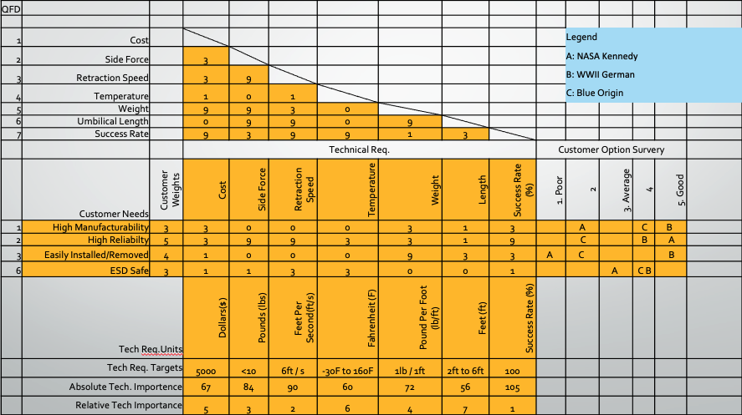

Appendix B: Full Decision Matrix
