Northrop Grumman Umbilical

Final Proposal

Jonathan Armijo
Leah Blakney
Griffin Brandt
William Shields

2021-2022




Project Sponsor: Northrop Grumman; Kaitlyn Barr, Kevin Padilla
Faculty Advisor: David Willy
Instructor: David Willy

DISCLAIMER
This report was prepared by students as part of a university course requirement. While considerable effort has been put into the project, it is not the work of licensed engineers and has not undergone the extensive verification that is common in the profession. The information, data, conclusions, and content of this report should not be relied on or utilized without thorough, independent testing and verification. University faculty members may have been associated with this project as advisors, sponsors, or course instructors, but as such they are not responsible for the accuracy of results or conclusions.

EXECUTIVE SUMMARY
The 2021 NAU Northrop Grumman Capstone team was challenged with designing a new umbilical retraction system (UBS) which will quickly remove all last-minute attachments to a vehicle right before it launches. The current design for a UBS is a bungee cord which attaches to the connections between the vehicle and the tower, when the vehicle launches, the cable detaches from it and is retracted quickly by the bungee. The problem with the bungee cord is it puts a side force or moment on the vehicle which can change its trajectory. The goal of this project is to create a new system that can retract the cord in the same time span, 6 ft/s, while pulling no force on the vehicle (<10 lbs.). The system must be able to withstand the same conditions as the current model and must be cost effective and easily maneuverable. With those customer requirement’s the team created many concepts that could work as a substitute, these designs were put through a Decision Matrix and Pugh chart which left the team with one concept left. The design is called the ‘Dog Leash’ and it is modeled after a winch system. The pieces of this project that the team must figure out includes a specification for specific motors, different types of heat resistant cords along with shielding from heat along with a system that performs 100% of the time. A specific gear ratio may prove to be useful but not entirely necessary, but tests and prototyping will single this out. To start prototyping the team used SolidWorks to create a rough 3D model which shows a proof of concept that the design does in fact work along with a direction to head into for a 2nd and final prototype for the following semester. The 2nd prototype will be much more advanced than the 1st. These advancements will include an updated motor assembly, along with a list of comments given to us by the client. The 2nd prototype like the 1st will be designed in SolidWorks and built-in real life at a shop provided to us by a sponsor. This design will be able to provide the team with physical results to see where the design fails and succeeds. In terms of safety factors, our product must work 100% of the time and in retraction, it also should be able to move the cable in a safe and mannered way. The one safety requirement provided to us by the client is that it needs to be Electrostatic Discharged Safe (ESD safe). This means that since the umbilical going to the vehicle is carrying electrical signals, which the team needs to create a device that will retract it without causing any disturbance in the signal transfer, this includes sending any unwanted signals or power to the vehicle. Testing procedures will follow to make sure all the systems work properly and that safety requirements will be checked. In specific these procedures will include testing of the motor, retraction cable, system structures, and heat resistance. These will be tested using the procedures outlined in Section 3 of this document. These procedures will also correlate to the Failure Mode Effect Analysis (FMEA) shown in Section 4. These two need to correlate to see if the areas of the product that the team think could fail shown in the FMEA fail in real life during the testing, and if they do updates on the model will need to persist. By the end of the semester the team hopes to have a fully working prototype to test all the customer and engineering requirements proposed by the client, with the data the team will collect by the 2nd prototype, advances can be made moving into the second semester.

TABLE OF CONTENTS

DISCLAIMER 2
EXECUTIVE SUMMARY 3
TABLE OF CONTENTS 4
Table of Figures 1
Table of Tables 2
1 BACKGROUND 3
1.1 Introduction 3
1.2 Project Description 3
1.3 Original System - 3
1.3.1 Original System Structure 3
1.3.2 Original System Operation 4
1.3.3 Original System Performance 4
1.3.4 Original System Deficiencies 5
2 REQUIREMENTS 6
2.1 Customer Requirements (CRs) 6
2.2 Engineering Requirements (ERs) 6
2.3 Functional Decomposition 6
2.3.1 Black Box Model 6
2.3.2 Functional Model/Work-Process Diagram/Hierarchical Task Analysis 7
2.4 House of Quality (HoQ) 8
2.5 Standards, Codes, and Regulations 10
3 Testing Procedures (TPs) 3
3.1 Testing Procedure 1: Cable Type 3
3.1.1 Testing Procedure 1: Objective 3
3.1.2 Testing Procedure 1: Resources Required 3
3.1.3 Testing Procedure 1: Schedule 3
3.2 Testing Procedure 2: Retraction Speed 3
3.2.1 Testing Procedure 2: Objective 4
3.2.2 Testing Procedure 2: Resources Required 4
3.2.3 Testing Procedure 2: Schedule 4
3.3 Testing Procedure 3: Temperature 4
3.3.1 Testing Procedure 3: Objective 4
3.3.2 Testing Procedure 3: Resources Required 5
3.3.3 Testing Procedure 3: Schedule 5
3.4 Testing Procedure 4: Side Force 5
3.4.1 Testing Procedure 4: Objective 5
3.4.2 Testing Procedure 4: Resources Required 5
3.4.3 Testing Procedure 4: Schedule 5
4 Risk Analysis and Mitigation 6
4.1 Critical Failures 6
4.1.1 Potential Critical Failure 1: Baseplate 6
4.1.2 Potential Critical Failure 2: Spool 6
4.1.3 Potential Critical Failure 3: Axle 6
4.1.4 Potential Critical Failure 4: Motor 6
4.1.5 Potential Critical Failure 5: Motor Holder 6
4.1.6 Potential Critical Failure 6: Mounting Screws 7
4.1.7 Potential Critical Failure 7: Gear Box 7
4.1.8 Potential Critical Failure 8: Bearings 7
4.1.9 Potential Critical Failure 9: Motor Controller 7
4.1.10 Potential Critical Failure 10: Cable 7
4.2 Risks and Trade-offs Analysis 7
5 DESIGN SELECTED – First Semester 8
5.1 Design Description 8
5.2 Implementation Plan 10
6 CONCLUSIONS 13
7 REFERENCES 14
8 APPENDICES 16
8.1 Appendix A: FMEA 16
8.2 Appendix B: CAD Drawings 17

Table of Figures
Figure 1: Northrop Grumman Umbilical Retraction System Structure 4
Figure 2: Umbilical Diagram 4
Figure 3: Black Box Model 7
Figure 4: Functional Model 8
Figure 5: 1st Prototype 8
Figure 6: Full Prototype 1 9
Figure 7: Exploded Assembly of the 1st Prototype 10
Figure 8: Full Assembly of the 1st Prototype 11
Figure 9: Housing Prototype 17
Figure 10: Driving Shaft Prototype 18
Figure 11: Wheel Prototype 19

Table of Tables

Table 1: Engineering Requirements Vs. Engineering Requirements 9
Table 2: Legend for Customer Option Survey 9
Table 3: Lower Section of Quality Function Deployment 10
Table 4: Standards of Practice as Applied to this Project 10
Table 5: Engineering Requirements Over Time 10
Table 6: Bill of Materials 11
Table 7: Team Budget 12
Table 8: Tentative Budget 12
Table 9: Full FMEA 16

BACKGROUND

Introduction
Northrop Grumman tasked our team with designing, prototyping, testing, and delivering a new umbilical retraction system. We were given engineering requirements and customer specifications our design must meet upon completion. The current technology Northrop Grumman is using is a tension loaded bungee cord. This current design has room for improvement and redesign due to the life cycle of the system being a one-time use. This leads to increased costs caused by the replacement need for the system. This project is important to Northrop Grumman and the aerospace and defense industries because umbilical’s provide many different things, such as electrical power, communications, or pressurized gases, to vehicles before launch. Consequently, it is imperative the umbilical is retracted to avoid becoming damaged under launch conditions.

Project Description
Our client representative, Kaitlyn Barr, presented the following project description to our team:
“The objective of this project is to design an umbilical retraction system. The umbilical retraction system will be designed to pull cables/hoses away from the vehicle after they are released to avoid damage to the launch vehicle. The retraction system needs to be easily installed and removable. It cannot exert excessive force on the umbilical prior to separation with the launch vehicle. In addition, it needs to be reliable for mission success and durable to withstand launch environments. Further improvements may also be made to the system at the discretion of the team such as protection of the umbilical against thermal and shock environments.”

Original System -
The original system has been in use for many years and is the standard for Northrop Grumman umbilical release devices. The system is a bungee cord loaded in tension which is released upon launch. The specifications are not widely let out. Most companies, including Northrop Grumman, our team's client, do not allow information outside of their building due to it being classified. Given this, in-depth understanding will not be possible, but the overview of the system can be broken down.

Original System Structure
The original system structure consists of an umbilical cable which is detached from the vehicle. The cable is detached by the retraction bungee which separates from the vehicle at launch. The umbilical cable is attached to an umbilical boom, but for Northrop Grumman’s larger scale vehicles, the umbilical cable will be attached to a tower. During launch, the umbilical cable will be detached and retracted out of the way to prevent any permanent damage from the launch conditions. The retraction bungee will incinerate and will need to be replaced for the next launch. The figure below illustrates Northrop Grumman’s current umbilical retraction system design.
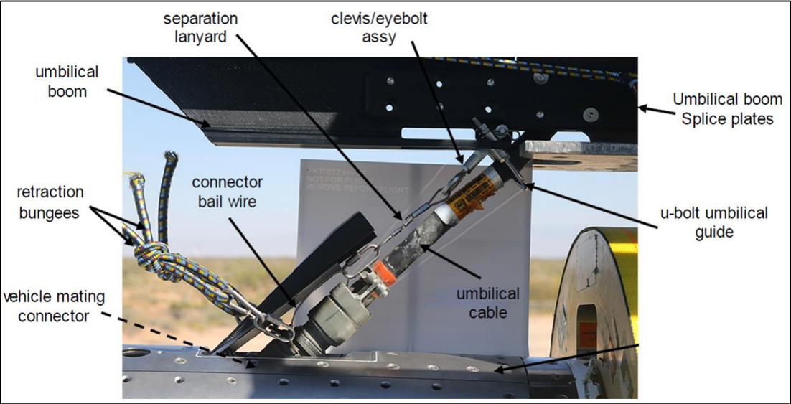
Figure 1: Northrop Grumman Umbilical Retraction System Structure

Original System Operation
The original system of the umbilical cable is illustrated in the figure below. The umbilical cable is attached to the right of the image, while the umbilical cable goes to the left. The attachment process is where the lanyard release connector is linked to the receptacle. The retraction bungee is pulled at an angle which creates a side force on the rocket. This is all the information given to the team from Northrop Grumman that describes the design aspects.
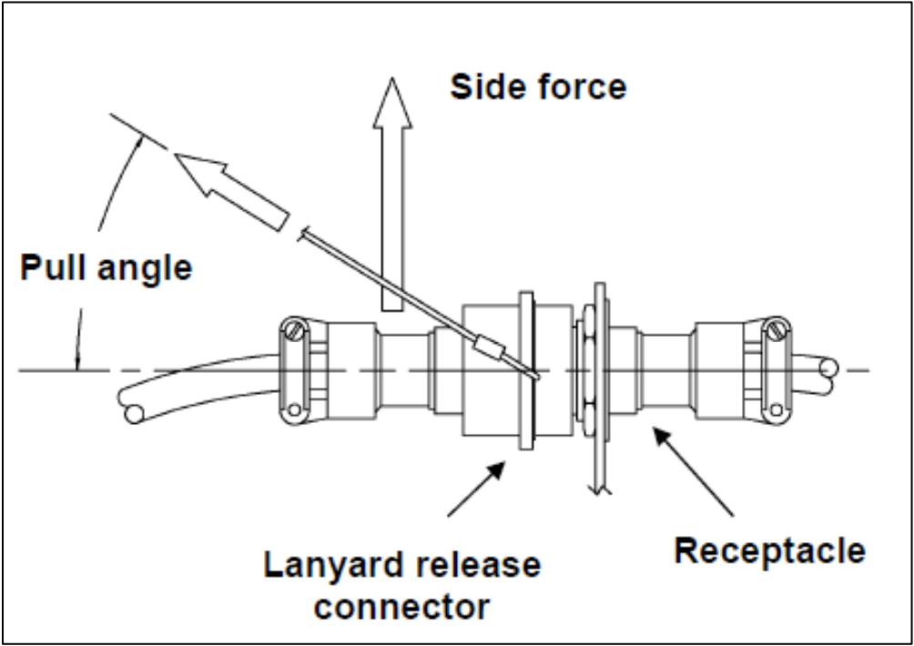
Figure 2: Umbilical Diagram

Original System Performance
The performance of the bungee retraction system used for most umbilical cable applications is highly successful. Information about umbilical cables is limited due to the secrecy associated with the defense industry. So, any exact details on the launch vehicle along with the umbilical cables are low. Further, because the launches are not easily replicated, gathering data as a team is not practical. So, at this point our performance understanding of the original system is low.

Original System Deficiencies
The design of an original system made of a bungee retraction system is a consistent design that has low deficiencies. The most important deficiency is the side force. The side force is emphasized by our client, which returns an important customer requirement. The original system is currently reliable but would not meet the one-hundred percent success rate. Creating a design that will minimize the side force will lead to a higher success rate due to a near minimal side force caused by the bungee attachment. The failure analysis performed on unsuccessful umbilical releases, done by the companies themselves and released to the public, found the side force initiated the failure. The other customer requirements would be highly rated and would not carry a need for improvement due to its low correlation. An engineering requirement that could be improved from the original system is the success rate. The success rate is an issue due to the minor part of the retraction cable which melts away during each launch, that becomes lessened by the cost.

REQUIREMENTS
The requirements set for this project were given by the client at the start of our project development: a new design that would improve upon the deficiencies of the current design.

Customer Requirements (CRs)
The customer requirements given to us during the client meetings follow as such. The design must have a low-cost while being durable. The cost must be less than the current system, which is around $12000 per launch. The durability of the system, at a minimum, must withstand two launches, whereas the current system is single use. Therefore, the design will save the company $24000 for every couple of launches. Our client expects the umbilical retraction system to have a one-hundred percent success rate. This means our design needs to be extremely reliable with no possibility of malfunctioning because then the vehicle could become damaged and worst-case result in a vehicle explosion. Other customer needs given to our team were to have a design that could be easily removed and installed to varying in size vehicles. Further, our design needs to be electrostatically discharged safe (ESD), so the vehicle does not short circuit during disconnection.

Engineering Requirements (ERs)
The following engineering requirements were provided to us by the client. Ideally, the design will remove all force acting on the side of the vehicle (side force) before and during liftoff, but we are allotted to have a side force that does not exceed ten pounds of force. As the current standard puts a hefty side force on the vehicle, our model must eliminate this aspect as much as possible and ideally, all together. The speed of retraction is the next crucial factor of the design. In detaching from the vehicle, the umbilical must move six feet in one second, which is comfortably obtainable through bungee cords, but designs that do not use this system may be more difficult to create and may result in a higher cost to manufacture. Another requirement is our design must not cost over five thousand dollars because this is the budget sponsored by Northrop Grumman to the team for this project. Weight is an important aspect of the design because our design must be easily removable and have a quick installation. If it is heavy and awkward to move, then the installation process will be slower. The device must be able to withstand brief moments of extreme temperature and must not change its reliability due to different air temperatures. As stated above, ensuring our device has a one-hundred percent success rate is of the utmost importance.

Functional Decomposition
The Function Decomposition section is used to picture the flow of energy sources within the system the team will be designing. From the beginning, these two models have been live documents and have gone through different changes as our design evolved. These changes as well as the current state of each model are described within their respective sections below.

Black Box Model
The purpose of creating a Black Box Model is to identify the main function of our project deliverable, an umbilical retraction system. Our team decided the main function is to retract the umbilical. Once the main function was identified, the team evaluated the overall material, energy, and signal flows into and out of the system. The materials which flow into and out of the main function are depicted with a bolded line. The energy flows are represented by a normal font size line and the signal flows are represented by a thin line. After some further analysis, our team identified the material flows into and out of the main function to be a human hand, the umbilical cord, and newly added, controller. The energy flows into the main function remained the same and are human energy and electrical energy. After the main function has been completed thermal energy and mechanical energy are released same as beforehand. Our design will need to be actuated therefore, the main function will have an on/off signal into and out of the system. We have narrowed our input signal to be the on signal that will actuate the system and the output signal to be the signal for the gear brakes. After developing some design concepts and referencing our old model, our team had a better idea of what is initially implemented into our system and led us to the conclusion of adding the controller input to our original Black Box Model. Our team had a fair understanding of the energy transfer within our system, so no change occurred between the original and the new model in terms of energy flow. Lastly, our team was able to narrow what the on/off signal flows into and out of within the system.
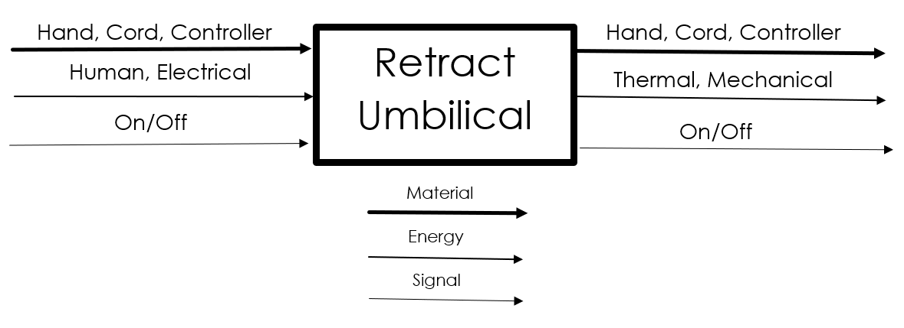
Figure 3: Black Box Model

Functional Model/Work-Process Diagram/Hierarchical Task Analysis
Our functional model shown in Figure 4 took the inputs from our Black Box Model shown above and analyzed the paths each input would take throughout our system. On the left of the model shown below, we have the inputs from our Black Box Model each being imported to the system. Next, these inputs are either transported or manipulated to accomplish our final goal of retracting the umbilical.
This model allowed us to better analyze and create our design concepts. By further understanding the material, energies, and signals going through our system, we were able to better visualize how these pieces would interact with each other.

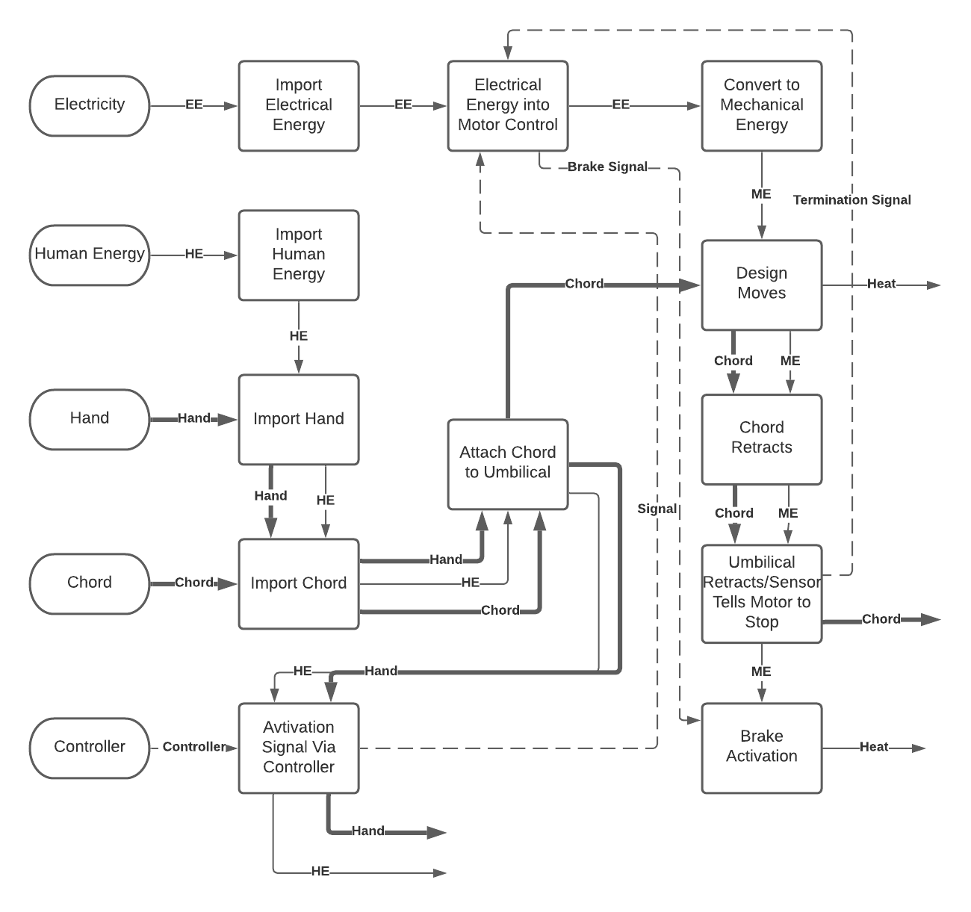
Figure 4: Functional Model
As our design has evolved throughout the course of this semester, so too has our functional model. Proper upkeep of our functional model is essential as it allows us to map out how our system will work and how new components or changes will affect the overall flow of the device. One notable change to our system and subsequently the functional model was the addition of a motor controller to manage the power input and motor speeds. Within the functional model, signals are both inputted and outputted from the motor controller which then go on to activate different sections of our design. Another change recently made from the preliminary design was the way that the signals were inputted into the system. To ensure that we maintained proper control over the design’s speed and activation/deactivation cycles, we implemented a controller which will be human operated that will send the activation signal to our motor control. These two changes were made to address one of the main failure concerns within our design which were the actuation systems. Further explanation of how we identified this concern is explained below within our Risk Analysis and Mitigation section of the report.

House of Quality (HoQ)
The House of Quality is split up into different tables. Table 1 depicts a comparison between the engineering requirements against themselves. This table will show the reader how each engineering requirement will be affected by the others and is rated on a qualitative scale ranging from 0, 1, 3, and 9. Intuitively, a weak relationship is given a zero and a strong relationship is given a nine. Shown in Table 3 is the rest of the Quality Function Deployment which compares the engineering requirements to the customer requirements along with the customer requirements to the benchmarking. It also should be noted that on the QFD, on the temperature, retraction speed, and side force categories, are the labels of [T.P #], these will correspond to their proper testing procedure. The engineering requirements against customer requirements show the most important aspects of the design are the success rate, speed of retraction and side force acting on the vehicle. Additionally, these were the most important aspects discussed with the client. The other aspects, although important, were not raised to the highest concern of the client. These include the weight, length, cost, and temperature rating of the design. The benchmarking in the customer option survey is defined by the legend shown in Table 2 where it was decided that the NASA Kennedy tower and the WWII German V2 tower were the most adept design to what the team was looking to compare against. This is justified as the Blue Origin design seemed overly bulky and from literature reviews did not seem to be the best design. Later in the report the decision matrix will be discussed, the ratings from the absolute technical importance row comes into play here where the designs were added up and placed out of one hundred and divided by the total to make a comparable rating system to rate against the concept generations.
Table 1: Engineering Requirements Vs. Engineering Requirements
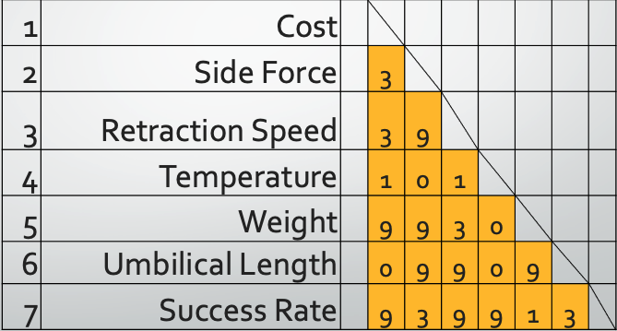
Table 2: Legend for Customer Option Survey
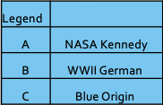

Table 3: Lower Section of Quality Function Deployment
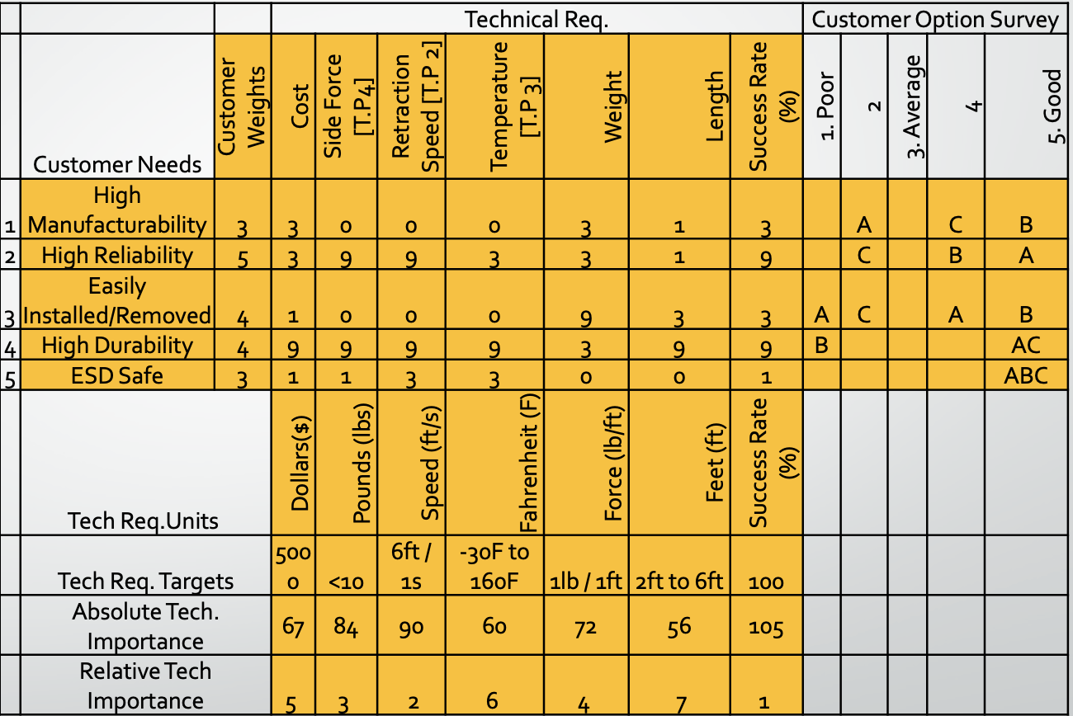

Standards, Codes, and Regulations
Table 4 below shows a list of the standards and codes that the team will have to keep in mind when designing the prototypes and final design. These regulations are set in place to make sure quality and safety service is met through all means of design.

Table 4: Standards of Practice as Applied to this Project
Standard Number or Code | Title of Standard | How it applies to Project
AGMA Table 1 | Equations for gear rating | Those equations for those gear rating will be useful in our calculations for our motor.
AISI M 1-4 | Design for Fatigue | The final design will include parts will steel so the fatigue understanding will aid the design.
ANSI B.1 | Procedures | The standard will help understand the procedures that go into designing.
IEEE: ESD 6.0 | ESD Control Program | The standard for ESD will need help with the electronics in our device.

The American Iron and Steel Institute will be useful for the team’s design. Steel will be used for our device and will start with the 3rd prototype. The sections M1-4 will breakdown the understanding of fatigue on steel. Section M4 goes into bolts which will be used to mount our device to the mounting part. The mounting part will be 12’ by 12’ where the device will attach. Understanding the fatigue capability for our steel parts will be helpful in our final designs.

American Gear Manufactures Association will be used in the understanding of the gear rating. The analysis will be completed for the gear rating into to manipulate our motor. Each of the symbols within the gear rating is paired with an equation that we can use to better understand the changes we can make to the motor such as gear ratio factor and reliability factor.

The American National Standards Institute create standards including the procedures for engineering while designing. The section picked detailed the procedures engineers must take and how provisions can occur during a project. The standard detailed how changes to the procedure can affect future aspects of the process of designing. Accommodating for those changes will need to be compiled.

The Institute of Electrical and Electronics Engineers will be important during the creation of our device because of the importance of electronics. Our client Northrop Grumman will give us more information on the topic of electrostatic discharge. Gathering more resources and specifically standards for the ESD will aid when finalizing our designs electronic aspect.

Testing Procedures (TPs)
The following section will discuss how the team plans to test our design prototype and final design to meet each of our engineering requirements. An explanation of how each test will be performed is given. This includes the equipment and space required to successfully complete the test. One of our engineering requirements which does not need an extensive test is cost. This engineering requirement can be evaluated by analysis of the number of parts needed for the design and material type used for each of the parts. Weight is a similar engineering requirement to cost. The weight of our design will be recorded with a scale before each testing trial. Further, our client requires the design to have a one-hundred percent success rate. This will not require a specific test, but rather the testing procedures be completed multiple times to evaluate the overall performance of the design. We plan to begin testing this semester and carry what we learn to adapt and change our design to make the best version to continue testing in the upcoming semester.

Testing Procedure 1: Cable Type
One of the most important components of this design is the retraction cable used. This cable will need to meet the following: be able to withstand launch conditions, be able to pull a one pound per one foot of cable and be able to resist friction wear and not lose structural integrity as the length increases. To find the correct cable to be used, a pack of five different cables made from different material concentrations and slightly different diameters will be tested. Though this test does not explicitly solve an engineering requirement, this test does help optimize our design bettering the chances of reaching the client’s engineering requirements tested by other testing procedures. The cable type test will hopefully be performed this semester.

Testing Procedure 1: Objective
The first step in the cable type test will be to gather the necessary equipment. To evaluate which cable coils around the barrel of our design the fastest, a simple timed test will be conducted. A team member will be responsible for measuring the cable length before actuation and the actuation of the design. Two team members will be responsible for timing the retraction of the cable once it has been extended to full length, and one teammate will be responsible for collecting the data on their personal computer. Then the team will calculate the retraction speed. This test will be repeated for the rest of the cables until it is known which one is the fastest. Luckily, the cables our team are considering are made of materials which well exceed the temperature and structural integrity requirements given to the team by the client.

Testing Procedure 1: Resources Required
This test will include the following equipment: our design (minus cable), the umbilical provided by our client, a tape measure, two stopwatches, the five different cable types, and a personal computer with Microsoft office. This test will require a space large enough to allow the umbilical cable to fully extend between two feet and six feet with the team in a safe distance from the testing site.

Testing Procedure 1: Schedule
This will the first test the team completes once the team has access to the necessary parts needed for the design. The final design is contingent on what kind of cable is selected; therefore, it is important to accurately evaluate them. Ideally, the parts will arrive before the end of this semester, so the team is able to test one cable in a sitting or spend a longer time testing all five cables at once.

Testing Procedure 2: Retraction Speed
This test is arguably the most important test the team will perform. The main function of our design is to retract the umbilical and our client gave our team a time frame in which it must. Our task is to retract six feet of cable in one second. Our client relayed to our team that the cable length will vary between two and six feet, but since our time restraint is for the longest length, six feet, we will conduct the retraction speed test at this length. We will time our design from when the umbilical disconnects from the mount until the six feet cable is completely retracted away from the actuation zone. The team believes this test will need to be completed multiple times throughout the upcoming semester due to design changes and reevaluations of how to make the design better and function more smoothly.

Testing Procedure 2: Objective
The first step in the retraction speed test will be to gather the necessary equipment. The next steps of this test will be to weigh our design using a scale and use the tape measure to record the length of the umbilical cable. Once those measurements are taken, the team will set up the testing area. This will include our design being extended the full umbilical cable length and setting up a camera to capture the test. Then, the team members will move to a safe distance away from the testing zone. One team member will actuate our design, two team members will time the retraction with stopwatches, and one team member will be responsible for recording the data on a personal computer. The team will evaluate the outcome of the design by repeating this test a minimum of seven times. Then calculations will be done to find the retraction speed and success rate. From the data collected, the team will be able to see if our design has met the retraction speed engineering requirement or if adjustments will need to be made to reach the six feet of cable per second requirement.

Testing Procedure 2: Resources Required
This test will include the following equipment: our design, the umbilical provided by our client, a tape measure, two stopwatches, a scale, a personal computer with Microsoft office, and a camera. The four team members will need to be present as well. This test will require a space large enough to allow the umbilical cable to fully extend with the team in a safe distance from the testing site.

Testing Procedure 2: Schedule
This test will take a bit of time to plan and complete. Realistically, the team does not know if the design will perform as expected which could lead to the test becoming longer. Additionally, it will take time to reset the trial and evaluate the data before a conclusion can be drawn. The team plans to begin testing this upcoming semester and learning from the tests to better our design and retest.

Testing Procedure 3: Temperature
Our design needs to be able to withstand launch conditions due to its proximity to the launch zone. Our client has specified that our design will need to operate at temperatures ranging from negative thirty degrees Fahrenheit up to one-hundred- and sixty-degrees Fahrenheit. This testing procedure will evaluate our design’s functionality over the full temperature range. This test is tricky to accurately execute because the launch conditions are difficult to replicate since the temperature transfer happens so fast. Currently, the team is brainstorming some ideas of how to heat and cool our design to reach the endpoints of our range. To reach one-hundred- and sixty-degrees Fahrenheit, the team had the idea of placing the design in a convection oven. The issue with this is idea is it does not stimulate the effects of flames that will be expelled from the launch vehicle onto the design. For the negative thirty degrees, the team had the idea of putting the design into a freezer, but the average freezer typically reaches zero degrees Fahrenheit. This test will be completed once the retraction speed trials are completed because the data from that test needs to be used for this one. This means this test will most likely happen later in the upcoming semester.

Testing Procedure 3: Objective
The first step in the temperature test will be to gather the necessary equipment. The team will use a heating source to heat the design up until the laser temperature reader reports a temperature of one-hundred and sixty-five degrees. A team member will carefully remove the design from the heat source and into the designated testing zone. The test area set up will be similar to the one used for the retraction speed test, where the umbilical cable is able to be fully extended with the team within a safe distance and a camera is positioned to record the trial. One team member will actuate the design, one will take the temperature at actuation, one will time the retraction, and one will record the data on a personal computer. An analysis will be completed to see if our design is able to perform as designed under heat stress by comparing the data found for the retraction speed test under normal conditions. Then, trials similar to the heat source will be conducted, but instead of a heating source, a cooling source is used. Once the design reaches a negative thirty, it will be pulled away from the cooling source and the speed of retraction will be calculated for evaluation against the retraction speed at normal conditions. This test will tell the team if the design is able to handle a range of temperatures experienced on the runway.

Testing Procedure 3: Resources Required
This temperature test will include the following equipment: our design, the umbilical provided by our client, a laser thermometer, a heating source (potentially an oven), a cooling source (potentially a freezer), protective gloves, two stopwatches, a scale, a personal computer with Microsoft office, and a camera. This test will require a space large enough to allow the umbilical cable to fully extend six feet with the team in a safe distance from the testing site.

Testing Procedure 3: Schedule
This temperature test will not happen until later in the upcoming semester since these tests will not be conducted until the retraction speed under normal conditions is complete. This is because for this test the team needs the baseline data of how the design retracts the umbilical under normal temperature conditions.

Testing Procedure 4: Side Force
Another engineering requirement our design must meet is have less than a ten-pound side force applied from the cable onto the vehicle. The team will utilize a force gauge to evaluate this by connecting the end of the cable to the force gauge and loading the design to simulate the force if the design were about to be actuated. The team would like to perform this test after the cable type has been selected this semester, or early in the upcoming semester.

Testing Procedure 4: Objective
The first step in the side force test will be to gather the necessary equipment. The force gauge will be placed as close to where the cable will connect to the umbilical in a real launch situation to try and make the measurement as accurate as possible. A team member will record the measured force value before and after the design is slightly actuated.

Testing Procedure 4: Resources Required
This side force test will include the following equipment: our design, a personal computer with Microsoft office, and a camera. The four team members will need to be present as well. This test will require a space large enough to allow the umbilical cable to fully extend with the team in a safe distance from the testing site.

Testing Procedure 4: Schedule
The side force test may be able to be tested this semester after the cable type test because once the cable type is chosen this test is able to be completed if the rest of the design is manufactured as well. If this test is not down this semester it will be completed early in the upcoming semester.

Risk Analysis and Mitigation
One of the points our client Northrop Grumman made clear from the beginning was that our design should be highly reliable as any type of failure during a launch can be catastrophic. Because of this, it was crucial that risk analysis and subsequent mitigation was a part of all design choices we made. Our FMEA which can be found below in Appendix A breaks apart our design by component and assesses the potential risk that may result from it. By determining the risks associated with each part, we can better plan on how to mitigate these risks through our design choices. The rest of this section summarizes the main points of our FMEA and describes some of the potential critical failures that we may experience and what design decisions went into preventing those.

Critical Failures

Potential Critical Failure 1: Baseplate
The baseplate component will be responsible for holding all the pieces of our design as well as being mounted to the tower. Because of these roles, the baseplate will have to withstand numerous load cycles as well as withstand the forces of the load. Our main concern with this component is that it may critically fail due do fatigue from cyclic loading which could cause the device to detach from the tower thus and possible causing damage to the launch vehicle. This would be caused by the propagation of cracks within the material over time as the design is ran over multiple trials. To ensure that this doesn’t happen, it is crucial that a proper material is chosen for this component that will meet our factors of safety for both yielding and fatigue.

Potential Critical Failure 2: Spool
The spool will be directly rotated by a keyway within the axle. The main function of the spool will be to hold and pull the cable by converting rotational energy into linear energy. Our main concern for this material would be possible plastic deformation on the surface due to the cable being overloaded. This deformation could potentially lead to erratic behavior of the cable which may cause it to tangle thus impeding rotational movement. To prevent this, we will select a material with proper resistances to deformation due to loading and impact.

Potential Critical Failure 3: Axle
The axle will be directly connected to the motor and will subsequently spin our spool mentioned above via a keyway. Two possible failures that concern us would result from bending of the shaft and from failure at the stress concentrations of the keyway. Both failures would be the result of overloading due to sudden jerks within the system. Proper deflection and stress analysis will be used to account for these failures.

Potential Critical Failure 4: Motor
The motor is one of the most important components of our design. As such, it is crucial that we properly size the motor as choosing a motor that is too small may cause it to burnout or run poorly. An oversized motor would lead to wasted money. To prevent this, thorough analysis of required torques and speeds were utilized to ensure that the motor we chose would work for our applications.

Potential Critical Failure 5: Motor Holder
The motor holder is responsible for keeping our motor held in place. Depending on the final motor we choose, this part can have a range of different appearances. No matter what we go with, it is crucial that our motor holder prevents vibrations and erratic behavior of our motor by properly securing it down to the rest of the design.

Potential Critical Failure 6: Mounting Screws
The mounting screws will be used to mount our design to the testing tower. These screws will have to withstand the forces of the design when it is stationary and when a load is applied. As such, thorough potential sheer force and fatigue analyses will be conducted on our screws to ensure that we pick hardware that meets our set factors of safety.

Potential Critical Failure 7: Gear Box
To stop our design from rotating once the umbilical has been properly retracted, we plan to use gear braking. For this to be successful, gears with proper surface hardness and fatigue resistances will have to be chosen.

Potential Critical Failure 8: Bearings
The bearings will be responsible for allowing the axle to spin with less friction. Our main concern with the bearings is that overloading and improper maintenance may lead to fatigue wear which could cause damage to the wall of our bearings thus hindering their performance. This in turn would lead to lower efficiency ratings and may even slow down our system.

Potential Critical Failure 9: Motor Controller
The motor controller will be responsible for controlling one of the most important components of our design, the motor itself. As such, it is crucial that our purchased motor controller works and that we make sure that we are running the device within the manufacturer stated limits. A potential overload of the device due to too much power could cause the device to burnup thus leaving us without a working motor controller.

Potential Critical Failure 10: Cable
The cable will extend from the spool to the umbilical and will be wound up around the spool to linearly retract the umbilical. Possible failure of the cable could come from exceeding the specified manufacturer load limit which could lead to the cable snapping and not retracting the umbilical. This however is unlikely as the cables that we have analyzed have load limits that well exceed our loads that we will be pulling.

Risks and Trade-offs Analysis
Whilst many of the components within our design have potential failures that could be catastrophic, the likelihood of these failures occurring are highly unlikely. This is because the load we are pulling is not relatively heavy, and thus falls well below the manufacturer’s stated limits for many of our components. The main concern for many of our components would be fatigue failure due to cyclic loading but proper inspection and maintenance would ensure that this type of failure does not occur.
One of the biggest concerns for our design has been actuating the system. Without precise actuation controls, our device was at risk of putting the launch vehicle in danger due to a delayed response. Originally, we planned to go with an Arduino microcontroller to control the speed and settings of our device but eventually decided against it based on the risks. Instead, we opted to use a motor controller found online which will ensure that our device is receiving proper levels of power and that we can control the speeds of our motor.

DESIGN SELECTED – First Semester
This next section will discuss the design the team has selected and how it will be created and what iterations it will go through over time. The first ever concept of a design the team thought of was a vacuum piston, but after harsh consideration it was decided that that design would have to many errors such as leaks and pressure problems. Therefore, a new concept had to be chosen, this was the Dog leash, winch, design. Over the course of this semester two concepts will be created for the winch, the first one will be made by a 3D printer over what the team thinks a rough design will look like. The second one will be created after getting feedback from the client after the team’s presentation with them on Monday November 15th. The current design is shown below in 5.1 in further detail but the base model for what the team is doing is based off a winch design.

Design Description
A winch design is conceptually simple, it includes a motor which is connected to a shaft inside of a wheel that can windup a road or chord to give tension or pull on an object. The 1st prototype as described above is a simple 3D printed model to see how feasible the design is and to give a good visual of where the weak points and stresses on the design lay. Figure 3below shows what the first concept of the design looks like. In this assembly, the position where the motor lays are off to the right. The wheel is held in place by a shaft that runs in between two solid plates to secure its movement to only on axis. As part of the challenge that was given to use by the client; the device must be mounted on a 12X12 square tube that is vertical from the ground. The holes to the side of the device would be a positioned mounting place for the tube.
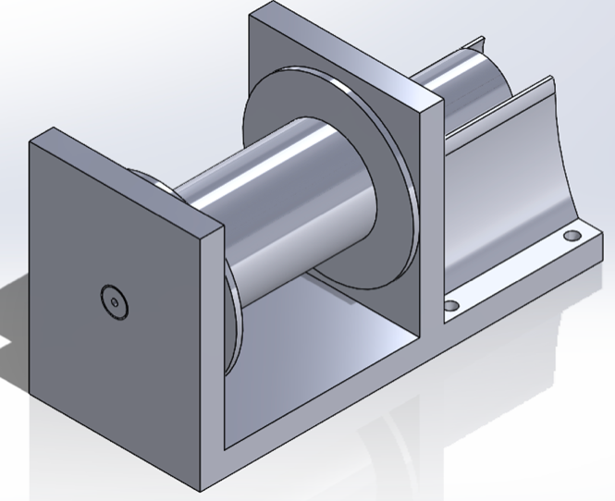
Figure 5: 1st Prototype
This first design showed a proof of concept by seeing the wheel spin. With it proving it would work, there is a mountain of problems within it that needs to be shown in future designs. A couple for instance, there needs to be bearings in place for the shaft to reduce friction on the plates. The motor needs to be optimized for the design as the motor for the prototype had almost no torque, that was to be expected though. Additionally, there needs to be positioning holes throughout the design as the four holes placed to the end of the design would create a moment on the design which is not ideal as it could break over time. The biggest issue with this design though is that it would never work for an ideal world as it was 3D printed the assembly process was ignored a little bit, and in the future, there needs to be a better process for assembly.
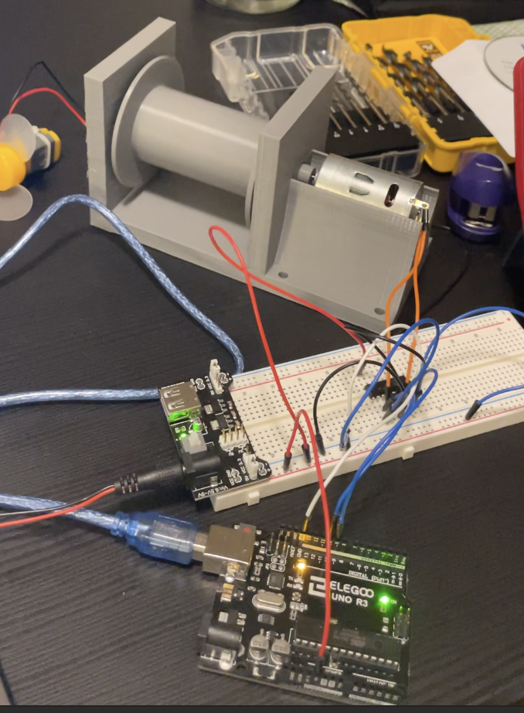
Figure 6: Full Prototype 1
Figure above shows the entire model of the 1st prototype. It was connected to a simple Arduino to control the features, but as seen when running the device, this can be unreliable. To solve this problem a full-scale motor controller will be needed. The actual motor used for this design was extremely small and was no able to pull that much force although it spun the wheel decently fast. As shown below in Table 1 is an outline for the direction the designs need to be headed as we progress with the year. The 1st prototype as depicted as much proved to show that the speed and pull force it had were too low. The next prototype though will still utilize a smaller motor but should hopefully be able to meet the requirements listed below. Eventually over the course of the year leading into the Spring semester, the actual requirements will be met. All the numbers shown for the 1st prototype were tested experimentally by seeing how much force it was able to pull and how fast it was able to move by a tachometer. The 2nd prototype numbers come from educated guesses based off the motor the team plans on getting, calculations for this are currently in the process of being done, they are just not completed now for professional validation. The last portion that needs to be checked is if a gear ratio will need to be created. This will be done with the 2nd prototype as for the first one would have shown it to be useless but give a bigger motor that would be able to supply the power for a gear ratio, it might be a valuable resource to easily control the motor speed on the winch. If the gear ratio shows to not be important for the upcoming prototype, then it will not be implemented in the final design.
Table 5: Engineering Requirements Over Time
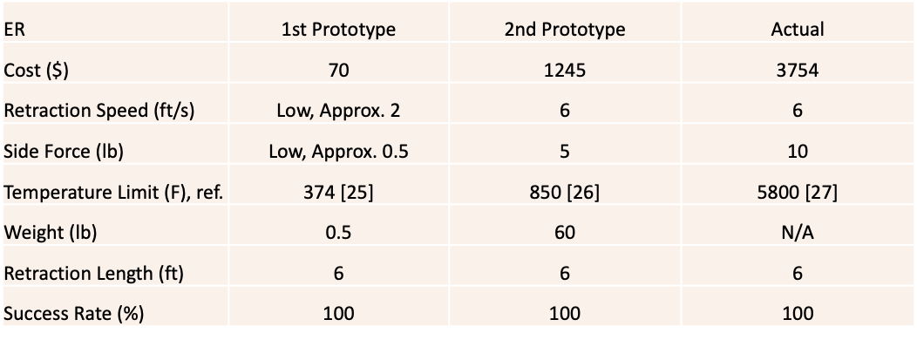

Implementation Plan
The 1st prototype was created using a SolidWorks package provided to us by Northern Arizona University. The design was then 3D printed using the MakerLab located at Cline Library in Northern Arizona University with a material of PLA. The material used for this design will obviously not be up to the standard presented by the engineering requirements. Figure below shows the exploded view of the rough concept that was 3D printed. Future design will have a much more extensive design implementation to them along with more accurate dimensions and parts. Figure on the other hand shows the assembled model. Although these are very rough drawings, they do represent the very first base of how the entire system will look.
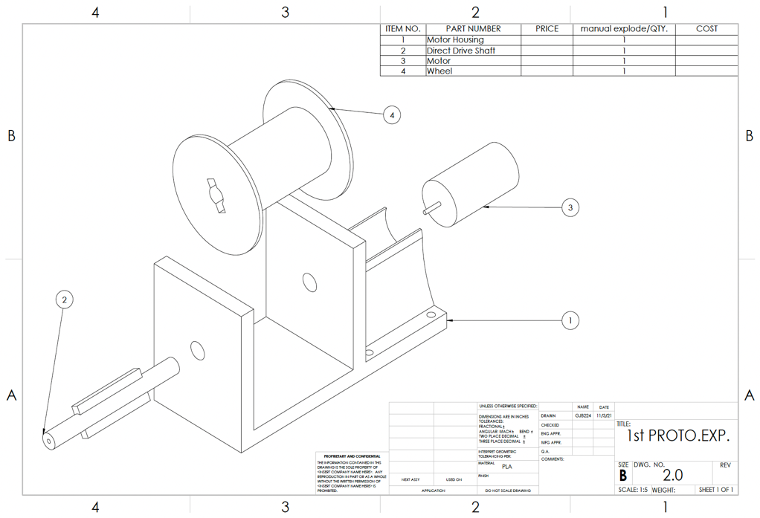
Figure 7: Exploded Assembly of the 1st Prototype
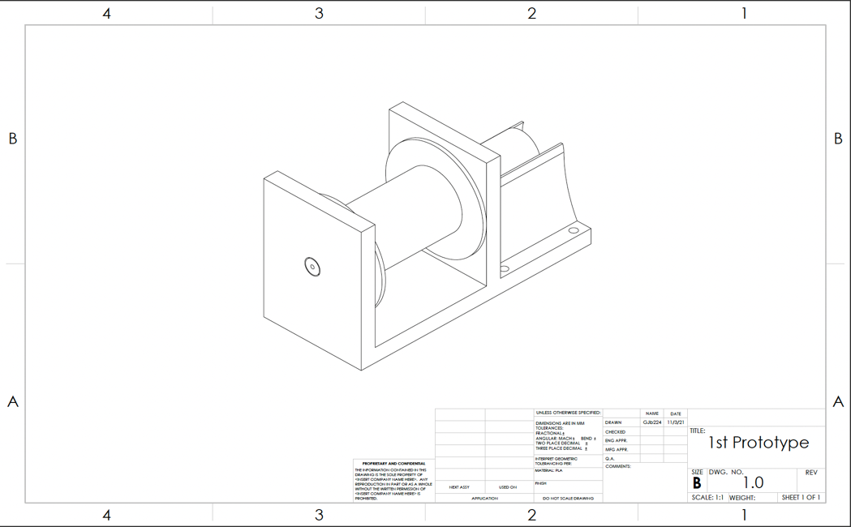
Figure 8: Full Assembly of the 1st Prototype
The 2nd prototype though will still be design on SolidWorks and then be manufactured out of wood since it is easy to use and work with and it is cost effective. This material still is not up to the task as the engineering requirements insist, but it is a good material to prototype with and to see a proof of concept. The 2nd prototype will be built at a wood shop provided to us by a sponsor (grandparent of Griffin Brandt). All materials will be supplied by the local handwear stores, and the electronic will be bought off different websites that can provide the materials, as listed in Table 2. The bill of materials to create these first two designs are shown in Table 2. This list provides an overview of what the 2nd prototype will have in it, along with giving a guideline to what the final design will also have to include as the design from the 2nd to final prototypes should be relatively close; all that will need to get done is a scaled-up design and different parts, but the base parts remain the same.
The Bill of Materials below goes into detail about the parts. The first three parts makes up the 1st prototype, which is detailed above. Those parts were a part of our team 1st prototype that was time sensitive due to the Presentation 3. The team needed a physical representation of our design for the presentation. The rest of the parts for the BOM are for our subsequent prototypes.
Table 6: Bill of Materials
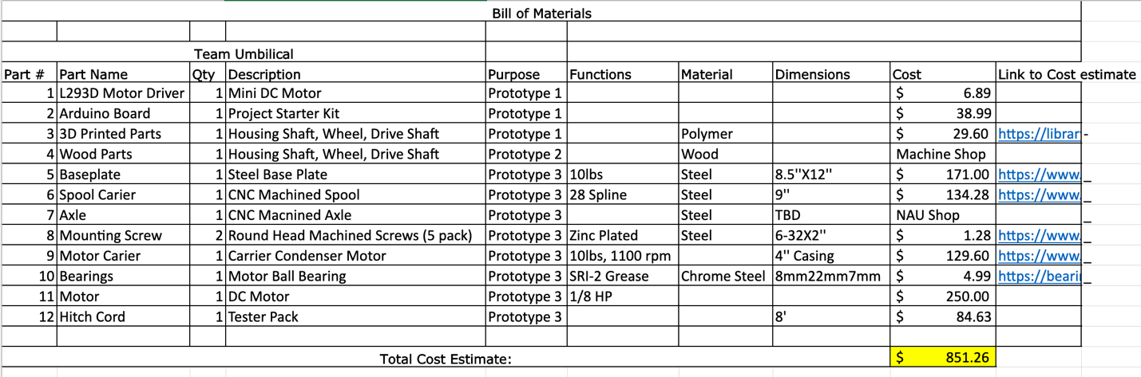
The budget for the upcoming prototypes is shown in Table 6 which includes the total cost for this semester, and what is left over for the next upcoming Spring semester. The extra dollar value in the contingency is a representation of parts not accounted for that might be used in the next upcoming prototypes, hopefully none of that value must be used as it would be better spent in the actual final design, but it is there if needed.
Table 7: Team Budget
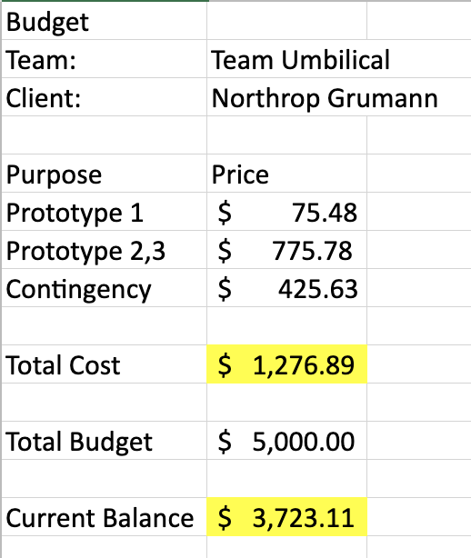

The tentative budget is a breakdown of our current spending. There are only two purchases that have gone through. The first purchase is for our cord. The cord will be used in testing that will hopefully arrive for the start of our testing at the end of the semester. The second part on the list is a reimbursement for the 1st prototype. The 3D parts were time sensitive and needed to be purchased quickly. There is another reimbursement that is in the process of being filed and is also for the 1st prototype. The current budget is safely within the team’s budget of $5000 so the team remains on budget.

Table 8: Tentative Budget
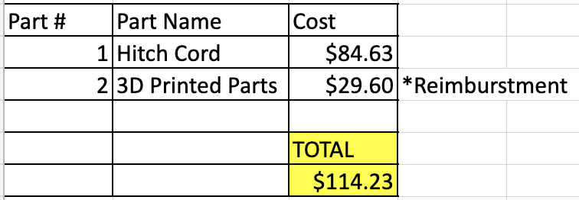

CONCLUSIONS
This document outlines the current state of the 2021 Northrop Grumman NAU Umbilical team design. The design project is to create a new umbilical that is just as successful and efficient as previous models with the added challenge of removing a side force created by the current retraction system of the umbilical. Over the course of the semester several design variants have been created, but the concept that the team felt solved the problem with the most ease was a winch design. The 1st model of the design was created using the SolidWorks package and gave a base for which the design will be created off. This 1st design was very rudimentary, and the team clearly saw which direction the next iterations need to go. There needs to be a better implementation of assembly involved in in the design, along with a larger motor and better motor control that are more reliable, and that can give the team results for testing. The testing procedures outlined that the cable, motor, structure, and thermal resistivity of the design will be experimented on to see where improvement can be made in future designs. Over the course of the next semester, the team will follow a tight schedule to make sure that the final product performs the tasks set to us by the client as well as coming in less than the budget allows.

REFERENCES
[1] | S. E.P., "The use of Inductive Wireless Power and Data Transfer System as Sounding Rocket Umbilical," Delft University , 2011. [Online]. Available: https://oatd.org/oatd/record?record=oai%5C%3Atudelft.nl%5C%3Auuid%5C%3A3321bfbe-f792-4a3d-b341-5ea9a492a1a8. [Accessed September 2021].
​[2] | ​S. Doroudgar, "Static and Dynamic Modeling and Simulation of the Umbilical Cable in a Tethered Unmanned Aerial System," Simon Fraser University , 17 June 2016. [Online]. Available: https://summit.sfu.ca/item/16604. [Accessed September 2021].
​[3] | ​D. C. Han Tao, "Adaptive Impredence Control of a Novel Automated Umbilical System for Propellent Loading," Harbin Institute of Technology , 11 August 2021. [Online]. Available: https://www.mdpi.com/1996-1073/14/16/4900/htm. [Accessed September 2021].
​[4] | ​A. Gosselin, "Technical Paper Session I-A- Automated Ground Umbilical Systems (AGUS) Project," Space Visions Congress , 2007. [Online]. Available: https://commons.erau.edu/cgi/viewcontent.cgi?article=3435&context=space-congress-proceedings. [Accessed September 2021 ].
​[5] | ​E. Boesiger, "41st Aerospace Mechanisms Symposium," NASA, 18 May 2021. [Online]. Available: https://core.ac.uk/reader/42739970#page=359. [Accessed Septmeber 2021].
​[6] | ​G. S. M. Alan C. Littlefield, "Design, Development,and Testing of Umbillical System Mechanisms for the X-33 Advanced Technology Demonstrator," NASA, U.S. Government, Kennedy Space Center, Merrit Island, FL, 1999.
​[7] | ​J. Bemis C. Tatum, "Rolling Beam Umbilical System," NASA, U.S. Government, Kennedy Space Center, Merritt Island, FL.
​[8] | ​G. J. T. P. M. William C. Manley, "Ares I Linear Mate Umbilical Plate and Collet," NASA, U.S. Government, Kennedy Space Center, Merritt Island, FL, 2012.
​[9] | ​B. G. Valentin Guinet, "ARES14BI “Hydra” - a two-stage experimental rocket project within the PRESEUS program," EUCASS Association, 2015.
​[10] | ​R. W. Calvert, "Umbilical Arms for the Saturn V Vehicle," IEEE Transactions on Aerospace, 1963.
​[11] | ​National Aeronautics and Space Administration, "Launch Complex 39, Pads A and B," NASA Facts, p. 8, 2004.
​[12] | ​Blue Origin, "Blue Origin New Shepard," Blue Origin, 2021. [Online]. Available: https://www.blueorigin.com/new-shepard/. [Accessed 8 2021].
​[13] | ​Tokai Spring, "Flat Sprial Springs," Tokai Spring, 2021. [Online]. Available: https://www.tokaibane.com/en/spring-design/flat-spiral-springs-formulas. [Accessed 9 2021].
​[14] | ​J. Tang, "Motor Sizing Basics," Oriental Motor, 17 January 2020. [Online]. Available: https://blog.orientalmotor.com/motor-sizing-basics-part-2-load-inertia?hsCtaTracking=95e3b5c5-570b-4403-9b54-aa346abde034%7C773a672a-9bbb-411d-ae39-0276910ef191. [Accessed 9 2021].
​[15] | ​R. G. Budynas, "Mechanical Engineering Design 11th Edition," McGraw Hill Education, 2020, pp. 681-791.
​[16] | ​R. J. Dalby, "V2 Rocket History," July 2019. [Online]. Available: v2rockethistory.com. [Accessed 9 2021].
​[17] | ​Nitra Pneumatics, "Pneumatic Cylinders," Nitra Pneumatics, 2020. [Online]. Available: https://cdn.automationdirect.com/static/press/nitra_cylinders_intro.pdf. [Accessed 9 2021].
​[18] | ​Conductix Wampfler, "Motor Driven Reels," Conductix Wampfler, 2021. [Online]. Available: https://www.conductix.us/en/products/motor-driven-reels. [Accessed 10 2021].
​[19] | ​NASA, "Artemis," NASA, 2021. [Online]. Available: https://www.nasa.gov/specials/artemis/. [Accessed 10 2021].
​[20] | ​R. Budyas and K. Nisbett, Shigley's Mechanical Engineering Design, vol. Eleven, McGraw Hill Education, 2020.
​[21] | ​D. Christensen, A. Lawrie and D. Zube, "Heroicrelics," Heroicrelics, [Online]. Available: http://heroicrelics.org/info/lut/mobile-launcher.html. [Accessed 14 October 2021].
​[22] | ​Department of Energy, Office of Science, "Science," Department of Energy, [Online]. Available: https://www.science.gov/topicpages/l/launch+umbilical+tower. [Accessed 14 October 2021].
​[23] | ​Z. Wang, D. Lan, T. Wang and B. Zhang, "Design of A Measuring Device and Winch Structure for Detecting the Distance of Two Seabed Pipelines," Marine Science and Engineering, 18 February 2020.
​[24] | ​American Society for Testing and Materials International, Form and Style for ASTM Standards, West Conshohocken, PA: ASTM International.
[25] | B. T. Lee Sin, "Injection Molding and Three-Dimmensional Printing of Poly(Latic Acid)," Science Direct, 2019. [Online]. Available: https://www.sciencedirect.com/topics/engineering/poly-lactic-acid. [Accessed 3 November 2021].
[26] | "High- Temperature Characteristics of Stainless Steel," Nickel Developement Institute , [Online]. Available: https://www.associatedsteel.com/does-heat-affect-steel/. [Accessed 3 Novemebr 2021].
[27] | Wikipedia, "Rocket Engine," Wikipedia, [Online]. Available: https://en.wikipedia.org/wiki/Rocket_engine. [Accessed 3 Novemeber 2021].
[28] | K. Your, "blasting off!," Know Your Meme, [Online]. Available: https://news.knowyourmeme.com/photos/1958576-tonight-on-bottom-gear. [Accessed 3 November 2021].

APPENDICES

Appendix A: FMEA
Table 9: Full FMEA
FMEA
Part # and Functions | Potential Failure Mode | Potential Effect(s) of Failure | Severity (S) | Potential Causes and Mechanisms of Failure | Occurrence (O) | Detection (D) | RPN | Recommended Action
Baseplate - Where all components will connect to and what will be mounted to tower. | Impact Fatigue | Erratic Operation, vibrations | 5 | Assembly errors, poor maintenance | 3 | 2 | 30 | Ensure that proper estimates are made for load
Spool Carrier/Housing - Responsible for supporting axle and spool. | Plastic Deformation | Appearance, possible tangling of cable | 3 | Overloading | 2 | 2 | 12 | Select material with high surface hardness. Maybe investigate a guiding system for the cable
Axle - Motor driven rod that our spool will rotate about. | Yielding | Possible system failure depending on severity of bend | 4 | Overloading | 4 | 1 | 16 | Select material with high resistance to yielding
Motor - Used to convert electric energy to mechanical energy, in this case rotational | Burnout | Lots of heat, bad performance or even failure | 7 | Too little or too much voltage/current, overloading | 5 | 3 | 105 | Properly size motor by calculating possible loads with a reasonable factor of safety.
Gear Box - Will allow us to increase or decrease rotational speed and torque coming from the motor. Ensures stress isn't put directly onto motor. | Contact fatigue, abrasive wear | Noise, lower performance, cracking | 3 | Overloading, improper maintenance | 3 | 8 | 72 | Ensure that proper maintenance is well defined. May need lubrication from oil based on operating temperatures and interference
Mounting Screw - These screws will mount our baseplate to the launch tower. | Failure from lack of locking mechanism, Fatigue | Erratic operation, vibrations | 6 | Overloading | 2 | 4 | 48 | Jack will perform shear analysis for our mounting screws with reasonable factor of safety
Arduino Board - Microcontroller for motor | Electrical failure | System will not operate | 8 | Improper connections, manufacturers error | 4 | 6 | 192 | Jonathan will test Arduino board and programming to ensure everything runs okay. Look into voltage supplies.
Motor Carrier - Responsible for holding motor in place | Release | Erratic Operation, vibrations | 6 | Falty restraining systems, vibrations | 4 | 5 | 120 | Griffin will determine a way to fasten our motor to where little vibration is introduced into the system
L293D Motor Driver - Responsible for controlling the speed and direction of our motor. | Electrical failure | System will not operate | 8 | Improper connections, manufacturers error | 4 | 6 | 192 | Jonathan will test driver to ensure all points are working correctly
Bearings - Will be used to allow shaft to rotate, attached to spool carrier. | Fatigue Wear | Poor performance, erratic operation | 4 | Improper maintenance, Overloading | 2 | 8 | 64 | Ensure that proper maintenance is carried out. Possible lubrication. Ensure that correct loads are used.

Appendix B: CAD Drawings
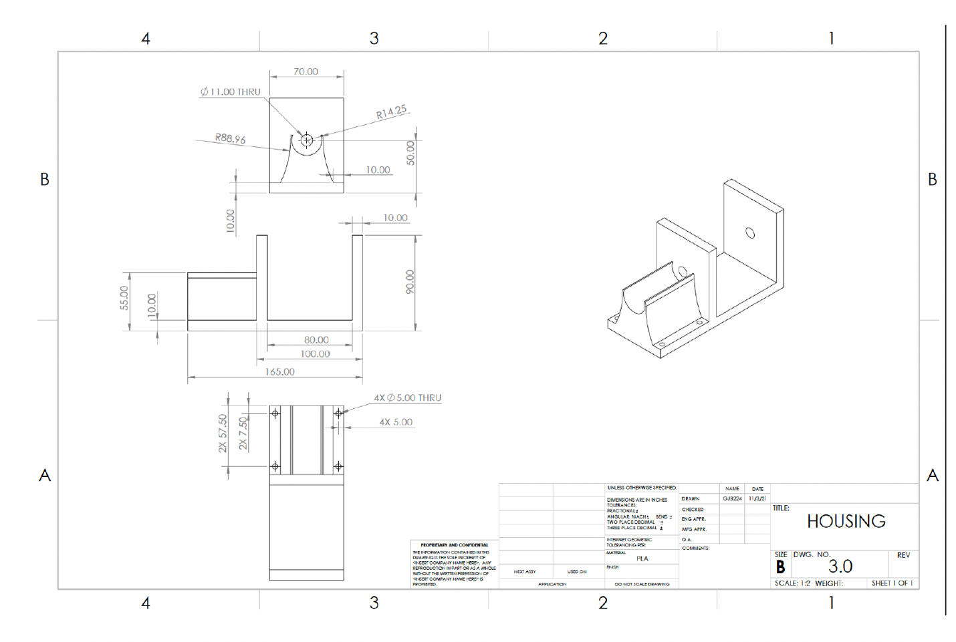
Figure 9: Housing Prototype
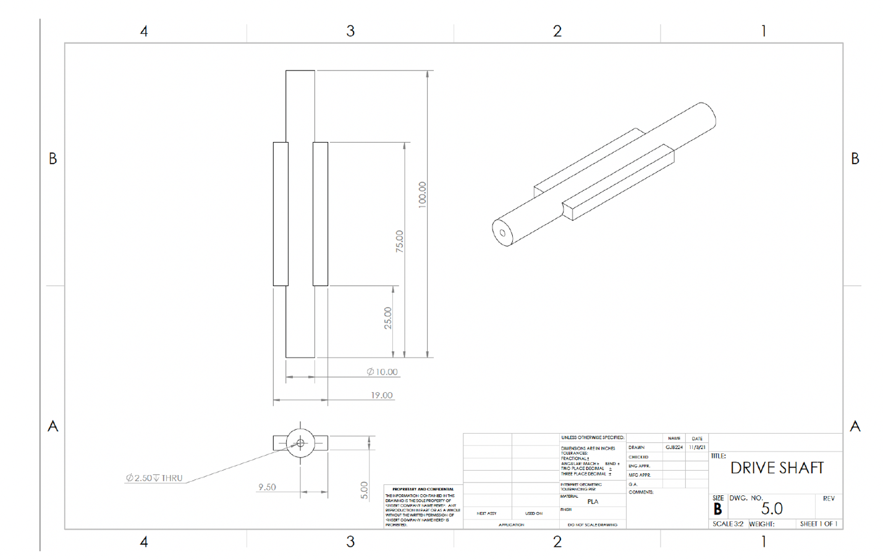
Figure 10: Driving Shaft Prototype

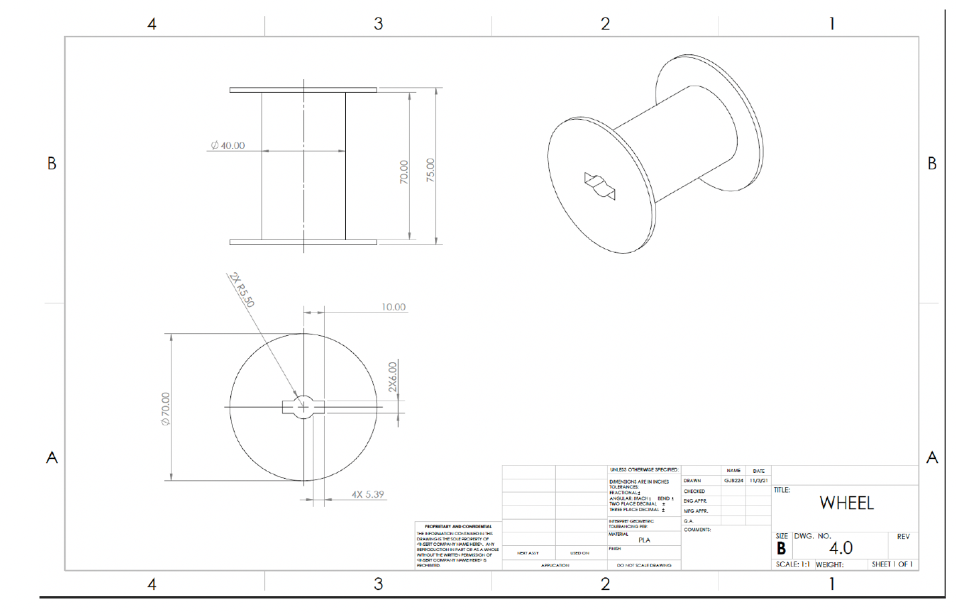
Figure 11: Wheel Prototype

