**To:** Dr. Severinghaus

**From:** Ionic Hearts

**Date:** March 26, 2021

**Subject:** Testing Results Document

**Project Overview**

The purpose of this report is to provide a summation of the tests that were performed by team Ionic Hearts (group 8) on the product that we developed. We have performed 17 unique tests to verify that our product has met all of the requirements that were laid out originally. We performed 8 Unit Test Step-by-Step (UTS) tests, 4 Unit Test Matrix (UTM) tests, and 5 Integration tests. It is also worth noting that we performed 13 Inspection tests but those are not detailed in this report or in the corresponding Workbook.xlsx document. We spent an estimated 8 days performing the tests, with a two day break in the middle to relax on the weekend (not included in the 8 days total), and the majority of the testing time was spent on the integration tests.

The remainder of this report is broken down into the following sections:

a. Introduction to the system

b. System Architecture showing areas that were tested

c. Requirements, status, type of test (Requirements tab on one page, color)

d. Most important requirements

e. Types of tests

f. Major tests

g. Analysis of results

h. Lessons learned

i. Appendix

**System Introduction**

Our client is *W. L. Gore* who are most known for their specialized fluoropolymers which have many applications. By using proprietary technologies with the versatile polymer polytetrafluoroethylene (PTFE), Gore has created numerous products for medical implants; fabric laminates; and cable, filtration, sealant, membrane, venting and fiber technologies for diverse industries. These industries include medical, aerospace, automotive, and others by applying their unique engineering solutions. With more than 3,400 unique inventions and being placed in the *Forbes Top 200 Privately-held US Companies*, *W. L. Gore* has proven themselves to be a prestigious worldwide company. Not only have we been able to work with a world renowned company such as *W. L. Gore* but we have also been in contact with an engineer working for them, who has helped guide us through this project.

*W. L. Gore* has tasked our team with developing a device that is capable of charging an implanted pacemaker battery. Currently, there is not a widely used way to charge implanted medical devices of any kind. This means that whenever the pacemaker battery dies, another surgery has to be done to remove the dead pacemaker and replace it with a new one. The majority of people with a pacemaker tend to be older in age, which means that surgery of any kind has higher risks of infections, slower recovery times, and overall takes more of a toll on the patient. The current lifetime of a pacemaker battery is 8-15 years, which is all relative to the patient and what kind of pacemaker they have implanted. Our device would be capable of safely charging the pacemaker that is implanted in the body, and prevent any additional surgery while extending the battery lifetime.

The method for charging the pacemaker that we decided to use is wireless charging. We did this through the use of resonant inductive coupling, which allows for a more precise and efficient charging over small distances. By operating our device at high frequencies 300kHz - 1.5MHz, we are able to produce a strong enough Electromagnetic field (EMF) that is capable of travelling through the body, while also inducing enough output current to charge a Lithium-ion battery. To prevent overcharging, we implemented a charge cut-off circuit using an Seeeduino XIAO which is capable of cutting off current to the battery once the battery reaches the programmed cutoff voltage. An additional requirement given to us by our client was to implement a wireless transmission device which would be responsible for transmitting data related to the pacemaker battery to some device outside the body. To do this we implemented a small bluetooth module inside the body which is connected to the same Seeeduino XIAO that is inside the body, that sends the battery voltage data to a Raspberry Pi outside the body. This data is then displayed on a simple touch screen display that utilizes a user interface generated by the Raspberry Pi to display the given data.

**System Architecture**

To better visualize the function of our device, a system architecture of our design can be shown below in *Figure 1.* Along with our system architecture, we have also included our main areas of testing that were emphasized during our testing phase.

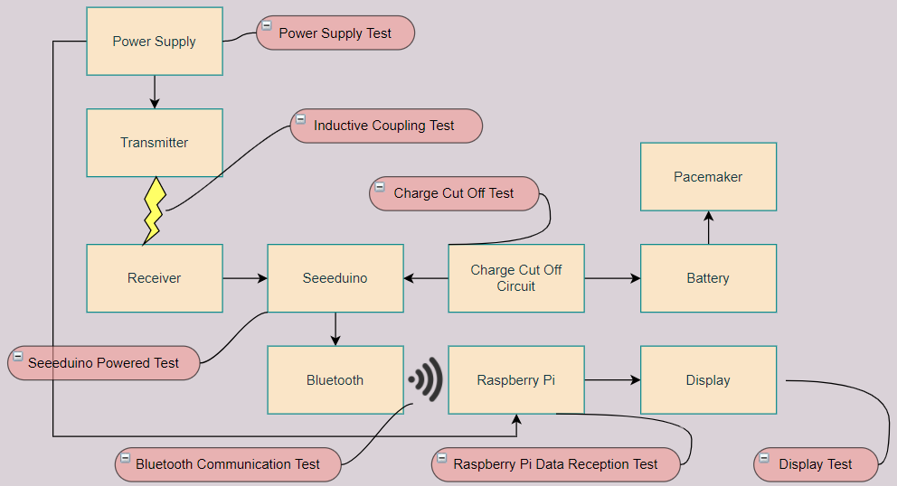  
*Figure 1: System Architecture with Testing Markers*

Our four main subcircuits are the wireless power transfer system (the transmitter and receiver), the charge cutoff circuit (Seeeduino), the wireless transmission (bluetooth module), and the user interface (Raspberry Pi and display). In order for our device to work according to our system requirements given to us by our client, each of the subcircuits must function properly. This means that the wireless power transfer system must produce a big enough EMF, the seeeduino must be powered by the receiver and control the bluetooth module, and the raspberry pi must be able to receive the data from the bluetooth module to then display it using a well organized user interface. The tests that we wrote up and performed make sure that our device will meet the requirements given to us by our client. These tests and main requirements will be highlighted later in the report.

**Requirements, Status, and Types of Tests**

Our Appendix holds the entirety of our test book, including our Requirements, the tests we performed, and whether we succeeded or failed in them. The Requirements section can be found in *Appendix 1a-1b*. The tests we performed and their statuses have been split up into three sections; the matrix-based unit tests (found in *Appendix 2a-2d*), the step-by-step based unit tests (found in *Appendix 3a-3h*), and the integration test (found in *Appendix 4a-4b*).

It is important to note that our requirements consisted of both our client’s requirements and our own requirements that we wanted to make up in order to exceed our client’s expectations. As such, a lot of our tests were performed to meet both types of requirements.

**Most Important Requirements**

Requirement 2.1 (The charging device must be capable of charging the pacemakers standard Lithium Ion battery) was marked as important because the purpose of this product at the end of the day is to prevent the need for a surgery by charging the battery instead of needing to replace it. This is the core problem that this product was designed to solve.

Requirement 2.3.1.2 (Not interfere with the function of the pacemaker) was marked as important because the safety of the patient is the number one concern for this project. An unsafe battery charger that runs the risk of disrupting the pacemaker unit and prompting an emergency surgery will not be considered under any circumstances.

Requirement 3.1 (The internal system needs to be able to process/compute the internal data to be able to transmit it) was marked as important because this requirement was expressly provided to us from our client. It is also a core stepping-stone for other requirements in the wireless communication system.

**Types of Tests**

We utilized UTM, UTS, Integration, and Inspection tests to check if our product met the requirements. Below is a quick explanation of each kind of test, and why they were used for different situations.

UTM - This kind of test focused on systems and results that contained numerical values. These tests were used when the inputs and outputs were numerical measurements and helped to ensure that the results stayed above or below the necessary thresholds.

UTS - This kind of test was used when a system had to be tested through multiple situations. The different situations commonly had to do with the environment and surroundings of the device. Results are indicated with a pass/fail instead of a numerical value.

Integration - Integration tests were necessary to make sure the various subsystems worked together correctly and efficiently. Similar to UTS tests, these tests are marked with a pass/fail system. These tests carry more weight than any of the other tests.

Inspect - The inspection tests are not documented with specific instructions because they were too simple to make a real test of. The inspection tests do not have any impact due to the changes in their environments and only have one thing result warranting a pass or fail.

**Major Tests**

Inductive Coupling Charge Rate through Related Mediums

This test was meant to ensure Requirement 2.1 was met by ensuring that the charge produced by the external apparatus was able to be received by the internal apparatus through the distance and biomaterial between the transmitter and receiver. We tested this using two separate tests:

* One test was used to test out the maximum distance between the two coils.
* One test was used to test out the ability to transmit power through a threshold of biomass.

The first test was conducted by simply taking the receiving coil and slowly moving it away from the transmitting coil until no more charge was being transmitted (as shown by whether or not the Seeeduino XIAO was on).

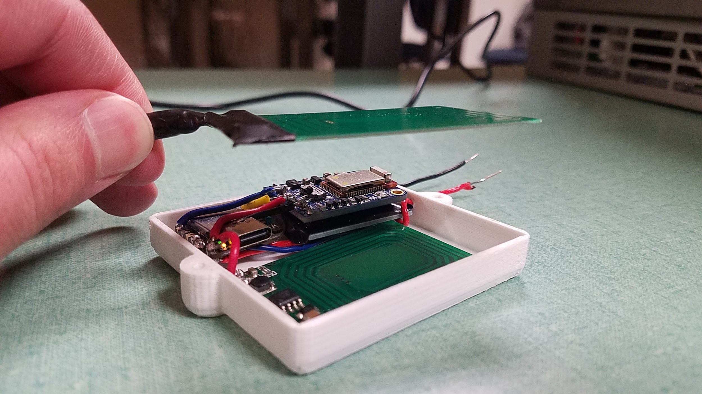

*Figure 2: Distance Between Transmitter and Receiver*

This distance between the two coils is roughly 2.75 cm, which is less than we expected, but (depending on the patient) feasible for our purposes. You can see the light on the Seeeduino turned on, which means that the receiving circuit has been activated (allowing current to flow to the battery).

The second test was conducted by having our hands in between the coils as charge was transmitted. We believe this was a viable way of testing this requirement because of the size of our hands and how that resembles the size of fat and muscle between the transmitter and receiver.

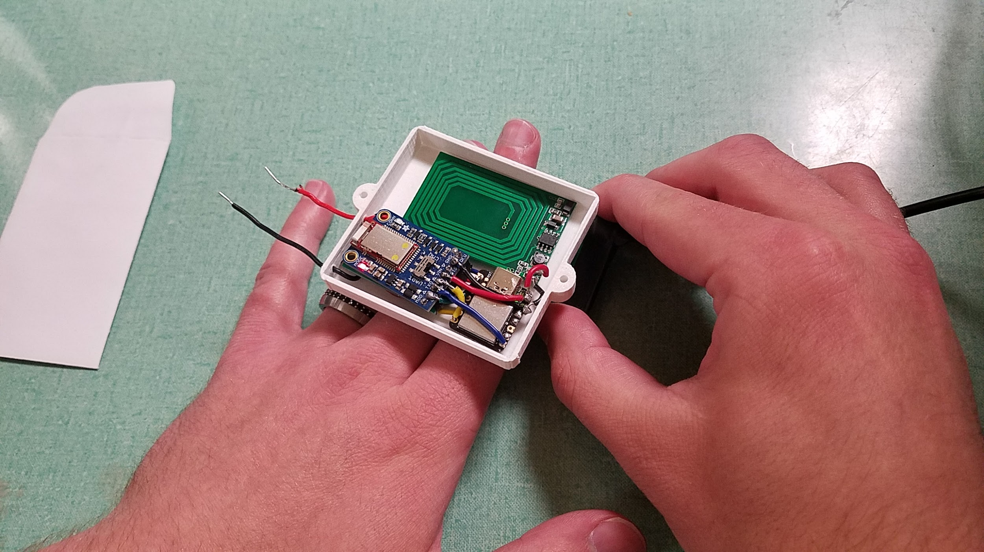

*Figure 3: Power Transmission with a Hand In-Between the Coils*

Although it is hard to see, there is an LED turned on in the Bluetooth component (blue chip, bottom-left corner of it) that indicates that the circuit has turned on. The transmission coil is beneath the hand, and the receiving coil is above the hand. Thus, power is able to be transferred through biomaterial that resembles a patient’s chest.

Safety

In general, we needed to make sure that our product is perfectly safe, given the fact that it would be inserted into an actual patient. This encompasses all of the requirements and sub-requirements under Requirement 2.3 and Requirement 5. Requirement 5, however, is not something that can necessarily be tested; rather, the components of our product will be inspected and ensured that they are not toxic to the body and biocompatible with the patient. Requirement 2.3 (and its sub-requirements), however, can be tested. The following requirements were tested in the following manner:

* Requirement 2.3.1: We first researched what frequencies were viable for our product. We concluded that any frequency under750 kHz is acceptable. Then we set the transmission board to each frequency to ensure that the board would be able to produce those frequencies at a stable and steady rate. We used an oscilloscope to verify the board’s production.

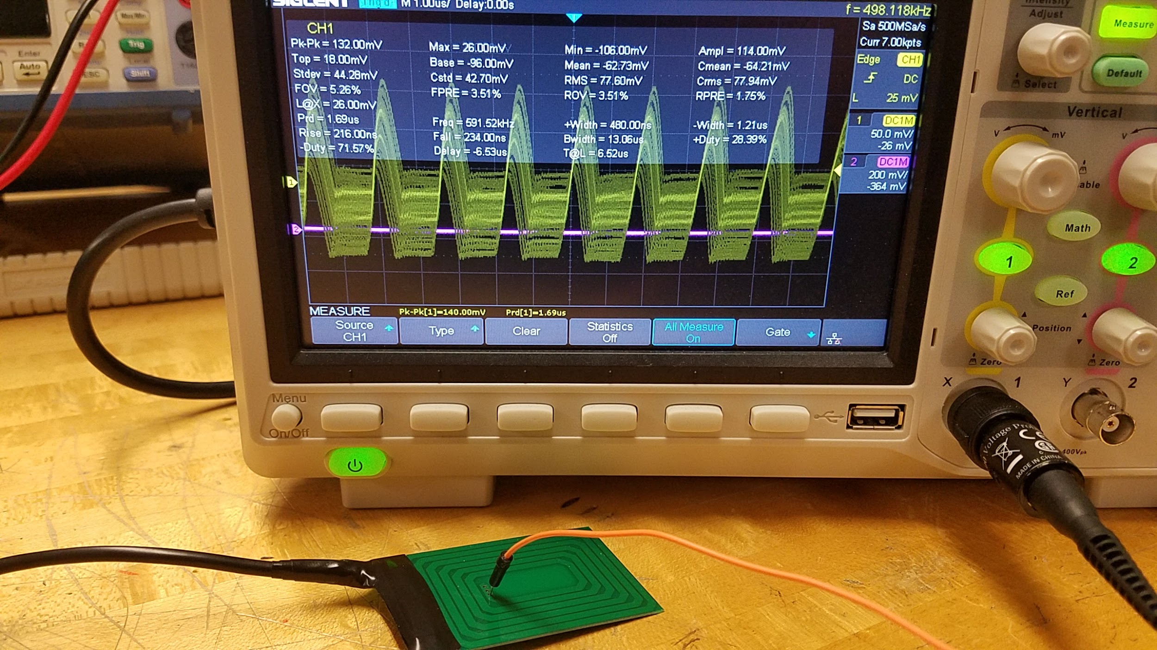

*Figure 4: Oscilloscope Reading of the Transmitting Coil*

According to the Oscilloscope, the coil is transmitting (on average) 591.52 kHz, which is well below the maximum frequency we can produce. This concludes the frequency safety test.

* Requirement 2.3.1.1: This requirement was tested in our integration test, mainly through the interaction test between the Charge Cut-Off subsystem and the Charge Transmission subsystem. Because of the nature of this requirement, we were unable to provide a picture of the successful test; the fact that the whole integration test was successful was enough to meet this requirement.
* Requirement 2.3.1.2: We were unable to verify whether or not our system would interact with the pacemaker specifically. But we were able to successfully verify that our Charge Transmission subsystem would not interact with the rest of our system, and we feel that is sufficient verification to meet the requirement.

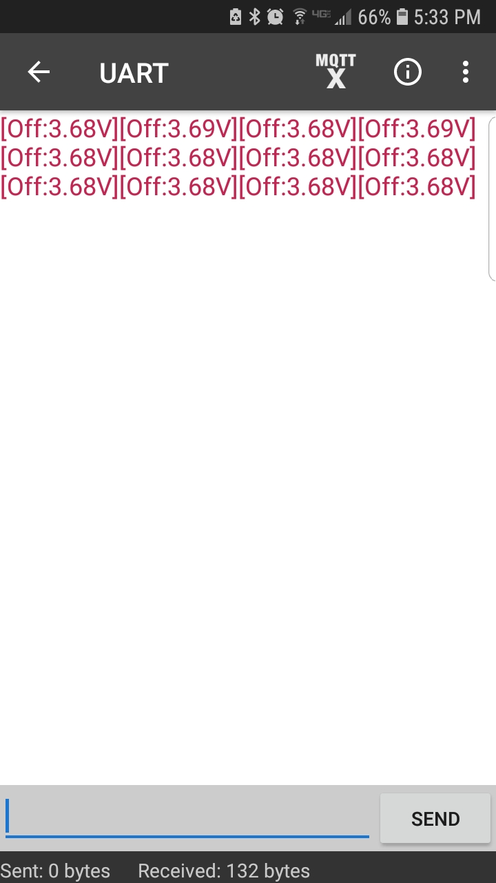

*Figure 5: Recording of Bluetooth Information while Power is Transmitted*

Given our design, the transmitter coil will be mere centimeters away from the receiver coil, and the receiver coil is right next to the cut-off circuit and the Bluetooth subsystem, so these components are all right beside each other. Knowing this, recording the data received by the Seeeduino and seeing it through the Bluetooth subsystem (via an app we found) shows that the electromagnetic field produced by the coils is not enough to have negative effects on the rest of the product.

* Requirement 2.3.2: This requirement was easily tested by pointing an Infrared Thermometer onto the coils of the Charge Transmission subsystem while they were activated.

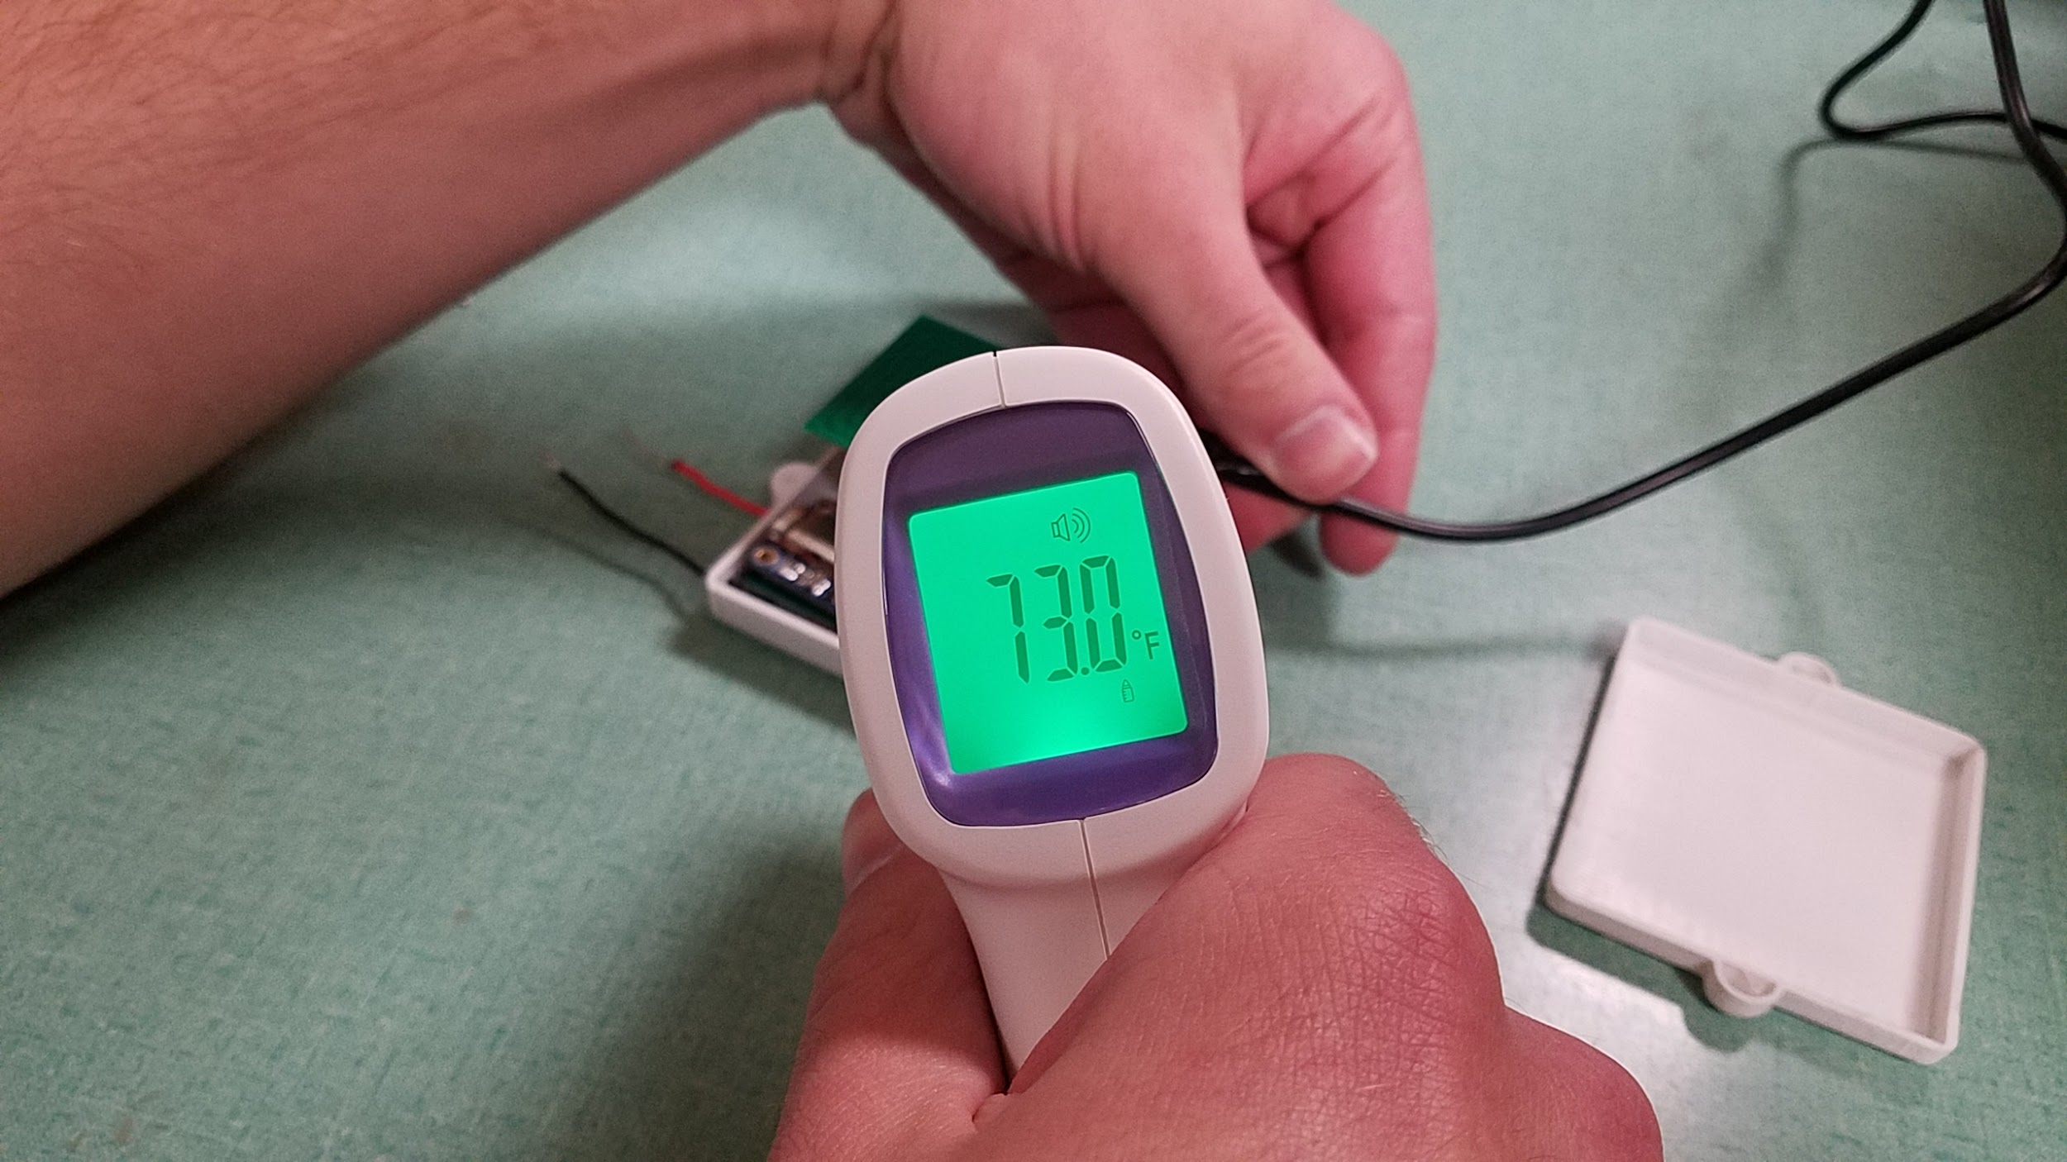

*Figure 6: Temperature Recording of Entire Internal Subsystem*

As previously stated, we used an Infrared Thermometer to determine the temperature of the subsystem that will end up inside the patient. *Figure 6* shows that the system’s temperature is 73.0°F (the temperature can vary, but definitely not above 75°F), which is well below the average body temperature. This means that there is no chance that our system’s temperature will rise to a dangerous level for the patient.

Integration Test

Our only Integration Test was composed of multiple “mini-tests” that we performed as worked on this project. Because our product has four subsystems, we needed to test the functionality of them working together before we solidified our integration. The best way to do this was to test each subsystem working together in pairs, cycling through every possible combination until we were satisfied with the results. Afterwards, we tested interactions between three subsystems (again, cycling through every combination), until finally testing every subsystem combined as our final product. The concept can be shown below in *Figure 7* (red arrows indicate testing, connected borders indicate two or more subsystems already connected).

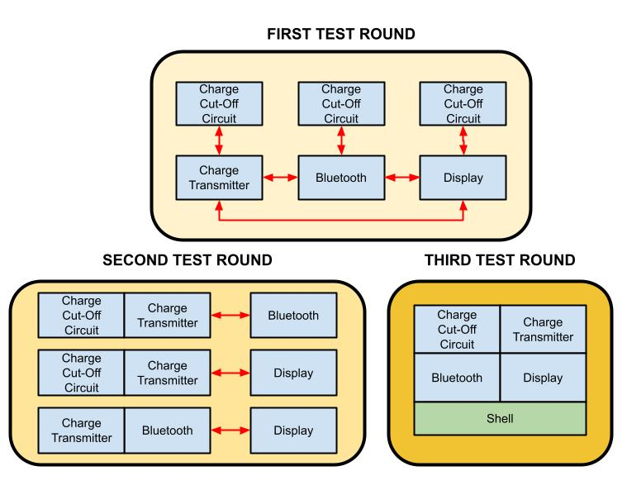

*Figure 7: Outline of Integration Testing*

As said previously, the testing was performed and recorded throughout the entire building stage of the project. It was much easier for us to pair and correct our subsystems as we modified them, rather than wait until the very end of the project to rush through these testings. The end goal of this test was to see that the entire system worked with every component, at which most (if not all) of our requirements are satisfied.

Given the fact that the previous tests had worked, it is clear that integrating the Charge Cut-Off circuit, the Charge Transmitter, and the Bluetooth subsystems together would be successful, and that is exactly what we saw. The only problem we have dealt with overall was connecting the Display subsystem to the rest of the components. We tried using a display that utilized a Raspberry Pi microprocessor, at which point the programming behind it was too complex and inevitably incompatible with the rest of our design. By the time we realized that, however, we were too late in updating the final product.

**Analysis of Results**

Most tests were successful, and we were able to fully develop a working product. The only test results that did not go as expected were any tests that involved the Raspberry Pi Display. The display almost works, in that it can display the voltage readings of the battery. However, we wanted to exceed this expectation and present the battery charge in a graph, and we were unable to do so. If we had more time, we firmly believe that we would be able to accomplish this goal.

Other than that minor setback, our product was completely successful. Every component successfully interacted with each other, and in a way that met all requirements (both our own and our client’s requirements), as well as in a way that was safe for the patient. The following is our client’s biggest requirements, and how we fulfilled each of them.

* *They needed a device that could charge a pacemaker battery while still inside the patient’s body*. Our product is able to charge the battery given that it needs to be charged.
* *The device needed to be safe for inserting into a patient*. With the internal apparatus’s shell, our device can be implanted into a patient with no components being exposed to their body.
* T*he device needed to show the current state of the battery*. Our product is able to read the battery’s voltage and transmit this data via Bluetooth. Although we wanted to transmit this data in a graphical form, this was not a requirement made by the client.
* *The device cannot overcharge the battery*. Our Charge Cut-Off subsystem is able to read the battery’s voltage and prevent current from flowing into the battery once it reaches a high enough voltage level.

Because we were able to meet all of those requirements, we can proudly say that our system is a successful product for our client.

**Lessons Learned**

Throughout the project there were varying degrees of success. Due to the complexity of our modules and overall project, the various successes came with challenges. Certain successes were earned as we were required to work around different hardware and software glitches. These challenges led to valuable lessons that will, in the end, help us become better engineers. of the lessons learned the most prominent were that of preplanning, and reacting to various situations. While building the modules, each of us learned our own lessons, which were shared with the group. Some lessons include having back up devices when our testing becomes too tedious for the device. Other tests led to problems involving compatibility with software. This granted insight to future prospects that affected how we proceeded. In a sense we learned from our previous mistakes, and applied the lesson of preparing multiple devices in case one were to fail so we would not fall behind. On a more minute scale the program that controlled our display had bugs, so we fixed-tested this by creating many versions of the code, before combining into our final program. Additionally while we were carrying out the project running into rough areas, forced us to focus more on some requirements that we deemed essential to our final product. These requirements like making the product biocompatible, became difficult to test and plan for as we physically and legally could not test this. so we had to find ways around this. Ultimately the overall testing of the product was successful, with minor inconveniences, that allowed for our better understanding of a general large scale project.

**Appendices**

Appendix 1 - Requirements

This appendix consists of all of our requirements used to develop and test our product.

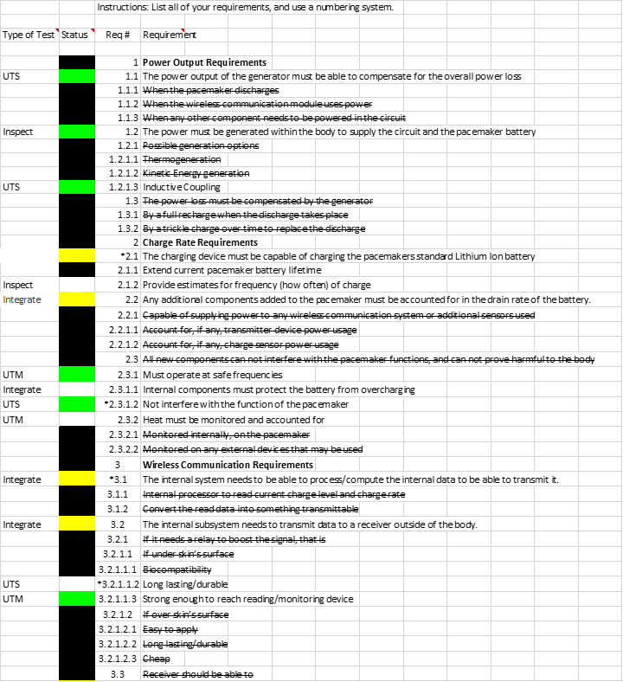

*Appendix 1a: Requirements*



*Appendix 1b: Requirements*

Appendix 2 - Unit Test (Matrix)

This appendix contains all of our tests that were performed to ensure our subsystems worked in each and every environment.

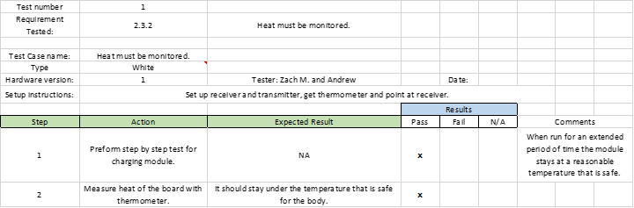

*Appendix 2a: UTM Test #1*

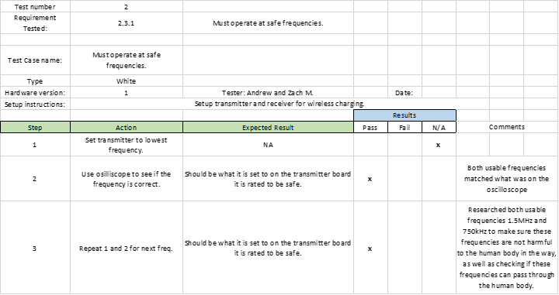

*Appendix 2b: UTM Test #2*

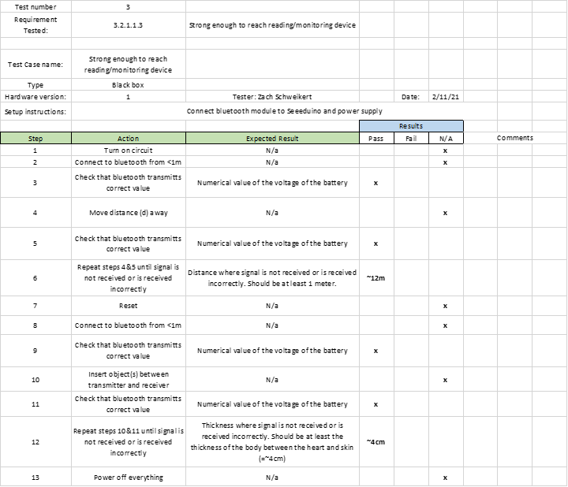

*Appendix 2c: UTM Test #3*

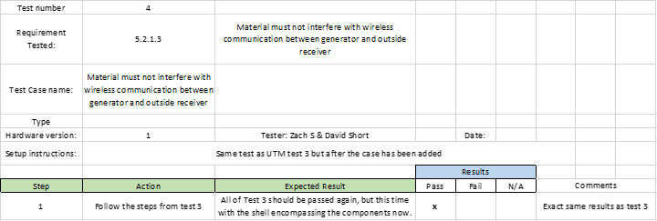

*Appendix 2d: UTM Test #4*

Appendix 3 - Unit Test (Step-by-Step)

Like *Appendix 2*, this appendix goes through testing multiple components of our product, but this time going through much larger tests at a step-by-step basis.

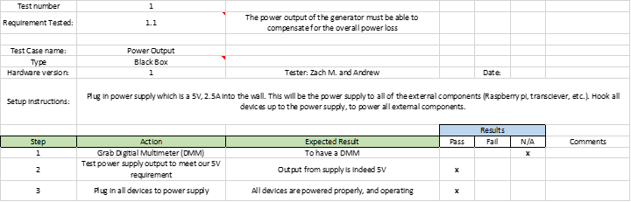

*Appendix 3a: UTS Test #1*

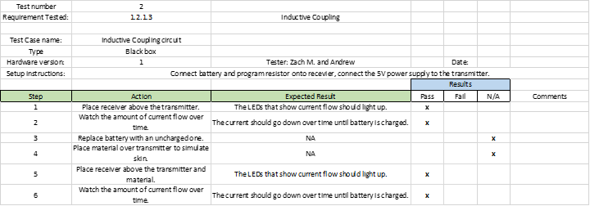

*Appendix 3b: UTS Test #2*

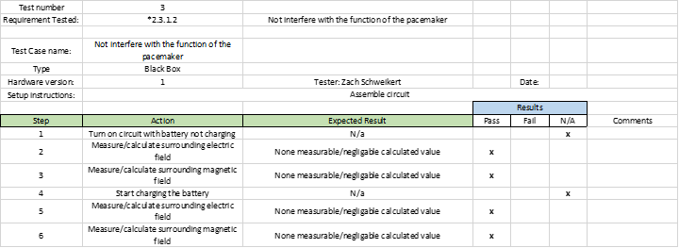

*Appendix 3c: UTS Test #3*

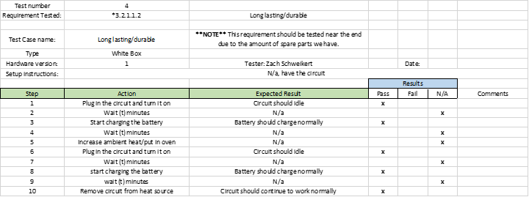

*Appendix 3d: UTS Test #4*

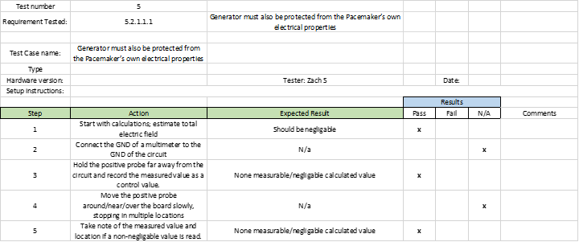

*Appendix 3e: UTS Test #5*

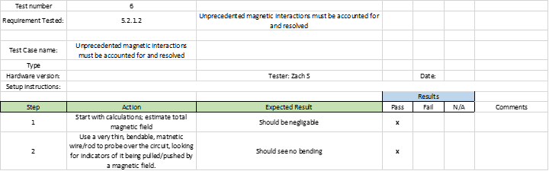

*Appendix 3f: UTS Test #6*

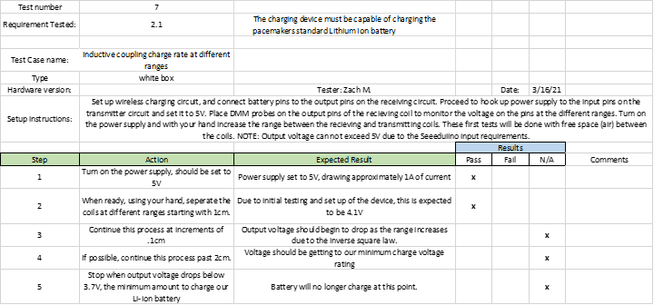

*Appendix 3g: UTS Test #7*

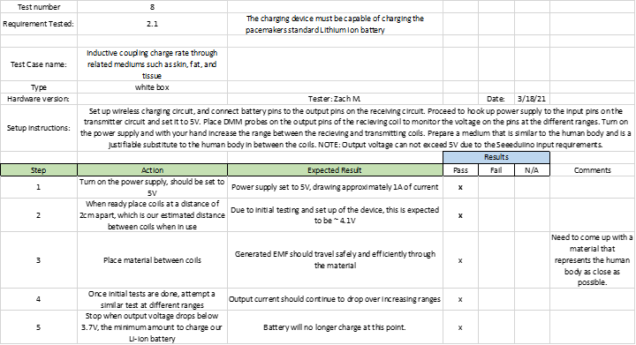

*Appendix 3h: UTS Test #8*

Appendix 4 - Integration Test

Though this is one very large test, it consists of several “mini-tests” that have all been combined because they all share the same singular goal: to ensure that all of our subsystems can be integrated into our final product.

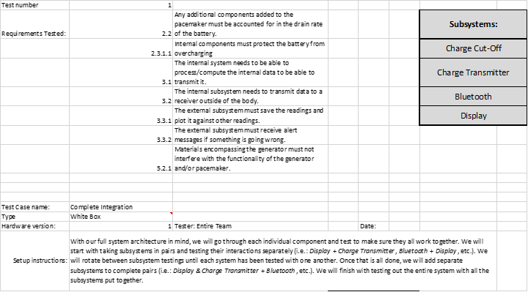

*Appendix 4a: Integration Test*

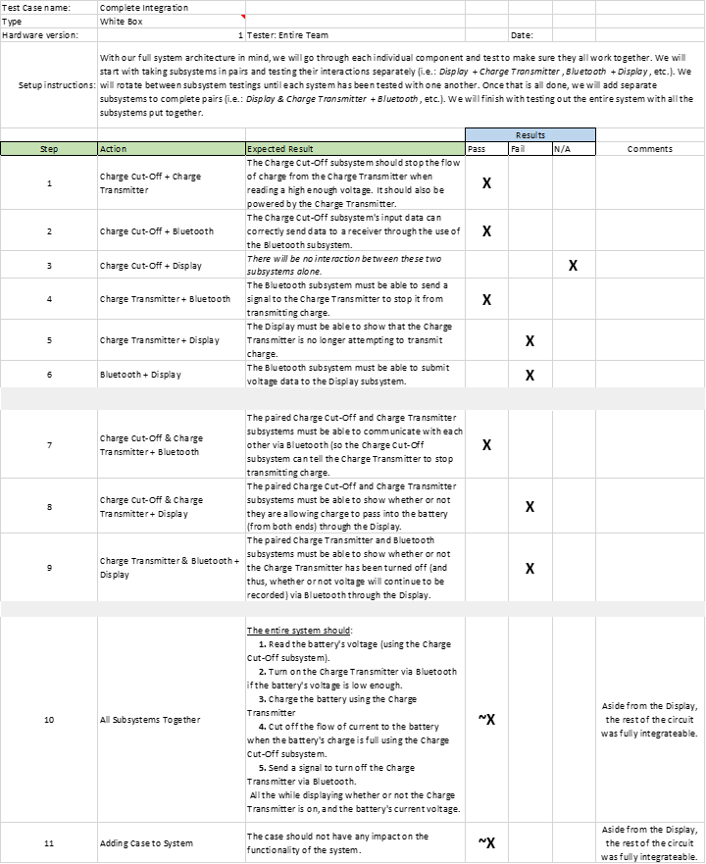

*Appendix 4b: Integration Test*