

Ionic Hearts

**Assignment:** Project Report

**Date:** April 16, 2021

**Team Members:**

* Ethan Ankley - [eta38@nau.edu](mailto:eta38@nau.edu)
* Andrew Kendall - [ajk372@nau.edu](mailto:ajk372@nau.edu)
* Zachary Mungillo - [zam49@nau.edu](mailto:zam49@nau.edu)
* Zachary Schweikert - [zjs57@nau.edu](mailto:zjs57@nau.edu)
* David Short - [das477@nau.edu](mailto:das477@nau.edu)

**Table of Contents**

1. Introduction.……………………………………………………………………………………….3
2. Design Process.……………………………………………………………………………………5
3. Final Design.……………………………………………………………………………………....7
4. Results.…………………………………………………………………………………………….9
5. Conclusion of Capstone Report.………………………………………………………………....13
6. User Manual
   1. Introduction.……………………………………………………………………………...16
   2. Installation and Use……………………………………………………………….……...18
   3. Configuration and Use…………………………………………………………………...18
   4. Maintenance……………………………………………………………………………...20
   5. Troubleshooting Operation………………………………………………………………20
   6. Conclusion.…………………………………………………....……………..……..…....21
7. Appendices……………………………………………………………………………….………22

**Introduction**

W. L. Gore & Associates is a multinational material-science company that has a hand in multiple different industries, one of which being the medical industry. They were founded in 1958, and their offices can be found in the United States, the United Kingdom, Germany, Spain, France, Italy, Brazil, Japan, Korea, and China. Although their biggest projects revolve around material engineering, they have many interests in projects that are not based on material science. In short, Gore favors material-science, but they have planted their roots in manufacturing a multitude of products found in several different fields and industries.

Being a company that provides a lot of products to the medical field, W. L. Gore & Associates gave us the task for our capstone project to charge a pacemaker battery. For clarification, the pacemaker is a revolutionary device implanted in a patient’s chest to prevent their heart from beating out of rhythm. This condition is usually caused by arrhythmia, a cardiovascular disease, atrial fibrillation, and atrial flutter. But there are many more heart conditions that could be the source of an abnormal heartbeat.

The way the pacemaker works is that it continuously monitors the patient’s heart in order to detect when the heart begins to beat out of order. If the patient’s heart beats incorrectly, the pacemaker sends a small pulse of electricity to “jolt” the heart back into rhythm. The pacemaker can shock the heart anywhere from once a week to once every few months, and can survive in a patient’s body anywhere from seven to fifteen years. Usually the heart condition never goes away, and the patient is forced to rely on a pacemaker for the rest of their lives.

The problem with the pacemaker is that, although it has a very long lifespan, that lifespan is not ideal for the patient. Pacemakers are implanted into the patient’s chest via heart surgery, which is a very invasive and sometimes dangerous procedure. Now, if a patient needs a pacemaker, then of course they will have to undergo the procedure at least once in their lifetime. The issue arises when they outlive the pacemaker battery, and they need a new battery. To get the new battery, they will need to undergo the surgery again which, given the fact that they already have a weakened heart due to their conditions, could be life threatening. And the younger the patient, the more they will need to swap out the battery over their lifetime. Someone who needed the pacemaker as a young adult (for example, early 20’s) may need to undergo over seven or more surgeries in total, and the older they get, the harder the surgery will be on their health.

Because of this problem, Gore has asked us to create a device that will charge the pacemaker’s battery while it is *still inside* the patient. They gave us free reign with this project, meaning we could use whatever method we wanted to charge up the battery. They only had a handful of criteria that we had to follow:

* The power output of our device must provide a safe and steady charge that can effectively reach the battery.
* The charge rate must be slow enough so as to not harm the battery.
* Our device must stop charging the battery when it is full so it cannot overcharge the pacemaker battery.
* The device must be safe enough to work inside the patient. This broad term can be summarized as such:
  + It must be biocompatible with the patient, meaning that it cannot leak harmful substances into the patient’s body.
  + It must be small enough so as to not interfere with vital bodily functions.
  + The frequency of the charge rate must be in a safe range for the body.

On top of all of these requirements, our client has asked us to add a feature to our device to allow wireless communication between our device and the outside world. They want this feature in our device in order to monitor the status of the pacemaker battery, ensuring it is being charged when necessary and discharging at a reasonable rate.

As stated, W. L. Gore & Associates wants this product because they have a large influence in the medical field and would like to reduce the amount of surgeries needed for someone with a heart condition that relies on the pacemaker. They tasked us with this goal for our capstone project, and we were given one school year and a total of $2,000 dollars ($500 from Northern Arizona University and $1,500 from Gore) to solve this problem and give them the product they were looking for.

**Design Process**

We started our project with researching what has already been developed, what were hurdles that other people had to overcome, what are the criteria we were given based off of, and (most importantly) what are different methods of charging a battery. After conceptual research we moved onto researching different products that we could purchase and use in our designs. It was very easy for us to map out the multiple components of our final product. The biggest challenge was deciding what the best method of charging the battery was. We originally had three ideas:

* Using kinetic energy to charge the battery.
* Using thermal energy to charge the battery.
* Using wireless power transmission to charge the battery.

Keeping these concepts in mind, while also acknowledging the other subsystems needed for our   
product to work, we developed a basic System Architecture (see *Figure 1*) with an undecided method of transferring power into the patient’s body. Aside from the charging subsystem, the major components we planned for were the Cut-Off Circuit (to protect the battery from overcharge), the Charge Sensors (to read the battery to prepare to protect it), and the External CPU (to orchestrate the process of wireless transmission, charge transmission, and charge cutoff).

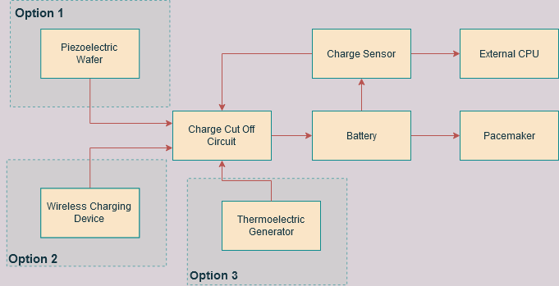

*Figure 1: Basic System Architecture with Undecided Power Source*

As we tested out the power charging methods, we came to the conclusion that the wireless charging method was the most feasible method. The piezoelectric film yielded too little electricity, and we had no reliable method of harnessing the thermal energy from the body either. Wireless charging provided the closest voltage and current rates required to charge the battery, which made it the ideal method.

After deciding the charging method, everything else went rather smoothly. We found a viable CPU used to control the cutoff circuit, a bluetooth chip for the CPU to transmit the data (using the code found in *Appendix A*), and a set of wireless inductive couplers that can be paired together to transmit enough charge to both charge the battery and the CPU. In a short amount of time we created every subsystem prototype and tested along the way. The greatest hurdle was integrating the subsystems. We wanted to perfect all the subsystems before doing so, at which this slowed down our production of the full prototype. Thanks to this method however, our prototype passed almost every test when fully integrated, so it required very little change to become the final product. The fully-integrated prototype, looking exactly like the final design, can be found in *Appendix B*. Here, a white plastic shell is coating the design (to seal it off from the rest of the patient’s body). To get an in-depth look at the innards of our design, you can look at *Appendix C*, where we are testing one of the requirements (the minimum distance required for charging through a patient’s body) for our prototype.

Testing our prototype went well, though we had some minor setbacks. We had to prepare multiple shells and maneuver the induction coils in order to fit it all together, as well as we had to replace some parts due to inefficiency or malfunctions. Although our prototype successfully accomplishes the goal, we still ended with issues in size, displaying the collected data, and we were unable to perfectly test whether or not it would work inside a patient. Testing inside a patient is much greater than our capabilities, so we have to accept that our test results and findings are sufficient for a working product.

**Final Design**

Following our exploration of modern devices that could be applied to our project, we decided on an inductive coupling charger. Taking into account our requirements, specifications, and desires for the outcome of the project, we created a basic system architecture (see *Figure 2* ). From our specification we determined the final product will require three different circuits. The first circuit involves our power supply and the transmitter of the inductive coil. Our second circuit consists of the receiver coil, a seeeduino module, a bluetooth module, and a charge cutoff module. The final circuit of our project is the display module, which makes use of the power supply previously mentioned, a raspberry pi and a compatible touch display screen.

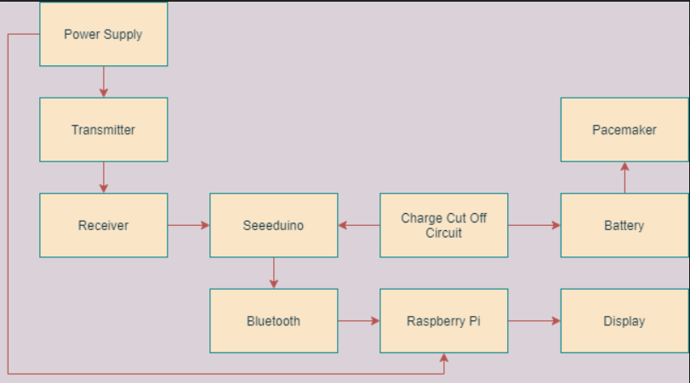

*Figure 2: Final Design System Architecture*

The first circuit uses a nine volts power supply that can power our charger and raspberry pi simultaneously. attached to the power supply in our first circuit is the transmitter module for the inductive couple. Originally our team's intention was to fabricate and manufacture a custom PCB, however we determined that due to our size constraints we needed to find a commercially available device. Due to this we found a device that allows us to keep the profile of our device smaller than our designed pcb would be, in addition to keeping the functionality of the inductor highly effective.

The second circuit mentioned includes our charge receiver which powers the other parts of this submodule. The receiver leads to the seeeduino, which relays information to the bluetooth module and the cut off circuit. The seeeduino acts as a microcontroller processing the information of charge and sends the necessary information. This allows the device to be capable of talking to the circuit outside the patient's body. In addition to communicating, the seeeduino provides data supplied to the cut off charge that makes the cut off circuit function at its base level. when the seeeduino passes a charge that the cut off sees as the predetermined threshold it returns info to the seeeduino alerting it to stop taking in charge (see *Figure 3*) From this point the seeeduino tells the receiver to shut off, while passing the charge level to the bluetooth. This module bridges the gap between the display and the charge receiving module. The function of the bluetooth sends a hexadecimal code value to the raspberry pi.

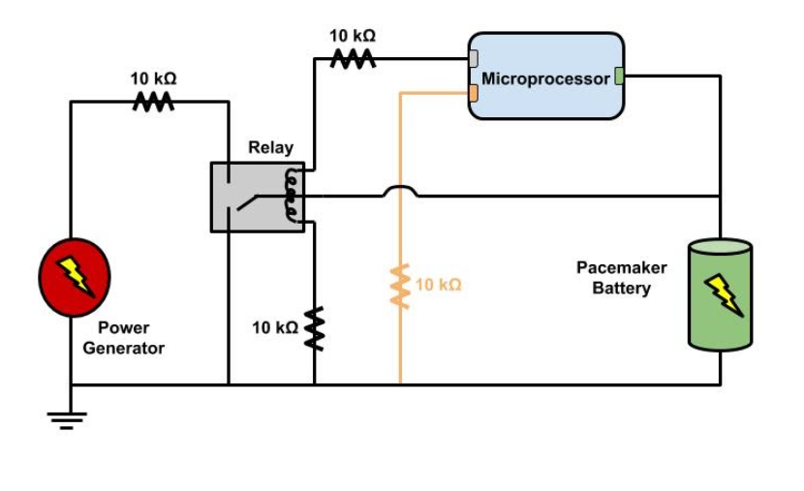

*Figure 3: Cut-Off Circuit Schematic*

The final circuit of our project follows the bluetooth module passing the charge level to the raspberry pi. The pi uses a bit file to connect to the bluetooth device, read that data and then store the battery level to a text document. This text document is then read by a software that plots the battery level over time, so there is a visual representation of the data and charge being supplied. This information is displayed on the seven inch touch display where said graph can be viewed (see *Appendix D*). All of the display module is powered by the initial power supply from the first circuit. Combining all three circuits creates our final design which is divided into parts that are intended to be implanted or not, communicate with each other by bluetooth or internal devices.

**Results**

In order to ensure that our device worked according to the requirements given, we conducted a series of tests on each requirement that could be tested. Shown below in *Figure 4* and *Figure 5,* the tests along with their results are shown. All the tests that were done, were done to show that all the requirements were met. Under the status column you will see a few different colors in which green means it was fully tested and confirmed, yellow indicates that it was tested but did not fully meet the requirements, and red indicates that this requirement failed in testing, or could not be tested. Along with this you will also notice a white box which indicates that the components were documented and understood, and a black box which means that this part and components were unknown.

  
*Figure 4: Testing Results Spreadsheet #1*



*Figure 5: Testing Results Spreadsheet 2*

We had a few tests that we considered to be most important to pass in order for our device to be able to say it properly functioned efficiently, safely, and to our given requirements.

The first of these tests was the inductive coupling wireless charging tests. Our tests focused on two different things with one being the operating ranges of wireless charging, and the second one being the ability to charge through different relative mediums. The first test, seen in *Appendix C*, was done over free space and was able to reach up to ranges of 2.75cm. Which given the distance between the surface of your skin and the heart would be sufficient in most patients. The next test was done with the relative mediums, seen in *Appendix E,* which was done through the casing and the hand of the tester. It was still enough to power the seeeduino implanted in the body, even through those mediums.

The second of what we consider the most important tests were the various safety tests. These tests encompassed operating frequencies and temperature to make sure that whatever we are implanting is safe to both the body and to the pacemaker. The operating frequency was tested at 590kHz which is considered safe to the human body, and this can be seen in *Appendix F*. The next test was measuring the temperature of the coils to make sure that they are not reaching temperatures that could potentially burn the patient. When performing the test, seen in *Appendix G*, we measured the temperature to be approximately 73℉ which passed the test.

The next important test was the data transmission tests, which revolved around the bluetooth module which was implanted into the body. This is considered important because it was an explicit request from our client to have some sort of system that can send data related to the battery to some outside source. Our bluetooth module was connected to the Seeeduino inside the body and would be powered on anytime the receiving coil was getting power. Since we have already done tests on powering the Seeeduino via wireless charging, we wanted to make sure that the bluetooth module was transmitting the correct information regarding the battery voltage. To do this we connected our phone to the module which then sent the battery voltage data as it was charging to the phone, this can be seen in *Appendix H*.

Lastly, we wanted our subsystems to all work together which is why the integration test is considered most important. Each of our subsystems tested really well individually, and were capable of accomplishing their designated tasks. The only issues that we had came from the integration tests. Getting the internal bluetooth module to work with the Raspberry Pi and its display proved to be challenging given the remaining time that we had. We had used the code provided in *Appendix I* to connect the internal apparatus’s Bluetooth with the external display, but we had troubles correctly organizing the data (the display still received said data). Though we would have liked to get the display working, we had another form of display via an app on the phone that connects to the bluetooth module. It is slightly less formal, and was used more for testing than actually being a part of our final design, but it demonstrated the functionality of our device during the integration tests.

Other than those two minor setbacks, our product was completely successful. Every component successfully interacted with each other, and in a way that met all requirements (both our own and our client’s requirements), as well as in a way that was safe for the patient. The following is our client’s biggest requirements, and how we fulfilled each of them.

* *They needed a device that could charge a pacemaker battery while still inside the patient’s body*. Our product is able to charge the battery given that it needs to be charged.
* *The device needed to be safe for inserting into a patient*. With the internal apparatus’s shell, our device can be implanted into a patient with no components being exposed to their body.
* T*he device needed to show the current state of the battery*. Our product is able to read the battery’s voltage and transmit this data via Bluetooth. Although we wanted to transmit this data in a graphical form, this was not a requirement made by the client.
* *The device cannot overcharge the battery*. Our Charge Cut-Off subsystem is able to read the battery’s voltage and prevent current from flowing into the battery once it reaches a high enough voltage level.

Because we were able to meet all of those requirements, we can proudly say that our system is a successful product for our client.

**Conclusion of Capstone Report**

Out of all the requirements that were tested, we labeled three of them as the most important requirements. We felt that for our device to best function efficiently and safely, these requirements must be met above all others. Not only do these requirements ensure the device works safely, but also that it meets the vision that we as a team, and our client, had for what we wanted our final design to look and operate like. These three requirements, along with their testing results, will be discussed below.

Requirement 2.1 (The charging device must be capable of charging the pacemakers standard Lithium Ion battery) was marked as important because the purpose of this product at the end of the day is to prevent the need for a surgery by charging the battery instead of needing to replace it. This is the core problem that this product was designed to solve. Our wireless charging device used to charge the Li-ion battery was marked with a yellow box. This is due to the fact that it was capable of charging the battery, but the efficiency of charge was lacking as we increased the range between coils. During the tests we would increase the range between coils, as well as place different mediums in between the coils and measure the output current. Once the coils reached a distance greater than 2cm, there was no longer enough output current to charge the battery.

Requirement 2.3.1.2 (Not interfere with the function of the pacemaker) was marked as important because the safety of the patient is the number one concern for this project. An unsafe battery charger that runs the risk of disrupting the pacemaker unit and prompting an emergency surgery will not be considered under any circumstances. This requirement was a little harder to test because we did not have access to an actual pacemaker, as well as the fact that there are a lot of variables that can play into affecting the function of a pacemaker. Our main concern with the wireless charging was the frequency at which it was operating at, and the heat coming from the coils that will be outside and inside the body. We measured the operating frequency of our device to be around 590kHz, which is considered to be a safe frequency to the human body, and by using a ferrite shield is safe to the pacemaker. When testing the implanted coil for excess heat that could damage the pacemaker, we left it running on maximum operating settings and then measured the temperature to be around 73℉ which is not harmful to the pacemaker titanium casing.

Requirement 3.1 (The internal system needs to be able to process/compute the internal data to be able to transmit it) was marked as important because this requirement was expressly provided to us from our client. It is also a core stepping-stone for other requirements in the wireless communication system. This test was marked with a yellow box which is mostly due to its performance in the integration tests, as it did find during the step-by-step tests.. We used a seeeduino microcontroller to read the voltage of the battery to know when to cut off charge to the battery, as well as send data via bluetooth to the external Raspberry Pi. It functioned well with the charge cut off circuit, but was not able to fully function with the Raspberry Pi display.

These requirements all have a couple things in common, the basic parts of each were all introduced in the beginning of the project even though some were optional, like the bluetooth communication of the device. The rest of the more non-essential requirements were made up more from the fact that we had to generate our own list and create a sort of guideline for ourselves for our final design. These requirements testing well was vital to the final product and its functionality to meet our clients initial specifications. The fact that we were able to expand on these requirements shows the creativity and thoughtfulness that was needed to draw some guiding lines for the project. This leads into the lessons and the knowledge that was obtained from creating everything from the initial requirements sheet to the final design.

This project let us use our engineering skills that we have learned over the course of our careers at Northern Arizona University. Applying these skills to a real life scenario helped show what we needed to work on to be successful in a job later on in life. Some of the lessons we learned include things like management of team and individual skills and time, design decision making, and even compiling information that can be used to inform others about the project and the work we have done. The format of the project allowed us to directly evaluate ourselves in a manner that would help us grow as engineers and team members for any future projects that we may work on. The first lesson that we learned very early on in the project was how to do some extensive research on various possibilities for the project and how to come to a decision on our choices.

This project consisted of each team member picking a possible source of power generation and researching the constraints and applications of each. These types of power generation consisted of wireless charging, thermogeneration, kinetic energy harvesting, and a few other options that were cast out pretty early in the decision making process. Each team member had to research and then build a small prototype for each of the types of generation and report back to the group on their findings. This leads to some bias forming within the group and each member’s own form of generation. This created small conflict in deciding which type was the best for the project. Then we had to sit down and decide which option fit the criteria of the project the best and then focus on the one we chose. We had to get rid of all the bias and look at the facts that each group member had presented. Scoring each of the types of generation in a decision matrix helped us decide that the wireless charging method was the best. The time it took to come up with the answer for which charging method was the best took some time out of our project. This led to the lesson that we needed to be more decisive and apply some more communication skills if we were going to work effectively as a team.

The next lesson that we learned is the way we reported information to our professor, graduate teacher’s assistant, and our client. Before each meeting or presentation we needed to have extensive reports and updates that we could then inform them of. Doing weekly update reports along with out weekly and biweekly meetings helped quite a bit in this aspect. Also, keeping a good detailed log of things that we purchased and what went on at team meetings helped us learn to keep track of information that we reported and needed to report. This skill will help us in the future with other projects and conveying information to our superiors.

Another lesson we were able to take away from this project is the ability to self-evaluate our own individual selves and the team as a whole. We were able to start seeing how much progress we had got done in a given day or week. We now know when to step up the pace we are working at and when more time is needed to continue on more complex parts of the project. At first, we struggled with dividing up the work to maximize the amount of objectives that we got done within the given week. After the first semester of the project we were finally able to get things assigned to each other in a reasonable amount of time. Each member of the group is now good at knowing what to get done and when to help each other with the harder parts of the project given each of our set of skills. Overall, this project was not just about getting a good grade to end our careers here but instead, helped us build essential skills that will be invaluable in the workplace.

**User Manual**

Introduction

Thank you for selecting the pacemaker battery charger developed by team Ionic Hearts. We are pleased that you have decided to select our team’s product for your purposes. Please remember that our product is only to be used for its intended purpose and we do not advise using it for other purposes. We developed this pacemaker battery charger to eliminate the need for the invasive pacemaker battery replacement surgeries. By limiting the number of invasive surgeries, patients can live lives of a higher quality and worry less over their physical well being. The product that our team developed allows for pacemaker batteries to be charged wirelessly through the body without the need of a scalpel, needle, or even medical experience (after it has been implanted along with the pacemaker). Some additional key features of our product include:

* Quick charging times: Charging the battery for two hours can allow for five years of pacemaker use (exact durations vary by patient)
* Battery charge level indication: You can wirelessly connect to the system via Bluetooth to monitor the exact charge level of the battery from any Android phone, or from our specialized Raspberry Pi powered display.
* Built for safety: The system has an automatic cutoff when the battery reaches its full charge potential to avoid overheating, expanding, and degradation of the battery health. Additionally, the battery charging is normally open to prevent the battery from charging when it is not intended to.

The purpose of this user manual is to inform you, the client, on how to use the pacemaker battery charging system that team Ionic Hearts designed. After reading this user manual, you should be able to safely operate the system and know what to do in the case of an unforeseen event.

Let us first examine the needs for our design, and continue to provide an overview of the implemented solution. Through this section, you should be able to gain a general understanding of why each need was met the way that it was, and how they can contribute to the system as a whole. The major needs that prompted our design are:

1. The charging device must be capable of charging the pacemakers standard Lithium Ion battery
2. The charging system should not interfere with the function of the pacemaker
3. The internal system needs to be able to process, and transmit data to outside the body
4. The designed system should be able to last longer than the current lifespan of a pacemaker (low side estimated at seven years)

1. The charging device must be capable of charging the pacemakers standard Lithium Ion battery. The battery used during development and in pacemakers are 3.7 V batteries. To charge a 3.7 V battery, a voltage source that supplies at least 4.1 volts is required. For this reason, wireless charging via inductive coupling was used and the couplings used supply a constant DC voltage of 5 V. The 5 V supply also powers the Bluetooth module, microprocessor, and discrete components in parallel. The addition of the microprocessor and discrete components allow the circuit to monitor, modify, and disable the charging of the battery. Other charging methods were considered initially but inductive coupling was selected as being the most viable solution.

2. The charging system should not interfere with the function of the pacemaker. Safety is of the utmost importance, especially when it comes to the medical field and implants. It is important that our system does not emit any noticable amount of electric or magnetic interference that could interfere with the function of the partnered pacemaker or the patient’s body as a whole. To reduce the amount of generated interference, the system utilizes standard inductive coupling PCBs that were manufactured with high precision. Additionally, the product is enclosed in a biocompatible casing to further protect the body and pacemaker from the battery charging system and vice versa.

3. The internal system needs to be able to process, and transmit data to outside the body. This system utilizes Bluetooth technology to transmit information about its current state to the outside world. The data it transfers is via UART and so can be easily interpreted by various receivers. There are two primary ways of receiving this information currently: via Android phone or via our custom Raspberry Pi powered display. Either method will allow you to see vital information about the battery charging system such as the battery charge level, battery health, system health, and notice of any errors. Please note that the Bluetooth transmitter is only powered when the inductive coupling is applied. You can read more about how to use this system in the next section.

4. The designed system should be able to last longer than the current lifespan of a pacemaker (low side estimated at seven years). Pacemaker technology is already well refined and any improvement to the technology must be equally as robust and durable. To ensure that this battery charging system will stand the test of time, it utilizes standard parts that have already proven their durability and reliability. On top of quality chosen parts, the system as a whole is enclosed in a biocompatible casing to increase its durability. The combination of these features should allow the battery charging system to reliably function for many years provided no significant, outside impact to the device.

Installation and Use

This section details how to set up the wireless charging system to begin using it. It operates under the assumption that the receiver component circuit has already been implanted into your (the patient’s) body by a medical professional. Do not begin to use this charging system until your doctor gives the OK to do so as the implant location will need adequate time to heal. This section also assumes that you know whether you would like to use the Raspberry Pi powered proprietary display or an Android phone. See the Introduction and Configuration and Use sections for more information about the usage of either system.

1. Remove the transmitter (optionally and the Raspberry Pi powered proprietary display) from their packaging. Neither device should have plastic wrapped around the outside.
2. Check the transmitter module for defects and ensure that it looks the same as the transmitter module pictured in *Appendix B*. Do the same for the Raspberry Pi module that is pictured in *Appendix D*.
3. Plug the power supply for the transmitter module into a standard 120V AC United States standard wall socket. (Optionally do the same for the Raspberry Pi display)
4. Insert the arm that is closer to the implanted device through the loop in the transmitter module’s sling and use the remaining two ends of the string to fasten the device around your body. Usually it will be the left arm that needs to go through the loop but can vary by patient.
5. Adjustments may be necessary to move the transmitter module directly over the implanted receiver module. You can confirm that the modules are aligned correctly by attempting to connect and use the Raspberry Pi display or an Android phone. See the Configuration and Use section for more information.
6. When finished using the product, unplug the devices from the outlet, remove the transmitter from your person, and re-insert everything back into their storage boxes for safekeeping.

Configuration and Use

This section details how to use the battery charging module under the assumption that it was installed via the steps that are detailed in the Installation and Use section. This section is broken down into two major sections: using an Android device to connect to the implanted Bluetooth module, and using the proprietary Raspberry Pi display to connect to the implanted Bluetooth module.

Some reasons to use each module are as follows. Either approach can achieve fundamentally the same data output. Note that both options can not be used at the same time, but they can be interchanged easily and quickly.

* Raspberry Pi Display - The display on this device is generally larger than the typical Android powered device for ease of viewing. Utilizing this module instead of an Android device frees up the Android device in question for other uses. Note: The Android application does not have to be open for the entirety of the charging but it is strongly encouraged to check up on it through the charging process frequently. This Raspberry Pi module provides an easier to use interface and is specially designed to interact with this hardware.
* Android Device - This is not offered as part of this system and would have to be purchased separately. Android devices are commonly small, battery powered, and portable making this an easier option in the case of travel. If you already possess an Android device with Bluetooth capabilities, this option is free.

To utilize the wireless battery charging system with the Raspberry Pi:

1. Turn the device on and tap on the Start Connection button.
2. If the device remains on the “Searching for Connection” screen for longer than 10 seconds, adjust the location of the power transmitter module to be more directly over the implanted receiver module as described in step 6 in the Installation and Use section.
3. The device should search for and find the connection to the implanted Bluetooth module automatically.
4. The default screen presents the battery charge level graph, which indicates the current charge level of the battery, its charge level as it charges over time, an indication of when the battery will be fully charged, and a time estimation for how long until the battery is fully charged.
5. Note that the battery does not have to be fully charged in one session but it is highly recommended to do so to preserve the battery health.
6. Along the left side of the screen are options to view similar graphs displaying battery health, system health, and a system log. The primary means of navigating the menus is through these options on the left side of the screen.
7. When the battery has reached its maximum charge capacity, the Raspberry Pi device can be powered off, or unplugged from the outlet. Failure to do this will not result in any issues, but will waste more power than necessary.

To utilize the wireless battery charging system with a Bluetooth capable Android Device:

1. Download and install the “Bluefruit Connect” app from the Google Play store (<https://play.google.com/store/apps/details?id=com.adafruit.bluefruit.le.connect&hl=en_US&gl=US>)
2. Open the app and find the “Ionic Hearts Battery Charger” from the list and click Connect.
3. If you do not see the “Ionic Hearts Battery Charger” on the list within 10 seconds, adjust the location of the power transmitter module to be more directly over the implanted receiver module as described in step 6 in the Installation and Use section.
4. Select the UART option. This section displays the battery charge level, battery health, system health, estimated time remaining until full charge, and system logs all as text on this screen. Only the battery charge level, and estimated time remaining are updated (once per second) since the others should not be changing that fast. If there is a noticeable change in the other readings, a system log detailing it will be printed.
5. Note that the battery does not have to be fully charged in one session but it is highly recommended to do so to preserve the battery health.
6. The Android device can be turned off or disconnected at any time without any issues but it is highly recommended you continue to use it to keep a close eye on the system as a whole. The app will remain installed on the device until removed so step 1 can be skipped in subsequent uses.

Maintenance

To ensure the longevity of this system, please store the components in the cases they were provided in and store them in a dry, room-temperature environment. If at any point, part of this system becomes broken or unusable, any replacement system should work with no additional configuration. We will not refurbish any broken parts for safety reasons.

Troubleshooting Operation

Please reference this section in the event of a problem before attempting to contact team Ionic Hearts or a medical professional. In the event that the problem you are encountering cannot be resolved through the steps detailed below, please contact team Ionic Hearts. If you otherwise feel something out of place within your body nearing the implant region, immediately contact a medical professional.

1. The implant is not appearing on the Android or Raspberry Pi display.

This could be because of multiple reasons.

First, ensure that the charger is as close to the body as it can be. Using the device through thick layers of clothing is not recommended and can lead to an incomplete connection. Check the display to see if the implant is found.

Second, ensure that the power transmitting module is squarely over the implant region. There is some leeway, but not in excess. Check the display to see if the implant is found.

Third, you may find that rotating the power transmitter module works better in your case. Depending on the angle of which the implant was inserted, rotating the power transmitter up to 90 degrees could help improve the connection between implant and power transmitter.

1. The connection keeps getting dropped on the Android or Raspberry pi display.

The primary causes for this would be movement of the power transmitter, and/or too much distance between the transmitter and implant. Though this device has straps on it to keep it in place for ease of use, they are not a surefire solution. Make sure that the straps are tied firmly and the device is secure and not moving. If this is already the case, you may find that moving the power transmitter module slightly more in the direction of the implant can improve the connection consistency.

Additionally make sure that the distance between the power transmitter and implant is as short reasonably as possible. This product is not designed to work through thick layers of clothing. Getting the transmitter as close as possible to the implant will help ensure a more reliable and consistent connection between the two.

1. The display is no longer updating, responding, or otherwise running into issues.

The software running the display(s) is independent of the hardware and software running on the internal battery charger. If your display freezes, the battery charging system should remain undamaged/unaffected.

The primary solution is to restart the device you are using. The Raspberry Pi display can be unplugged from its power supply and plugged back in while an Android device can be powered off and on, and the method depends on the specific model of device.

An alternative solution is to utilize the other monitoring device. If you are currently having problems with an Android device, try using the Raspberry Pi and vice versa. See the Installation and Use section for more information about getting up and running with the other display system.

Conclusion

This concludes the user manual for the pacemaker battery charging system developed by team Ionic Hearts. Our team wishes both the clients, and other interested parties the best in the future as it relates to our product and otherwise. For any questions, comments, or concerns regarding this system, please feel free to email us at [zjs57@nau.edu](mailto:zjs57@nau.edu) and we will get back to you as soon as we can. Again we wish all the best for you, the reader, and please look forward to the great things that our team members will continue to do in the future.

**Appendices**

*Appendix A*: Program Applied to the Seeeduino XIAO

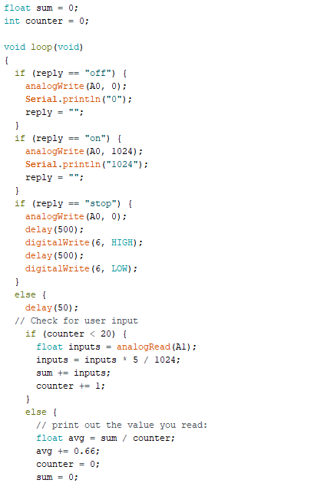

We used the Seeeduino XIAO microprocessor as our internal CPU. The Bluetooth chip (Bluefruit LE Friend UART) was connected to the XIAO, and it came with its own sample-code to be utilized by Arduino IDE-based CPUs. The code displayed above is the code we added to the sample-code.

*Appendix B*: The Final Design and Prototype.

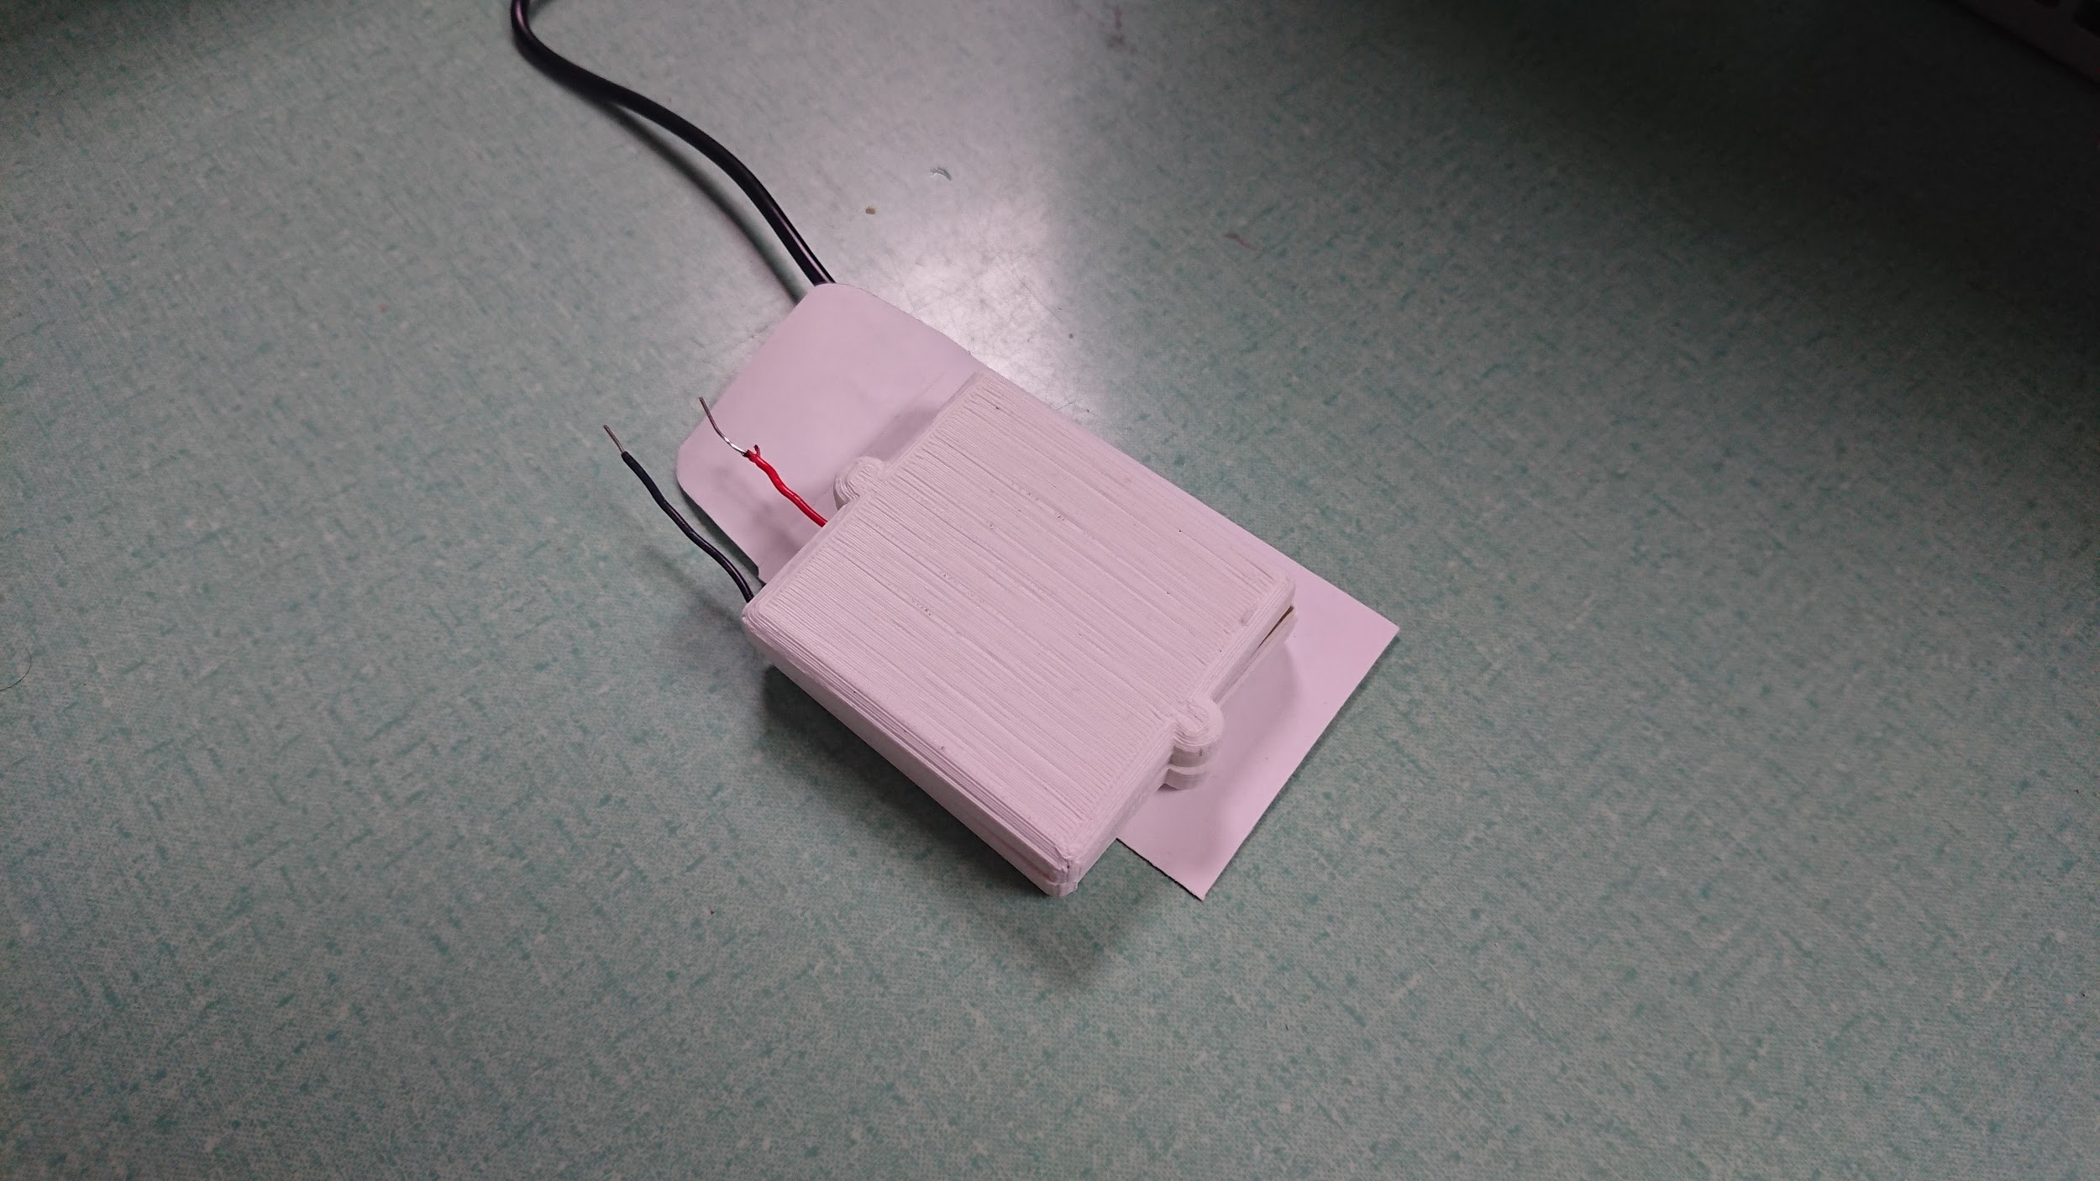

This image is the image of our prototype. Due to our continuous testing throughout making it, we needed very little change from that and the final design. So this is also the image of our final design.

*Appendix C*: Inductive Coupling Test Through Free Space

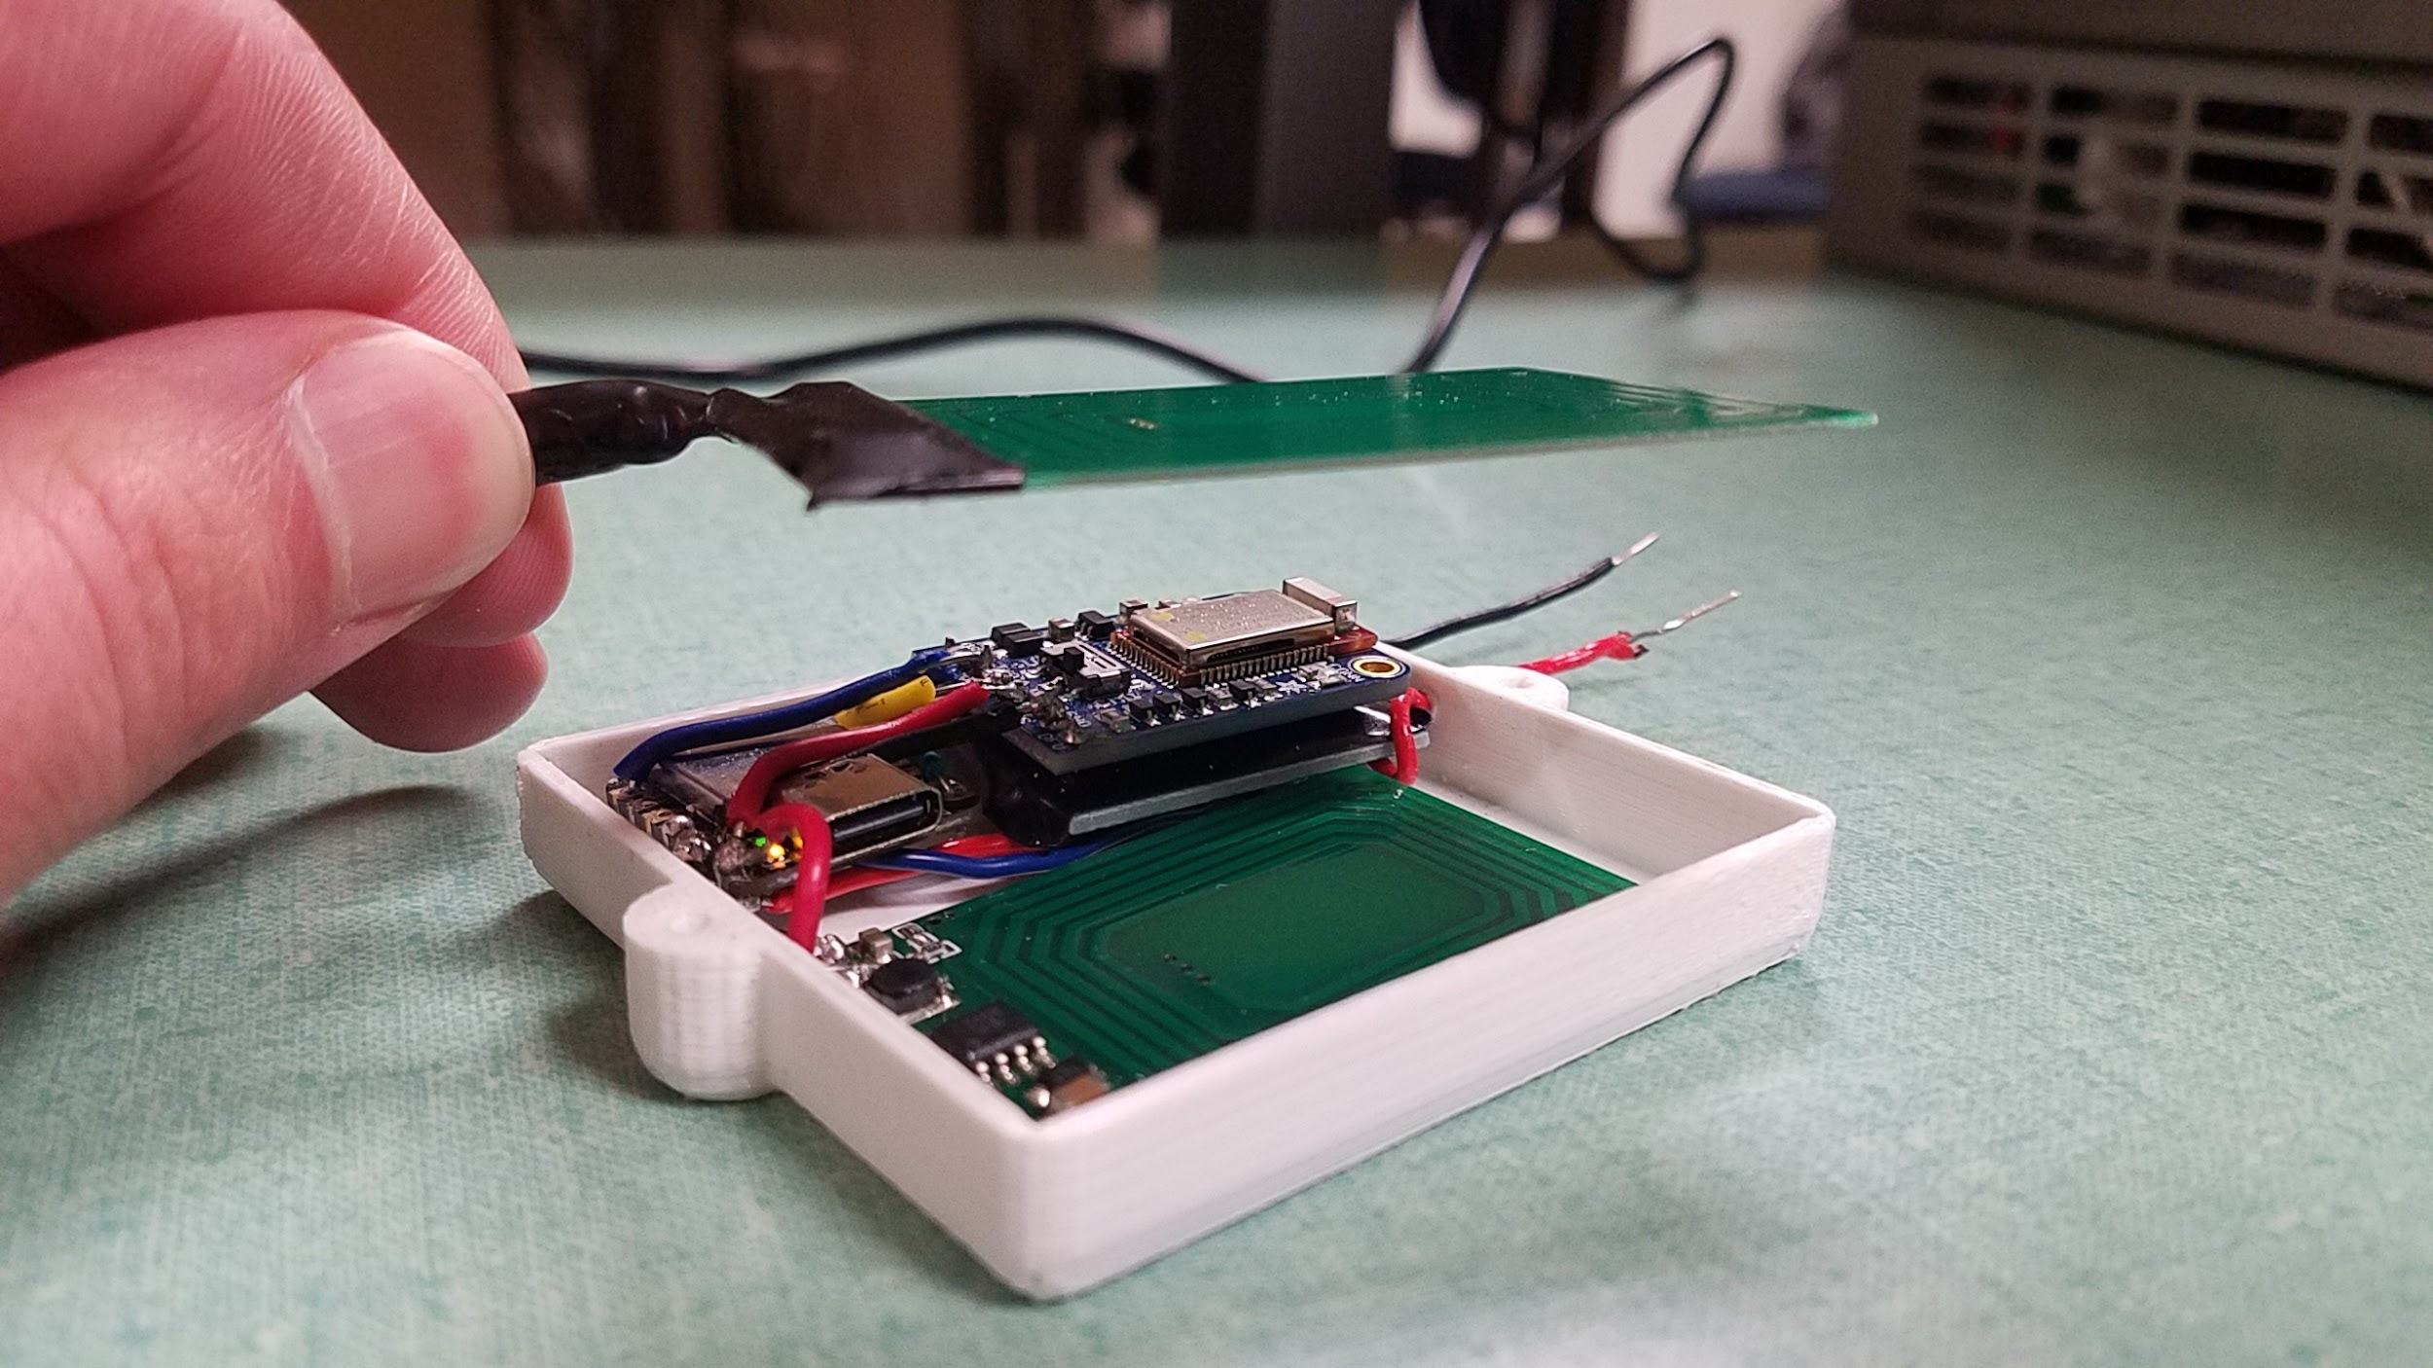

This is the test we performed to see how far the two charging coils can be apart before charge is no longer flowing. From this test we can see that the maximum distance is roughly 2.75 centimeters.

*Appendix D*: The Raspberry Pi-Powered Proprietary Display

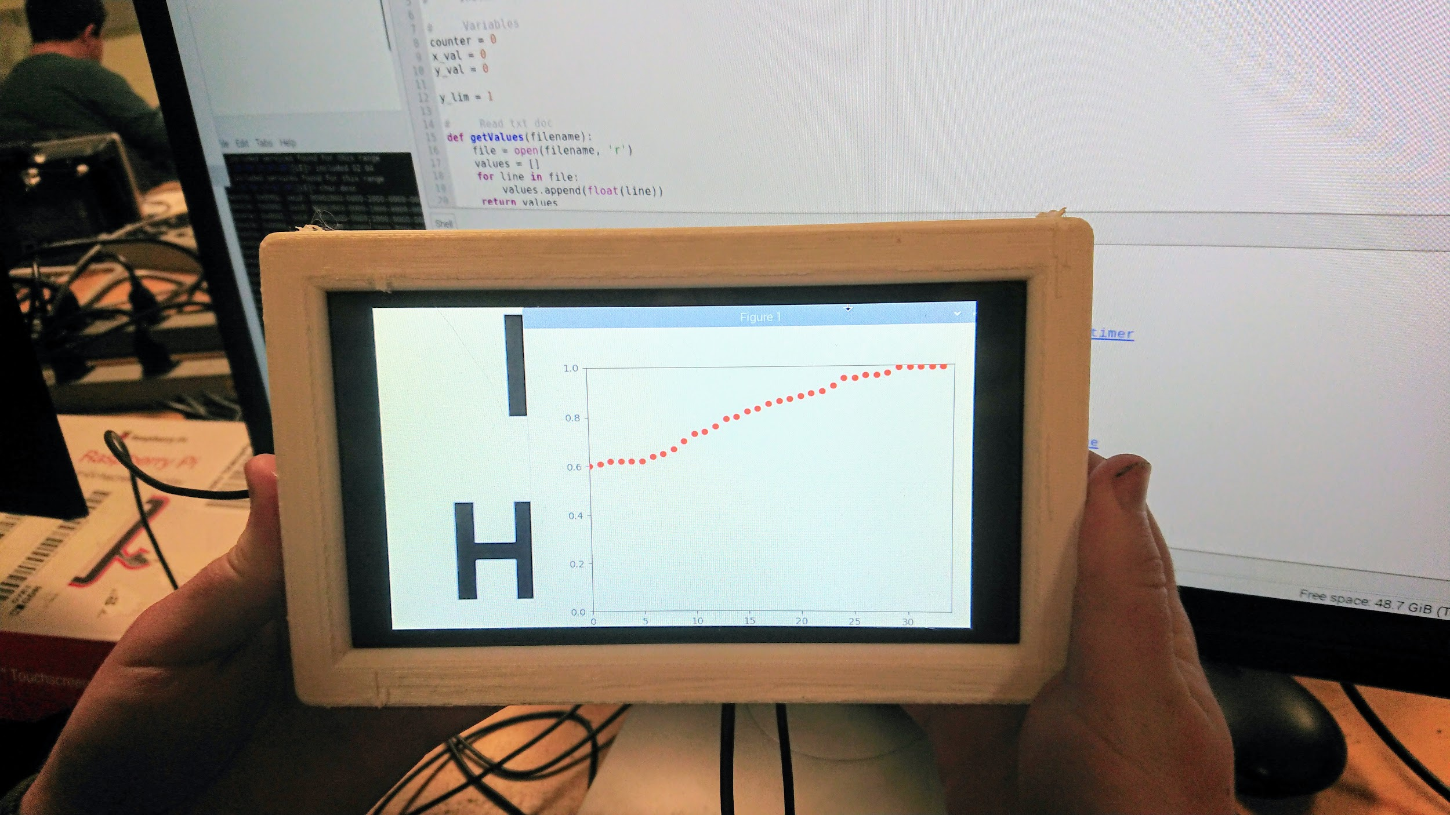

This is the Raspberry Pi display we used to show the data that our internal apparatus collects. The internal CPU reads the battery’s charge (voltage) and sends that data to the external CPU. Then the external CPU reports this data to the display, as well as graphs the data so our patient can see how their battery’s charge is changing over time.

*Appendix E*: Inductive Coupling Test Through Relative Mediums

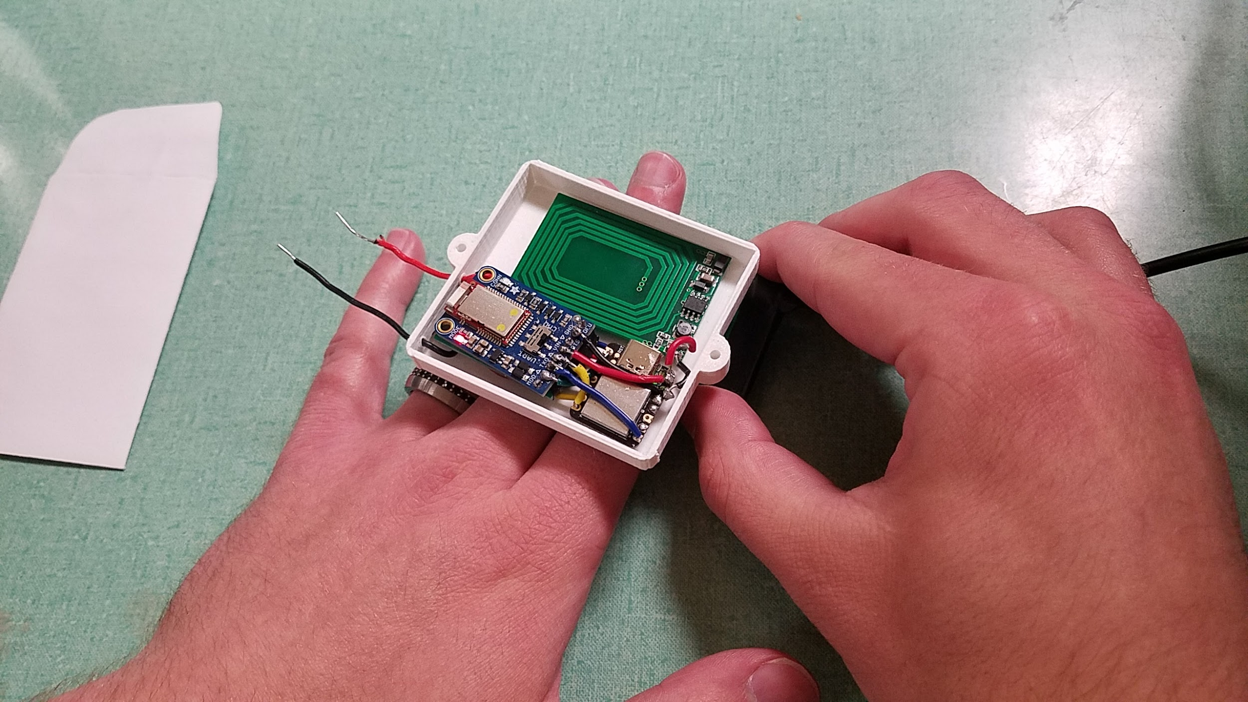

This shows us testing our final design’s ability to transfer charge throughout a medium similar to the human chest. We had no way of testing our design’s functionality inside an actual patient, so testing the charge transfer across our hands was the next best thing.

*Appendix F*: Operating Frequency Test

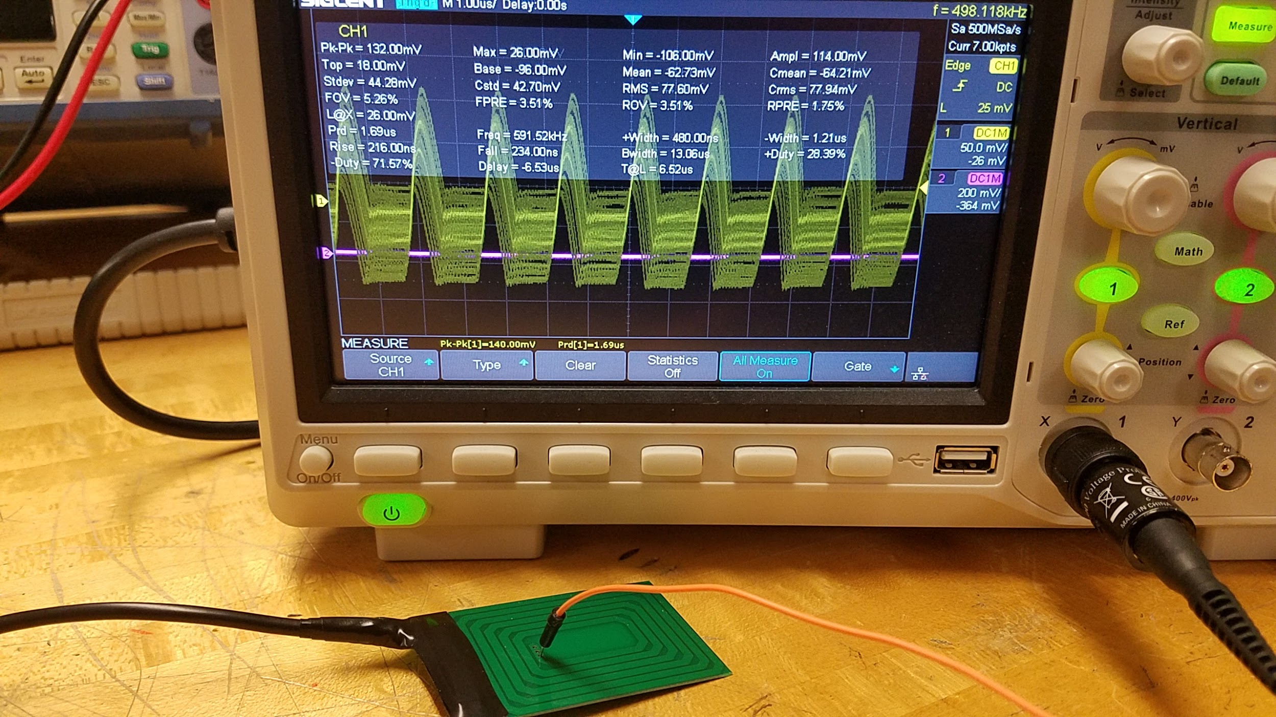

This image shows our tests to ensure that the charge is transmitted at a safe and reasonable frequency. In the image you can see that the frequency at which the charge is being transmitted is about 590 kHz, which is well below the safety threshold (750 kHz).

*Appendix G*: Coil Temperature Tests

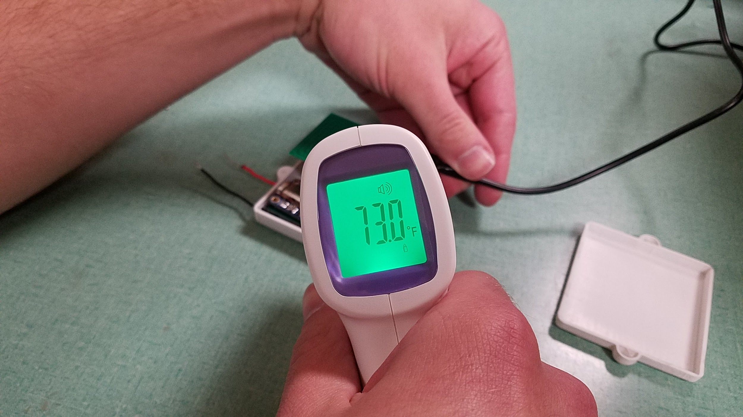

The internal apparatus must be safe to implant into the patient temperature-wise. Any machine implanted into a patient could cause serious health problems if it exceeds the patient’s natural body heat. Fortunately, the internal apparatus (after running for a while) only heated up to 73.0°F, which is well below the average body temperature (98.6°F).

*Appendix H*: Bluetooth App Display of Battery Voltage



In order to test that the Bluetooth subsystem of the internal apparatus worked correctly (while we were still waiting for the display subsystem to be finished), we needed to test that we could receive data, and that it was correctly reading the battery’s charge. Using an Android app on our phones, we were able to receive the data transmitted from the internal apparatus’s Bluetooth chip. And we know that the data was recorded correctly because it was reading an *almost* fully charged 3.7V battery.

*Appendix I*: Graph Display Python Code



To program the Raspberry Pi touch-screen display, we used Python to develop the code. This code above was used to take the received data and plot it into a “Voltage/Time” graph.