SESCSIMPro Script Editor

for Intel

Requirements Document



Brian Crampton, Eric Miles, & Yoshani Thiruvilangam

November 19, 2001
Revision 1.0

Table of Contents

Table of Contents i
Introduction ii
Problem Statement 1
Background 1
Business Issues 1
Value of a Technology Solution 1
Competitive Products 1
Business Environment 2
Solution Statement 2
Requirements 3
Goals 3
Functional Requirements 3
Performance Requirements 3
Constraints 4
Business Philosophy 4
Specifications 4
Feasibility Issues 5
Appendix A: Table of Acronyms 6
Appendix B: Resources 7

Introduction

Intel is one of the leading corporations that is developing technology in the computer and Internet field that is changing the world. For this project we will be assisting the components automation systems division. This division is responsible for creating software to control the tools that manufacture semiconductor memory products. In order to create the scripts to control the tools, Intel currently uses an inefficient and tedious script-making process. For our project we will be designing a software tool to generate these scripts.
Some of the goals of this document are the following:
- Present the requirements that have been collected by the ENSCRYPT team for the SECSIMPro Script Editor project introduced by Harlan Mitchell of Intel
- Resolve any miscommunications regarding the purpose and intent of this project at an early stage in the development process
- Allow for revision as clarifications and changes are applied to the currently stated requirements
The remaining sections of this document address the above issues in more detail. The first section is the problem statement that contains detailed information regarding the problem given, such as, background, business issues, the benefits of a solution, and business environment issues. The second section is a solution statement that gives a high-level outline of what we will be designing. The third section provides the project requirements, including goals, functional requirements, performance requirements, constraints, and business philosophy. The fourth section includes the project specifications given up to this point and the last section is a list of feasibility issues.

Problem Statement

Background

A specialist in the automation world is responsible for designing software to control manufacturing tools. SECSIMPro is the standard software created by GW Associates that is used by many companies to compile SECS Message Language (SML) and SECS Script Language (SSL) files to be used in the testing of these tools.

Currently at Intel, all created scripts are hand-written, which is a tedious and time-consuming process. In order to expedite the script creation/test process, Intel would like to have an application interface with the ability to easily create SML and SSL scripts.

Business Issues
From Intel’s point of view, the development of this tool will help produce SML and SSL scripts easier, more efficiently, faster, and without having to have expert knowledge on script syntax.

Value of a Technology Solution
This tool would be valuable because it would allow the quick creation of test scripts, thereby allowing the user to focus primary interest on more profitable tasks. Through the time saved by using this product, Intel will gain profit that would far exceed the cost of developing the tool.

Competitive Products
According to our client there are no competitive products available for this project. This concurs with our research effort, as we were unable to find any material on this topic.

We identified the following to be possible reasons for the absences of any competitive products
- Not essential – This product is not required to complete the task of creating tool software.
- Copyright issues – The development of a marketable software product that develops SSL and SML scripts might infringe with the copyright of GW Associates, Inc.
- Time and cost issues – Companies might not have the time and money to spend on this type of development project.
- Unconsidered idea – There is a possibility that this idea has not been thought of yet.

Business Environment
Since hardware technology is constantly advancing, the types of SML and SSL scripts used for testing must change over time. Even though additional messages are being constantly added to SML and SSL, the general purpose GUI would be able to adapt to these revisions. Even though the demand for this product is not particularly high, it would be extremely useful. This product may also be advantageous for other companies currently using SML and SSL.

Solution Statement

The final project to be delivered to the customer will be a fully functional application that will allow the user to quickly create SML and SSL scripts. The GUI will contain the following features:
- A full listing of messages provided by the user that can be updated from an external messages file.
- Ability to select available messages on the left hand side of the program window, followed by clicking the ‘Add Message’ button, an automatic script will be generated on the right hand side of the program window.
- Be able to click in fields on the right hand side and update the field values.
- The script will be able to be saved and then compiled into the SECSIMPro program.
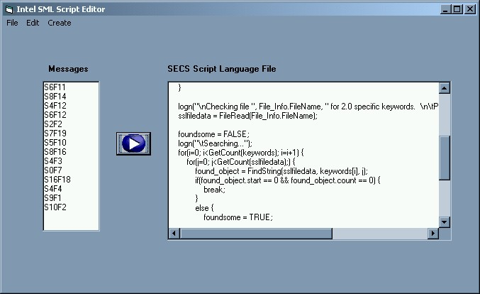
Figure 1 – Sample screen shot

Requirements

Goals
The goal of this development effort are as follows:
- Easy to use Graphical User Interface
- Create SML and SSL scripts
- Ease of adding new messages with evolving technology

Functional Requirements
The following is a list of high-level functional requirements the client has requested from our team.
- The program must be able to create SML and SSL scripts.
- The program must be able to save scripts to a file.
- The program must be able to edit currently created SML and SSL scripts.
- The program must be able to update SML and SSL fields.
- The program does not have to load a file.
- The program does not have to compile scripts.

- Program must be able to obtain all possible messages.
- The program must get standard messages from a specified location.

- Program must display messages and current script.
- The left hand side textbox will show the current available messages.
- The right hand side textbox will show the currently generated script.

- The program must have the following behaviors:
- Load available messages on startup
- Wait for user to select messages to add
- Add message when user selects ‘Transfer’
- Display current script file
- Popup window when user clicks on modifiable field in the script
- Update user defined fields
- Save created script files when user clicks save

- Product should have an indefinable lifetime
- Product must work as long as there is a need for it.
- Product must be able to continuously function as long as it’s needed.

Performance Requirements
Given below is a summary of the performance requirements.
- Program should be reasonably fast
- The program must not have any noticeable delays between user instantiated operations and the output
- The program must be able to run with the same speed as any standard application.

- Program should run flawlessly.
- The program must not terminate due to run-time errors.
- Program must not contain internal logical errors.
- Program must perform desired functionality.

- Program should not consume excessive memory
- Running the program must not absorb excessive system resources.
- The program must not consume more memory than any standard application.

- Program should resemble a standard Windows application
- Program must contain standard menu and tool bars.
- Program must contain standard textboxes and user buttons.
- The program must be a standard executable file.

Constraints
The following constraints were given for this project.
- Program must run on Windows NT/2000 environment
- Program will be written in Microsoft Visual C++

Business Philosophy
Intel has a standard for well-documented source code. For this program, the source code must uphold to the Intel standard. In addition, and scripts created by the program must also be well documented.

Specifications
There are currently no specific performance values required.

Feasibility Issues
The following is a list of some initial concerns and constraints our team has identified.
- Cost of informational/educational material – The cost required for us to learn what is necessary to complete this project (i.e. SML, programming software)
- Learning how to use SECS Message Language (SML) – Every member in the group will be required to learn SML. This learning curve is a potential risk towards the completion of this project.
- Learning how to use SECSIMPro – In order to compile created SML scripts, we will need to learn how to use SECSIMPro. Failure to learn SECSIMPro may be detrimental to the project.
- Avoiding licensing issue for SECSIMPro – SECSIMPro requires a license, but we will be using the limited demo version. The demo version will allow us to compile 10 times or run 100 messages. In order to avoid purchasing a license, we plan to continually reinstall the demo version.
- Obtaining varied sample script from client – In order to perform proper testing for our program, it will be necessary to test its abilities on a wide range of sample scripts. We will depend upon the client to obtain these sample scripts.
- Obtaining SECSIMPro help file and tutorial information – Since SECSIMPro no longer freely distributes the help file for the SECS Message Language, we will fully depend upon the client to obtain the help file and other tutorial information.
- Person to person visits – Due to the distance between the client and us, it will be important that we utilize meeting times effectively to observe the clients working environment.
- Ability to complete all milestones on time – Even though we are in the very early stages of the project, completing all milestones at the specified time is always a potential risk.
- Creating what the client wants – As with all engineering design projects, miscommunication between the client and the team can result in a program that is not what the client intended.

Appendix A: Table of Acronyms

GUI | Graphical User Interface
SECS | Semiconductor Equipment Communication Standards
SML | SECS Message Language
SSL | SECS Script Language

Appendix B: Resources

SECSIMPro Software Link: http://www.gwa.com/products/secsimpro.htm
ENSCRYPT Website Link: http://www.cet.nau.edu/~emm4/intel
ENSCRYPT E-mail: emm4@cet.nau.edu

