Intel Script Editor

Functional Specifications



Brian Crampton, Eric Miles, & Yoshani Thiruvilangam

July 30, 2026Table of Contents

List of Figures iii
1. Introduction 1
1.1 Executive Summary 1
1.2 Problem Description 1
1.3 Product Description 3
1.3.1 Process Overview 4
1.3.2 Prototype Interface Proposed 5
1.4 Product Functions 10
1.5 General Constraints 10
1.6 Assumptions 10
2. Software Architecture Overview 11
3. Specific Functional Requirements 12
4. Use Cases 15
Case 1: New SML Message 15
Case 2: Edit SML Message in the Message Library 16
Case 3: Delete A SML Message From A SML File 17
Case 4: Delete A SML Message Permanently 17
Case 5: SML File Creation 18
Case 6: Creating a SSL Synchronous Script 19
Case 7: Creating an Asynchronous SSL Script 21
Case 8: Delete A SSL Function Permanently 22
Case 9: Delete A SSL Function From A Synchronous SSL Script 23
Case 10: Edit A Function In A Synchronous SSL Script 24
Case 11: New SSL Function 25
5. Performance Requirements 26
6. Design Constraints 26
7. Attributes 26
8. Conclusion 27
9. Appendix A: Table of Acronyms 28
10. Appendix B: Resources 29

List of Figures

Figure 1: SML and SSL Design Process 3
Figure 2: Flowchart for SML and SSL Creation 4
Figure 3: Welcome Screen Window 5
Figure 4: SML File Creator Window 6
Figure 5: New SML Message Creator Window 6
Figure 6: SML Message Editor Window 7
Figure 7: Synchronous Script Creator Window 8
Figure 8: New SSL Function Creator Window 8
Figure 9: SSL Function Editor Window 9
Figure 10: Asynchronous Script Creator Window 9
Figure 11: Software Architecture Overview 11

1. Introduction
1.1 Executive Summary
On October 1, 2001 Harlan Mitchell, a Software Engineer from the Components Automation Systems division of Intel Corporation approached the Capstone Project Group with an application for a SECSIMPro SML/SSL Script Editor. As a result, team ENSCRYPT (http://www.cet.nau.edu/~emm4/intel) was formed on October 24, 2001 to design and implement this project. Intel Corporation is the leading supplier of products and services that comprise the elements of computer architecture and the Internet. The Components Automation Systems division at Intel is responsible for creating software to control the tools that manufacture semiconductor products. In order to test the tool software, test scripts need to be created. Intel currently uses an inefficient and tedious handwritten process. On December 13, 2001, team ENSCRYPT proposed a software solution to develop that will address the needs of the client. The proposed software will support easy, automated creation of scripts and will eliminate the difficulties in remembering the complex syntax of the SECS languages, allowing the engineers to focus in more profitable tasks. The client accepted a Requirements Document on November 26, 2001. This document provides detailed functional specifications for the proposed software solution.
1.2 Problem Description

Introduction to the Client

Intel is known for creating semiconductor memory devices, i.e. chips. Intel makes its money by creating chips for people who need them: distributors, original equipment manufacturers of computer systems and peripherals, PC users who buy Intel’s PC enhancements, and makers of industrial and telecommunications equipment (www.intel.com).

The technology involved in the chip manufacturing process has increased dramatically within the last decade. The chip fabrication process has evolved from a human interaction process to a completely automated one, using high-tech tools and machines.

An ‘automations specialist’ is responsible for designing software to control these manufacturing tools. SECSIMPro is the standard software created by GW Associates that is used by many companies to compile SECS Message Language (SML) and SECS Script Language (SSL) files to be used in the testing of tool software.

Currently at Intel, all SECSIMPro (SSP) scripts are hand-written, which is a tedious and time-consuming process. In order to expedite the script creation/test process, Intel would like to have a graphical script-editing tool that can be used to easily create SML and SSL scripts.

Business Issues

As with most chip manufacturers, the main goal of the Intel Corporation is to make money. To do this, Intel needs to get its chips out on the market before other companies. The following ordered list outlines Intel’s money making strategies:

- Increase the speed of chip production
- Reduce the production costs
- Create chips with the desired functionality
- Create faster chips
- Create reliable chips
- Create smaller-sized chips
- Create chips with reduced power consumption

Since increasing the speed of production is the most important step in making money, automation is a crucial competitive factor for Intel.

Inefficiency of Currently Used Methods

In order to generate scripts to be used in the testing of automation tool software, Intel relies on the SECSIMPro proprietary languages, SML and SSL. The goal of this project is to provide software that supports easy, automated creation of these files much faster than the current handwritten method.

Using the software utility we propose to build, the client would no longer need to worry over the details of the syntax of the language and handwriting all the required code. We estimate that the development of this project will reduce time required to create these scripts up to 70%.

In addition, the time spent by handwriting these scripts is costing the company money and resources. By decreasing the time necessary to generate the SML and SSL files, the company would be decreasing the production costs, which effects Intel’s second most important money making priority.

Even though the result of the project will not directly contribute to any of the remaining priorities, by reducing the amount of time required to generate SML and SSL files, an employee can focus on more profitable tasks.

Program Requirements

After careful analysis and discussion with the client, we proposed to design a software solution that meets the following requirements:

- Ability to create and save Asynchronous SSL files
- Ability to create and save Synchronous SSL files
- Ability to create SML files
- Library to hold user defined SSL functions
- Library to hold user defined SML messages
- Library to hold SML templates
- Ability to add future SML templates
- Checking SSL files after creation for dependent SML messages
1.3 Product Description
In order to understand the purpose of our project, first let us look at the process Intel currently uses to develop SML and SSL files. An automations specialist, such as our client, must develop SML and SSL files to test manufacturing tool software. When creating these files, a specialist must first research the available messages for the tools and then develop the necessary scripts. This process is estimated to take seven days to create an initial script.

With our product, we estimate that the design process can be accomplished in approximately 2 days. Figure 1 shows both processes.
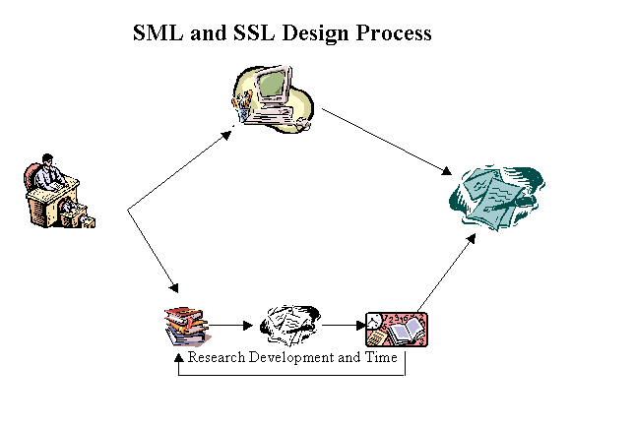
(proposed software)
≈ 2 days work time
(Intel’s Current Method)
≈ 7 days work time
ENSCRYPT
SML Editor
Specialist
Finished Files
(SML and SSL)
Figure 1: SML and SSL Design Process
1.3.1 Process Overview
The following flow chart demonstrates the steps in the creation of SML files and SSL scripts.

SSL Asynchronous Script
SSL Synchronous Script

SML Files
New/Edit/Delete Message
New/Edit/Delete Messages
& Functions
New/Edit/Delete Message
Add
Messages
to File
Add Message calls and Functions to Script
Add Messages Calls to Script
Save File
Save Script
Save Script

Figure 2: Flowchart for SML and SSL Creation

The user will select one of three options when stating the program. Depending on which type of file is being created, the program will give them the option to edit, delete or create a new message and/or function. After the necessary messages and functions are available, the user will be able to use them in the generation of their desired file type. Finally, the program will allow them to save their creation.

1.3.2 Prototype Interface Proposed
The following few pages give a quick overview of the major sections of the program with their corresponding demonstration screen shots.

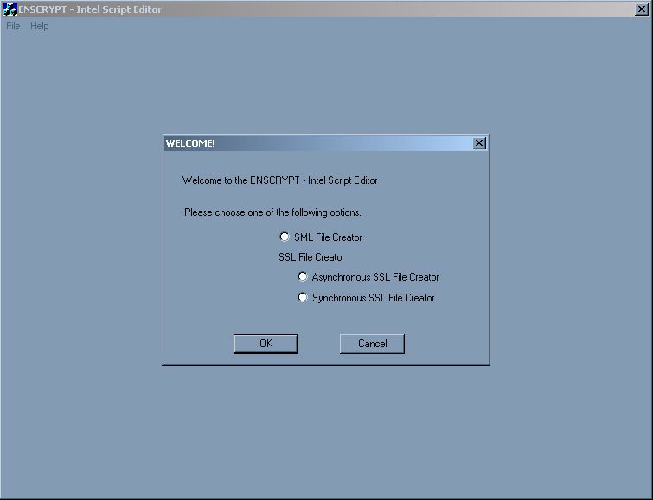
Figure 3: Welcome Screen Window
Welcome Screen: The Welcome Screen displayed in Figure 3 will display when the program first opens. This will give the user the option of choosing which type of file to work with.

SML File Creator: The SML File Creator displayed in Figure 4 will open when the user chooses to create a new SML file. This window will provide the user with a list of all available Messages, a preview box for messages, and a display of the currently generating SML File. Buttons will be provided on the window to provide additional functionality.

New SML Message Creator: The New SML Message Creator window displayed in Figure 5 will open when the user chooses to create a new SML message from the SML File Creator window. This window will display a current list of all Message Templates, a preview display for Message Templates, and some fields to collect the desired Message label.

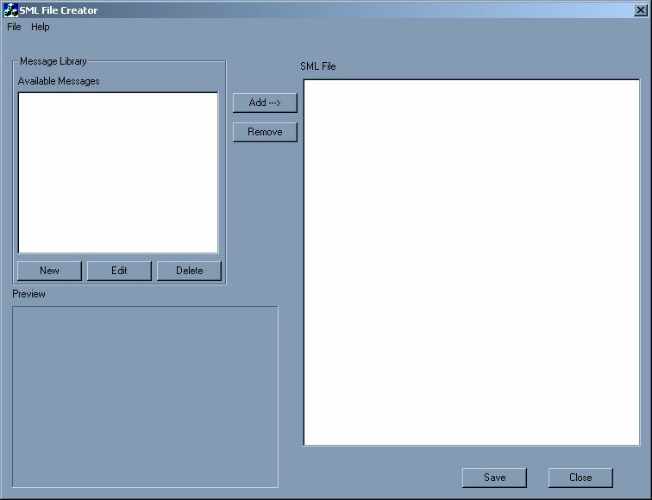
Figure 4: SML File Creator Window

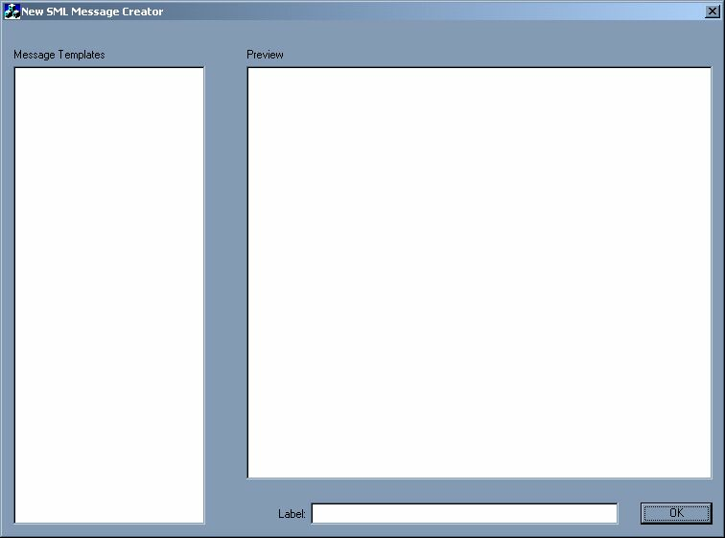
Figure 5: New SML Message Creator Window
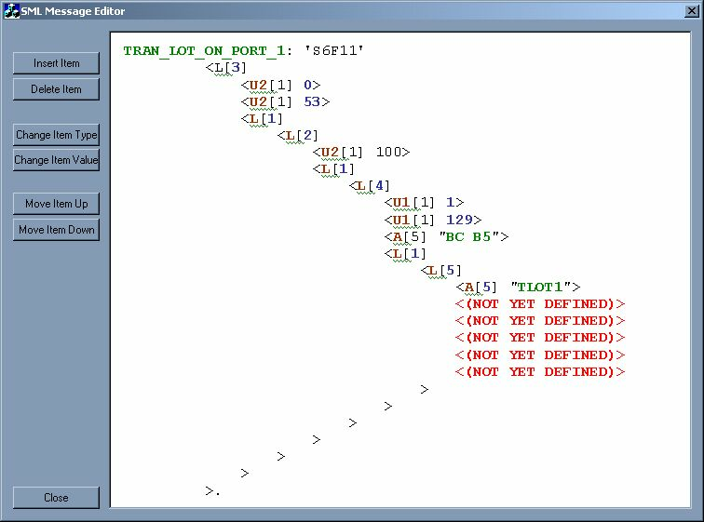
Figure 6: SML Message Editor Window

SML Message Editor: The SML Message Editor window displayed in Figure 6 will guide a user through the process of generating an SML Message according to a specified template. This window will provide a large text box with an editable script. Various buttons will be provided to help with the process.

Synchronous Script Creator: The Synchronous Script Creator window shown in Figure 7 will open when the user selects to create a Synchronous Script from the Welcome screen. This window will provide a list of available functions, a preview box for these functions, a list of used functions, and a display of the currently generating script.

New SSL Function Creator: The New SSL Function Creator window will open when the user clicks ‘New’ from the Function Library frame in the Synchronous Script Creator window. This window, displayed in Figure 8 below, will ask the user for basic function attributes such as visibility and function name.

SSL Function Editor: The SSL Function Editor will open when a user is creating a new function or editing an existing function. This window, diagrammed in Figure 9, will display a list of messages that can be used in the Function Editor and display the currently generated Function.

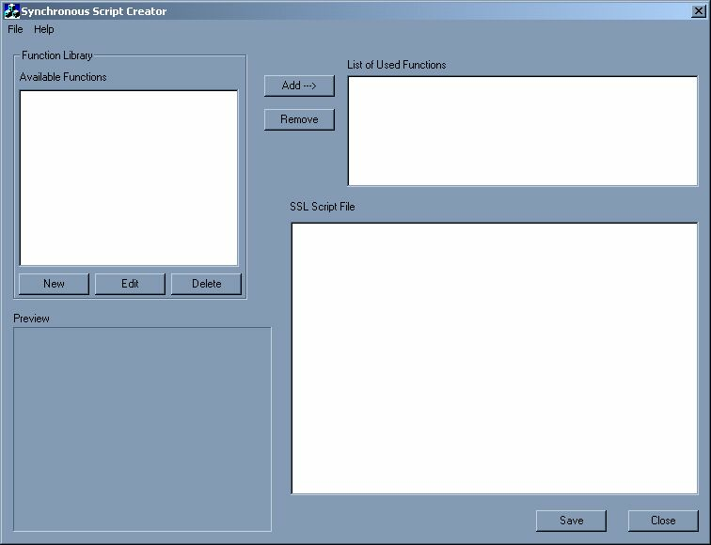
Figure 7: Synchronous Script Creator Window

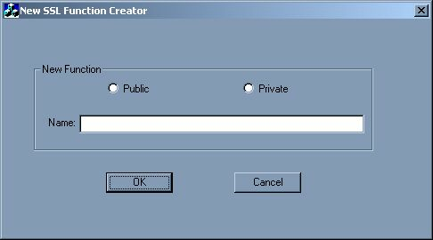
Figure 8: New SSL Function Creator Window

Asynchronous Script Creator: The Asynchronous Script Creator shown in Figure 10 will provide the use with a list of available messages that can be added to the Asynchronous script, a preview box for the messages, and a display of the currently generated Asynchronous Script File. Additional buttons will be provided to gain additional functionality.

For more details on any of these windows, please view the Use Case Scenarios in Section 3.
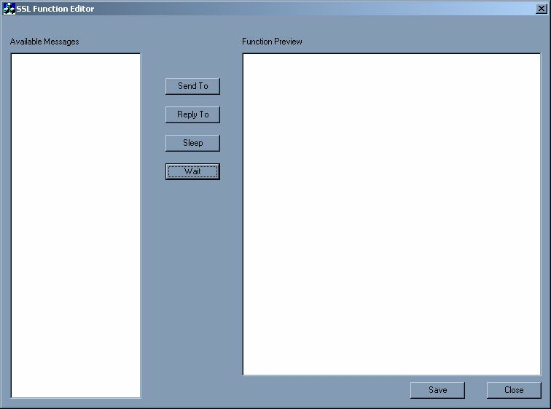
Figure 9: SSL Function Editor Window

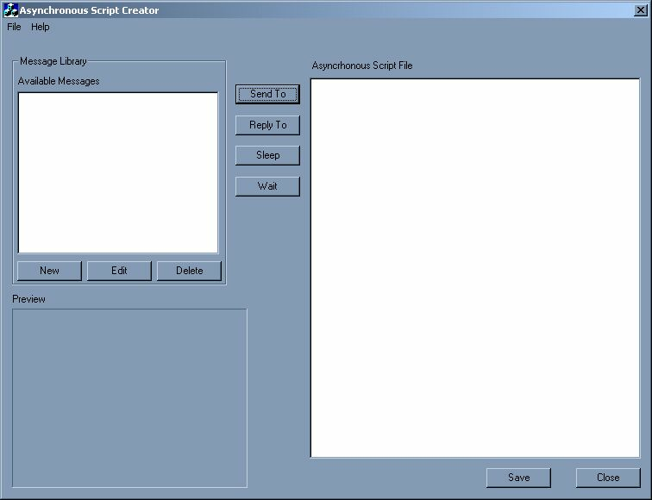
Figure 10: Asynchronous Script Creator Window
1.4 Product Functions
The following is a list of high-level functional requirements for Phase I of the Intel Script Editor. These requirements are elaborated upon in section 3.

- The program must be able to create SML messages from a template

- The program must be able to create SSL functions

- The program must be able to create SML files

- The program must be able to create Synchronous SSL files

- The program must be able to create Asynchronous SSL files
1.5 General Constraints
Our client has specified two constraints for this project:
- Cost: This project should be a virtually no cost project.
- Platform: The project should be developed for use on the Windows NT/2000 platform.
1.6 Assumptions
For this project, we have the following assumptions that will be imperative to the success of this project:
- The client will be considered the expert on the relevant subject matter. No other source will be acceptable or sufficient.
- The client will respond to all inquiries regarding the project within three days.
- Speed of machine: 700 MHz or faster processor
- Monitor resolution at least 800x600
- At least 256 monitor color depth
- Program will not require training for users knowledgeable of subject matter.
2. Software Architecture Overview
The following diagram is a graphical representation of our software architecture overview.

All classes will stem from the main GUI class. The two main groups of architecture bodies included in the GUI are the Editors and the Library Manager.

The Editors package will contain functionality for SML editing, asynchronous SSL editing, and synchronous SSL Editing. Each type of editor will have a different set of implantation that will be used to generate the desired scripts. The Editors will rely on the Library Manager to obtain information about stored functions, messages, and message templates.

The Library Manger will be responsible for maintaining the three program libraries: SML Messages, SSL Functions, and SML Templates. The SML Message and SSL Function library will be dynamic, allowing the user to add, edit and delete items from the library. These libraries will be stored into files on the hard disk. The SML Template Library will be a hard coded library that can from the hard disk.

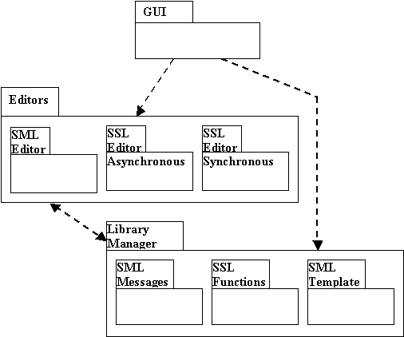

Figure 11: Software Architecture Overview
3. Specific Functional Requirements
The following outline is are the specific details of the functional requirements introduced in Section 1.4.

1. The program must be able to create SML messages from a template

Description
When the need for a new SML message arises our product will provide support with creation of the message. All SEMI standard messages will be able to be created with the use of standard templates for the different messages. As new message standards get introduced, users will be able to manually add-in standard templates of these to the template library.

Inputs
User Interfaces: see figures 4, 5, 6.
Data Required : User will provide all needed values to construct a complete message, which could includes list lengths, labels, and names.

Processing
When the user selects the option of creating a new SML message, the Template Library will be loaded into the current workspace. User will then select a standard template and our product will display the pseudo code of the message. The user will then be requested to provide a label for the message and required fields. After all the required information is entered our software will add the new message to the Message Library.

Outputs
The new message will be added to the SML message library. This message will be permanent until user deletes it.

2. The program must be able to create SSL functions

Description
User will be able to create SSL functions with ease. The structure of the function will be built for the user by the software after the user had provided the necessary basic information such as name of function and function type. Every function that will be created by user will be stored in a library for reuse.

Inputs
User Interfaces: See figures 7, 8, 9.
Data Required : User will have to provide a name, and the body for the function.

Processing
After user selecting the option to create a new SSL function, our software will prompt the user for the name, type, and provide assistance in creating the body of the function. All this information will be read in and a complete function will be generated and saved to the Function Library.

Outputs
An additional function will be added to the SSL function library. This function will be permanent until user deletes it.

3. The program must be able to create SML files

Description
Users will need to create SML files that contain messages. Users will be able to create a new SML file with messages by transferring previously created or newly created messages to the file. These files can be edited for contents and then saved in a location specified by the users.

Inputs
User Interfaces: See figure 4.
Data Required : Message library, file name, location of file to be saved.

Processing
The Message Library will be loaded in to the current workspace to assist the user in creating a new SML file. When the user selects a message from a list the message body will be loaded into a display window. From here the user can add this function to the file. This file can be saved in a location specified by the user.

Outputs
An .sml file will be generated and saved.

4. The program must be able to create Synchronous SSL files

Description
When creating a Synchronous SSL file the users will be able select and add functions from a list of previously created functions. The users will also be able to create new functions that can be added to the file. After performing desired changes the file will be saved in a location specified by the users.

Inputs
User Interfaces: see figure 7.
Data Required : Function library, file name, location of file to be saved.

Processing
When the user selects the option of creating a new synchronous SSL file, the Function Library will be loaded into the current workspace. The user will be able to select and add functions from this library to a file. This file will be saved in a user specified location.

Outputs
An .ssl file will be generated and saved.

5. The program must be able to create Asynchronous SSL script

Description
Users will be able to create a new asynchronous SSL file. To this file the users will be able to add messages that have previously been created. Every such added message will be used to setup a case structure required to reply to any type of message. After performing any needed changes the users will be able to save the file to a specified location.

Inputs
User Interfaces: See figures 8, 10.
Data Required : Message library, file name, location of file to be saved.

Processing
When the user selects the option to create asynchronous SSL script the Message Library will be loaded into the current workspace. The User will be prompted to provide a name for the function. The software will generate a script, which the user will be able to view. This script will contain a function outline with the name specified by the user with a while loop embedded in it. The user will then be able to add additional messages to this script by selecting them from the Message Library. For every message added our software will create a case structure and will allow the user to edit the script manually. Finally, the script will be saved in the user’s desired location.

Outputs
An .ssl file will be generated and saved.

4. Use Cases
Case 1: New SML Message
Scenario: User is making a new SML message
Actors: Joe, Automation Specialist
Steps:
- Joe opens the Intel Script Editor program.
Explanation: Welcome screen in Figure 3 appears with radio button selections for SML File Creator, Asynchronous SSL Script Creator, and Synchronous SSL Script Creator.

- Joe selects SML File Creator option and clicks OK.
Explanation: SML File Creator window as seen in Figure 4 appears. The two-column Available Messages list box in the upper left hand corner is filled with previously created messages, displaying the type and the name of each.

- Joe clicks on the New button.
Explanation: The New SML Message Creator window in Figure 5 appears with a list of all available message templates in the Message Templates list box.

- Joe selects a message type from the Message Template list box.
Explanation: The software will capture the complete body of the message template from the Template library and load it into the Preview text box where the Joe will be able to view the pseudo code.

- On the Label text box Joe will type in a label for the message and click the OK button.
Explanation: The SML Message Editor window in Figure 6 appears. Joe will be able to see the pseudo code with the label of the message in it.

- Joe will then fill in the required information for the body of the message
Explanation: The required fields will be bolded and in different colors depending on their category. Joe will be able to click on them and fill in information.

- After looking at the code being generated, Joe clicks on the Close button
Explanation: The software will parse through all information in the text box and save the new message to the SML Message Library. The SML Message Editor window will disappear.

- Joe clicks on the Close button in the SML File Creator window after seeing that newly added function in the Available Messages list box.
Explanation: The SML File Creator window will disappear. Joe will be able see the new message he added in the Message list box with its label and type.

- Joe clicks on the X button in the ENSCRYPT- Intel Script Editor window.
Explanation: The program will completely shut down.

Case 2: Edit SML Message in the Message Library
Scenario: User wants to edit a previously created SML message
Actors: Joe, Automations Systems Division, Intel
Steps:
- Joe opens the Intel Script Editor program.
Explanation: Welcome screen in Figure 3 appears with radio button selections for SML File Creator, Asynchronous SSL Script Creator, and Synchronous SSL Script Creator.

- Joe selects SML File Creator option and clicks OK.
Explanation: SML File Creator window as seen in Figure 4 appears. The two-column Available Messages list box in the upper left hand corner is filled with previously created messages, displaying the type and the name of each.

- Joe clicks on the message in the list box that he wants to edit.
Explanation: The message in the list box is highlighted. The message body is obtained from the message library and displayed in the Preview box.

- Joe clicks on the Edit button within the Message Library container.
Explanation: The SML Message Editor window as seen in Figure 6. appears and the selected message is displayed. The fields will be bolded and in different colors depending on their category. Joe will be able to click on them and fill in new information.

- After finishing the editing, Joe clicks on the Close button.
Explanation: The software will parse through all information in the text box and save the new message to the SML Message Library. The SML Message Editor window will disappear.
- Joe clicks on the Close button in the SML File Creator window.
Explanation: The SML File Creator window will close and control returns to the main Welcome window.

- Joe clicks on the X button in the ENSCRYPT- Intel Script Editor window.
Explanation: The program will completely shut down.
Case 3: Delete A SML Message From A SML File
Scenario: User is deleting a SML message from a SML File.
Actors: Joe, Automation Specialist
Steps:
- Joe selects a function in the currently opened SML file in the SML File Creator window as seen in Figure 4.
Explanation: Joe will leave the cursor in the body of the message he wants to delete in order to select it.

- Joe clicks on the Remove button.
Explanation: The selected message will be removed from the file. Joe will be able to see the updated SML file in the SML File text window.
- When Joe is satisfied with the file, he clicks on the Save button located in the bottom right hand corner of the window.
Explanation: A Save window will appear, prompting Joe to enter in a name of the file.
- Joe enters a valid name and clicks on the OK button within the Save window.
Explanation: The program will capture the data in the SML File window and save it to the specified file name, which Joe created. The save window will disappear and control will transfer back to the SML File Creator window.

- To Exit, Joe clicks on the Close button in the bottom right hand corner.
Explanation: A check will be performed to make sure that, if there is data in the SML File text box, it has been saved. The file has been saved, so the current window disappears and control returns back to the opening screen in Figure 3.
- Joe clicks on the X button in the ENSCRYPT- Intel Script Editor window.
Explanation: The program will completely shut down.

Case 4: Delete A SML Message Permanently
Scenario: User is deleting a SML message from the Message Library.
Actors: Joe, Automation Specialist
Steps:
- Joe opens the Intel Script Editor program.
Explanation: Welcome screen appears in Figure 3 with radio button selections for Library Manager, SML File Creator, Asynchronous SSL Script Creator, and Synchronous SSL Script Creator.

- Joe selects SML File Creator option and clicks OK.
Explanation: SML File Creator window as seen in Figure 4 appears. The two-column Available Messages list box in the upper left hand corner is filled with previously created messages, displaying the type and the name of each.

- Joe clicks on the message in the list box that he wants to delete.
Explanation: The message in the list box is highlighted. The message body is obtained from the message library and displayed in the Preview box.

- Joe clicks on the Delete button.
Explanation: The selected message will be removed from the Message Library and the Message Library will be updated and saved.

- Joe clicks on the Close button in the SML File Creator window after seeing that the Available Messages list box no longer contains the deleted message.
Explanation: The SML File Creator window will disappear.

- Joe clicks on the X button in the ENSCRYPT- Intel Script Editor window.
Explanation: The software will completely close down.

Case 5: SML File Creation
Scenario: User wants to create a new SML file and save it
Actors: Joe, Automation Specialist
Steps:
- Joe opens the Intel Script Editor program.
Explanation: Welcome screen in Figure 3 appears with radio button selections for SML File Creator, Asynchronous SSL Script Creator, and Synchronous SSL Script Creator.

- Joe selects SML File Creator option and clicks OK.
Explanation: SML File Creator window as seen in Figure 4 appears. The two-column Available Messages list box in the upper left hand corner is filled with previously created messages, displaying the type and the name of each.

- Joe clicks on a message in the list box.
Explanation: The message in the list box is highlighted. The message body is obtained from the message library and displayed in the Preview box.

- Joe clicks on the Add button.
Explanation: The selected message is added to the SML File text box, which contains the actual SML file.

- Joe clicks on another message in the Available Messages list box.
Explanation: As before, the message is highlighted and displayed in the Preview box.
- The Add button is clicked again.
Explanation: The selected message is added to the SML File text box. The message is added to the end of the file. As Joe adds messages, they are inserted in sequential order.
- When Joe has added the desired messages to the file, he clicks on the Save button located in the bottom right hand corner of the window.
Explanation: A Save window will appear, prompting Joe to enter in a name of the file.
- Joe enters a valid name and clicks on the OK button within the Save window.
Explanation: The program will capture the data in the SML File window and save it to the specified file name, which Joe created. The save window will disappear and control will transfer back to the SML File Creator window.
- To Exit, Joe clicks on the Close button in the bottom right hand corner.
Explanation: A check will be performed to make sure that, if there is data in the SML File text box, it has been saved. The file has been saved, so the current window disappears and control returns back to the opening screen.
- Joe clicks on the X button in the ENSCRYPT- Intel Script Editor window.
Explanation: The program will completely shut down.

Case 6: Creating a SSL Synchronous Script
Scenario: User wants to create a new synchronous SSL Script
Actors: Joe, Automations Systems Division, Intel
Steps:
- Joe opens the Intel Script Editor program.
Explanation: Welcome screen in Figure 3 appears with radio button selections for SML File Creator, Asynchronous SSL Script Creator, and Synchronous SSL Script Creator.

- Joe selects Synchronous SSL Script Creator option and clicks OK.
Explanation: Synchronous SSL Script Creator window as seen in Figure 7 appears. The Available Functions list box in the upper left hand corner is filled with previously created functions, displaying the name of each.

- Joe clicks on a function in the list box.
Explanation: The function in the list box is highlighted. The function body is obtained from the function library and displayed in the Preview box in the lower left hand corner.

- Joe clicks on the Add button.
Explanation: The selected function is added to the List of Used Functions list box where it shows only the name of the function. The function is also added, in sequential order, to the SSL Script File text box where it will show the name as well as the body of the function. This text box contains the actual SSL Script that Joe is creating.

- Joe clicks on another function in the Available Functions list box.
Explanation: As before, the function is highlighted and displayed in the Preview box.
- The Add button is clicked again.
Explanation: The selected function is added to the SSL Script File text box at the end of the file.
- When Joe is satisfied with his SSL Script File he clicks the Save button located in the bottom right hand corner of the window.
Explanation: A Save window will appear, prompting Joe to enter in a name of the file.
- Joe enters a valid name and clicks on the OK button within the Save window.
Explanation: The program will capture the data in the SSL Script File window and save it to the specified file name, which Joe created. The save window will disappear and control will transfer back to the Synchronous Script Creator window.
- To Exit, Joe clicks on the Close button in the bottom right hand corner.
Explanation: A check will be performed to make sure that, if there is data in the SML File text box, it has been saved. The file has been saved, so the current window disappears and control returns back to the opening screen.
- Joe clicks on the X button in the ENSCRYPT- Intel Script Editor window.
Explanation: The program will completely shut down.
Case 7: Creating an Asynchronous SSL Script
Scenario: User wants to create a new asynchronous SSL Script
Actors: Joe, Automations Systems Division, Intel
Steps:
- Joe opens the Intel Script Editor program.
Explanation: Welcome screen in Figure 3 appears with radio button selections for SML File Creator, Asynchronous SSL Script Creator, and Synchronous SSL Script Creator.

- Joe selects Asynchronous SSL Script Creator option and clicks OK.
Explanation: The New SSL Function Creator window in Figure 8 will appear. The Public/Private option will be disabled. The window will prompt Joe for a function name.

- Joe enters in a function name and clicks OK.
Explanation: The window will disappear and the Asynchronous Script Creator window as seen in Figure 10 appears. The two-column Available Messages list box in the upper left hand corner is filled with previously created messages, displaying the type and the name of each. The newly created function with a while loop inside appears in the Asynchronous Script File text box.

- Joe clicks on a message in the list box.
Explanation: The message in the list box is highlighted. The message body is obtained from the message library and displayed in the Preview box.

- Joe clicks the Reply To button.
Explanation: The program breaks down the message type into a unique number and outputs a nested Case statement inside the while loop.
- Joe clicks within the Asynchronous Script File text box and hard codes additional functionality i.e. variables, comments.
Explanation: In this case the user is permitted to hand write additional code within the Asynchronous Script File text box.
- When Joe has finished creating the file, he clicks on the Save button located in the bottom right hand corner of the window.
Explanation: A Save window will appear, prompting Joe to enter in a name of the file.
- Joe enters a valid name and clicks on the OK button within the Save window.
Explanation: The program will capture the data in the Asynchronous Script File text box and save it to the specified file name, which Joe created. The save window will disappear and control will transfer back to the Asynchronous Script Creator.
- To Exit, Joe clicks on the Close button in the bottom right hand corner.
Explanation: A check will be performed to make sure that the data inside the Asynchronous Script File text box has been saved. The file has been saved, so the current window disappears and control returns back to the opening screen.
- Joe clicks on the X button in the ENSCRYPT- Intel Script Editor window.
Explanation: The program will completely shut down.

Case 8: Delete A SSL Function Permanently
Scenario: User is deleting a SSL function from the Function Library.
Actors: Joe, Automation Specialist
Steps:
- Joe opens the Intel Script Editor program.
Explanation: Welcome screen in Figure 3 appears with radio button selections for Library Manager, SML File Creator, Asynchronous SSL Script Creator, and Synchronous SSL Script Creator.

- Joe selects Synchronous SSL Script Creator option and clicks OK.
Explanation: Synchronous SSL Script Creator window as seen in Figure 7 appears. The Available Functions list box in the upper left hand corner is filled with previously created functions, displaying the name of each.

- Joe clicks on a function in the list box.
Explanation: The function in the list box is highlighted. The function body is obtained from the function library and displayed in the Preview box in the lower left hand corner.

- Joe clicks on the Delete button.
Explanation: The selected message will be removed from the Function Library and the Function Library will be updated and saved.

- Joe clicks on the Close button in the Synchronous SSL Script Creator window after seeing that the Available Functions list box no longer contains the deleted function.
Explanation: The Synchronous SSL Script Creator window will disappear.

- Joe clicks on the X button in the ENSCRYPT- Intel Script Editor window.
Explanation: The software will completely close down.
Case 9: Delete A SSL Function From A Synchronous SSL Script
Scenario: User is deleting a SSL function from a synchronous SSL Script.
Actors: Joe, Automation Specialist
Steps:
- Joe selects a function from the Available Function list box of a currently open Synchronous SSL Script in the Synchronous Script Creator window in Figure 7.
Explanation: Joe will click on the function name in order to select it. The function name will be highlighted in the list box.

- Joe clicks on the Remove button.
Explanation: The selected function will be removed from the List of Used Functions and also from the file. Joe will be able to see the updated Synchronous SSL Script in the SSL Script File text box.

- When Joe has finished deleting the function, he clicks on the Save button located in the bottom right hand corner of the window.
Explanation: A Save window will appear, prompting Joe to enter in a name of the file.

- Joe enters a valid name and clicks on the OK button within the Save window.
Explanation: The program will capture the data in the Synchronous Script File text box and save it to the specified file name, which Joe created. The save window will disappear and control will transfer back to the Synchronous Script Creator.

- To Exit, Joe clicks on the Close button in the bottom right hand corner.
Explanation: A check will be performed to make sure that the data inside the Synchronous Script File text box has been saved. The file has been saved, so the current window disappears and control returns back to the opening screen.
- Joe clicks on the X button in the ENSCRYPT- Intel Script Editor window.
Explanation: The program will completely shut down.

Case 10: Edit A Function In A Synchronous SSL Script
Scenario: User is editing a SSL function in a synchronous SSL Script.
Actors: Joe, Automation Specialist
Steps:
- Joe selects a function from the Available Function list box of a currently open Synchronous SSL Script in the Synchronous Script Creator window in Figure 7.
Explanation: Joe will click on the function name in order to select it. The function name will be highlighted in the list box. The full preview will be displayed in the Preview box.

- Joe clicks on the Edit button.
Explanation: The SSL Function Editor window appears in Figure 9.

- Joe will make all necessary changes to the function.
Explanation: Joe will be able to make changes using the Send To, Reply To, Sleep, Wait button and he will also be able to type in any changes in the Function Preview text box.

- Joe clicks on the Save button in the SSL Function Editor window. Explanation: The new SSL function will be saved to the Function Library. This will replace the previous function that had the same name.

- Joe clicks on the Close button in the SSL Function Editor window. Explanation: The SSL Function Editor window will disappear.

- When Joe has finished editing the function, he clicks on the Save button located in the bottom right hand corner of the window.
Explanation: A Save window will appear, prompting Joe to enter in a name of the file.

- Joe enters a valid name and clicks on the OK button within the Save window.
Explanation: The program will capture the data in the Synchronous Script File text box and save it to the specified file name, which Joe created. The save window will disappear and control will transfer back to the Synchronous Script Creator.

- To Exit, Joe clicks on the Close button in the bottom right hand corner.
Explanation: A check will be performed to make sure that the data inside the Synchronous Script File text box has been saved. The file has been saved, so the current window disappears and control returns back to the opening screen.

- Joe clicks on the X button in the ENSCRYPT- Intel Script Editor window.
Explanation: The program will completely shut down.
Case 11: New SSL Function
Scenario: User is creating a new SSL function.
Actors: Joe, Automation Specialist
Steps:
- Joe opens the Intel Script Editor program.
Explanation: Welcome screen in Figure 3 appears with radio button selections for Library Manager, SML File Creator, Asynchronous SSL Script Creator, and Synchronous SSL Script Creator.

- Joe selects Synchronous SSL Script Creator option and clicks OK.
Explanation: Synchronous SSL Script Creator window as seen in Figure 7 appears. The Available Functions list box in the upper left hand corner is filled with previously created functions, displaying the name of each.

- Joe clicks on the New button.
Explanation: The New SSL Function Creator window in Figure 8 appears.

- Joe will enter required information and click the OK button.
Explanation: Joe will have to select either public or private for the function and will type in a name for the function. Upon clicking the OK button the New SSL Function Creator window will disappear. The SSL Function Editor window will appear with the outline of the function built using the information supplied by Joe in the New SSL Function Creator window. This will be seen in the Function Preview text box.

- Joe fills in the body of the function.
Explanation: Joe will be able fill in the body of the function by using the Send To, Reply To, Sleep, Wait buttons and by manually typing in the Function Preview window.

- Joe clicks on the Close button in the window.
Explanation: The SSL Function Editor window will disappear.

- Joe clicks on the Save button in the SSL Function Editor window. Explanation: The currently created function will be saved in the Function Library and the Function Library will be updated.

- Joe clicks on the Close button in the SSL Function Editor window. Explanation: The SSL Function Editor window will disappear.

- After seeing the new message in the Available Functions list box in the Synchronous Script Creator window, Joe clicks the Close button.
Explanation: The Synchronous Script Creator window will disappear.

- Joe clicks on the X button in the ENSCRYPT- Intel Script Editor window.
Explanation: The software will completely close down.
5. Performance Requirements
Given below is a summary of the performance requirements for our project:
- Program should be reasonably fast (assuming a 700 MHZ processor)
- The program must load within 5 seconds
- The program must initialize all 3 libraries within 10 seconds
- The program must save file within 2 seconds

- Program should run with no errors.
- The program must not terminate due to run-time errors;
- Errors should be elegantly handled, reported, and continue
- Program must not contain internal logical errors.
- Program must perform desired functionality.

- Program should not consume excessive memory
- Program should not consume more than 15Mb RAM

- Program should use standard Microsoft Foundation Classes
- Program will use Visual C++ menu and tool bars.
- Program will use Visual C++ textboxes and user buttons.
- The program must be a standard executable file.

6. Design Constraints
For our design project, the client has not specified any constraints. However, the client has recommended that the project be written in Microsoft Visual C++.

7. Attributes
Two qualitative constraints that exist for our program are the following:
  - The program should allow for the updating of new SML Message templates without modifying the source code of the program. This would allow for advancement of new SML templates.
  - It was discussed with the client that the number of possible features for this project are endless. Therefore, this program will most likely require future upgrades for functionality. The program should be built such that upgrades can be made as easily as possible.
8. Conclusion

This document has focused on the functional specifications of this project. After careful analysis throughout this specification outline, it is the opinion of ENSCRYPT that this project is still completely feasible. We await your approval of our functional specification and look forward to entering the phases of implementation.

9. Appendix A: Table of Acronyms

GUI | Graphical User Interface
SECS | Semiconductor Equipment Communication Standards
SML | SECS Message Language
SSL | SECS Script Language
SSP | SECSIMPro

10. Appendix B: Resources

SECSIMPro Software Link: http://www.gwa.com/products/secsimpro.htm
ENSCRYPT Website Link: http://www.cet.nau.edu/~emm4/intel
ENSCRYPT E-mail: emm4@cet.nau.edu

