Intel Script Editor

As-Built Document



Brian Crampton, Eric Miles, & Yoshani Thiruvilangam

July 29, 2026Table of Contents

List of Figures iii
1. Introduction 1
2. Problem Statement 2
2.1 The Clients 2
2.2 The Client’s Business 2
2.3 The Problem 3
2.4 Value of the Solution 3
3. Process Overview 4
3.1 Team Organization 4
Brian Crampton 4
Eric Miles 4
Yoshani Thiruvilangam 5
3.2 Project Management Framework 5
3.3 Design Methodology 6
3.4 Documentation Deliverables 7
3.5 Project Timeline 7
4. Requirements 9
4.1 Goals 9
4.2 Requirements 9
Functional Requirements 9
Performance Requirements 10
4.3 General Constraints 10
5. Solution Statement 11
5.1 Overall Solution 11
5.2 Functionality Specifications 12
5.3 Architecture Overview 12
6. Usability Test 14
6.1 Test Method 14
6.2 Outcomes 15
6.3 Usability Summary 16
7. Conclusion 17

List of Figures

Figure 1: Team Layout 4
Figure 2: Design Methodology 6
Figure 3: Project Timeline Summary 8
Figure 4: Intel Script Editor Screen Shot 11

1. Introduction
Intel is one of the leading corporations that is developing technology in the computer and Internet field that is changing the world. For this project we assisted the components automation systems division. This division is responsible for testing the software that controls the tools that manufacture semiconductor products. In order to create the scripts to test the control software, Intel currently uses an inefficient and tedious script-making process. We have designed a software tool to help generate these scripts.
Some of the goals of this document are the following:
- Describe the problem in more detail
- Provide a detailed description of the overall process of the project including team roles, organization, design methodology and specific deliverables
- Discuss the programs requirements and our solution that meets these requirements
- Describe the usability testing session and our results
2. Problem Statement
2.1 The Clients
Our client for this design project was Intel Corporation. More specifically the project was sponsors by:

Harlan Mitchell, Software Engineer
Zachary Henkel, Software Engineer

Our sponsors can be reached at:

Intel Corporation
Components Automation Systems
5000 W. Chandler Blvd.
Chandler, AZ 85226

Our technical advisor throughout the design project was:

Dr. Eck Doerry
Assistant Professor
Computer Science and Engineering

Dr. Eck Doerry can be reached at:

PO Box 15600
Northern Arizona University
Flagstaff, AZ 86011
(928) 523-9377
(928) 523-2300 (FAX)
Eck.Doerry@nau.edu

2.2 The Client’s Business

Intel is known for creating semiconductor memory devices, i.e. chips. Intel makes its money by creating chips for people who need them: distributors, original equipment manufacturers of computer systems and peripherals, PC users who buy Intel’s PC enhancements, and makers of industrial and telecommunications equipment (www.intel.com).

The technology involved in the chip manufacturing process has increased dramatically within the last decade. The chip fabrication process has evolved from a human interaction process to a completely automated one, using high-tech tools and machines.

In order to control these high tech machines, control software must be used. Control software is responsible for controlling every action a machine is to perform. Our clients are responsible for testing the correct functionality of this control software. The control software is tested using SECS Message Language (SML) and SECS Script Language (SSL) files.

2.3 The Problem
Currently at Intel, all SML and SSL scripts are created using minimal software support. Creating these scripts can be a tedious and time-consuming process. In order to expedite the script creation and test process, Intel would like to have a graphical script-editing tool that can be used to easily create SML and SSL scripts.

2.4 Value of the Solution
In order to generate scripts to be used in the testing of automation tool software, Intel relies on the SECSIMPro proprietary languages, SML and SSL. The goal of this project is to provide software that supports easy, automated creation of these files much faster than the current handwritten method.

Using the software utility we propose to build, the client would no longer need to worry over the details of the syntax of the language and handwriting all the required code. We estimate that the development of this project will reduce time required to create these scripts up to 70%.

In addition, the time spent by handwriting these scripts is costing the company money and resources. By decreasing the time necessary to generate the SML and SSL files, the company would be decreasing the production costs. Also, by reducing the amount of time required to generate SML and SSL files, an employee can focus on more profitable tasks.

3. Process Overview
3.1 Team Organization
On October 24th 2001, the ENSCRYPT team was formed. This team was composed of three Computer science and Engineering majors from Northern Arizona University. Each team member was designated for a particular team role as shown in the figure below.
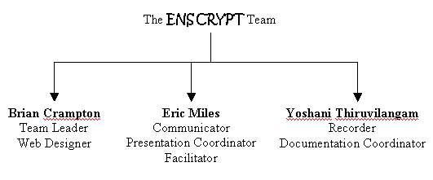

Figure 1: Team Layout

Here is a summary of the team roles, according to person responsible:
Brian Crampton
Team Leader: The duties of the team leader included communicating to the advisor, calling and running team meetings, and monitors individual team member performance and participation.

Web Designer: The web designer was responsible for developing and maintaining the team web site. The group, the client, and the advisor used the website to monitor the team’s progress. The URL for our team website is http://www.cet.nau.edu/~emm4/intel.

Eric Miles
Communicator: The team communicator orchestrated communication between the team members and the client. Having this role eased communication with the client and limited possible confusions.

Presentation Coordinator: The presentation coordinator was responsible for organizing and structuring presentations during the projects lifetime. This person was also responsible for any additional audio or video effects required for the presentation.
Facilitator: The facilitator responsibility was to act as a neutral role to help resolve any team disputes. In the event of a dispute between to team members, this person attempted to resolve the situation by listening to each side of the argument and created an unbiased solution.

Yoshani Thiruvilangam
Recorder: The recorder took meeting minutes, provided necessary documentation to the web designer. This person was also responsible for maintaining the team notebook as well as reminding the team of upcoming deadlines.

Documentation Coordinator: The documentation coordinator was responsible for organizing and structuring all documents. The documentation coordinator was not responsible for creating all required material for the document, but rather combining individual pieces into a single coherent document.

3.2 Project Management Framework
In order to ensure a constant cycle of development, a mandatory weekly meeting was scheduled to occur Wednesday from 12p to 1:30p in the Engineering Department. Additional meetings regularly occurred on Tuesdays and Thursdays at 6pm in North Morton Computer Lab. During a typical meeting, the recorder would give a synopsis of the previous meeting. The other team members would then approve the minutes. Then items of concern were discussed accordingly. Before the meeting was adjourned, the next meeting would be scheduled.

When a team decision was required, all decisions were made on a 2/3rd majority vote. Before a team vote would take place, time was taken to discuss both sides of the issue at hand.

The teams monitoring method consisted of informal discussions regarding individual activity. During the discussion, team members would give a brief description of the tasks they were working on. After this discussion, each team member would be given an opportunity to voice their opinion on the productivity of the other members. The recorder documented all information discussed at each evaluation. The team evaluation occurred approximately every other week.
3.3 Design Methodology
For the development of this project, the client asked us to use a Continuous Improvement Plan (CIP). This is similar to the Incremental Plan commonly taught at Universities.
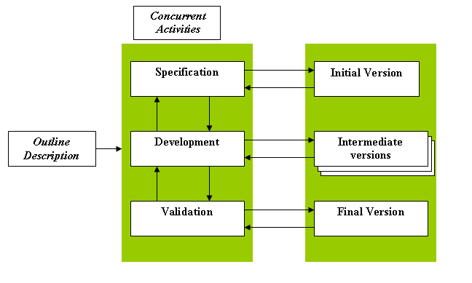
Continuous Improvement Plan

Figure 2: Design Methodology

The continuous improvement plan begins by taking a set of requirements and created an initial version. Through a series of development phases, several intermediate versions are created. At each development stage, the CIP allows the requirements to be updated or changed. Each development phase should result in a version of the program that closer better meets the overall requirements of the project than the previous versions. After all of the requirements can be validated, a final version is then complete.

3.4 Documentation Deliverables
The team had agreed to use Microsoft Word 2000 for all team documents. All documents created for the team were saved in the team website in a folder entitled ‘docs’. Here is a summary of the documents that were created during out design project:

Document Name | Date
Team Bylaws & Standards Document | October 31, 2001
Team Inventory Document | November 7, 2001
Requirements Document | November 19, 2001
Risk Assessment Document | November 30, 2001
Feasibility Study Document | November 30, 2001
Proposal Document | December 13, 2001
Coding Standards Document | February 6, 2002
Functional Specifications Document | February 13, 2002

3.5 Project Timeline
Our project went through a total of 3 major phases: Requirements Capture, Project Design, and Implementation. The diagram below details out major steps in each of these phases.

The requirements capture phase consisted of the following:
- Requirements Acquisition: Met with client to discuss the requirements of the project to be built.
- Feasibility and Risk Assessment: Team analyzed whether or not the project could be accomplished.
- Proposal: Document detailing a proposed solution to the problem.

The project design phase consisted of the following:
- Functional Specification: After the proposal was accepted, the team detailed out the exact specification that needed to be accomplished. This document was also submitted to the client for acceptance.
- Design: After the functional specifications were approved, the team developed a detailed design of how to design the program.

The implementation phase consisted of the following:
- Implementation Phase 1: This was the first phase of implementation. After completion, all SML functionality was included. A prototype was submitted to the client after this initial stage.
- Implementation Phase 2: This was the second phase of implementation. This phase included all of the SSL functionality required by the program. The second prototype was submitted to the client at the completion of this phase.
- Usability Test: Shortly after the submission of Prototype 2, our team went to our client’s place of business and performed usability test of the program on a small group of people. Please see section 6 for the results of this test.
- Project Completion: After the usability test, multiple additions and corrections were suggested for the program. The remaining weeks of the project were used to complete as many of these requests as possible and wrapping up the project.

Figure 3: Project Timeline Summary
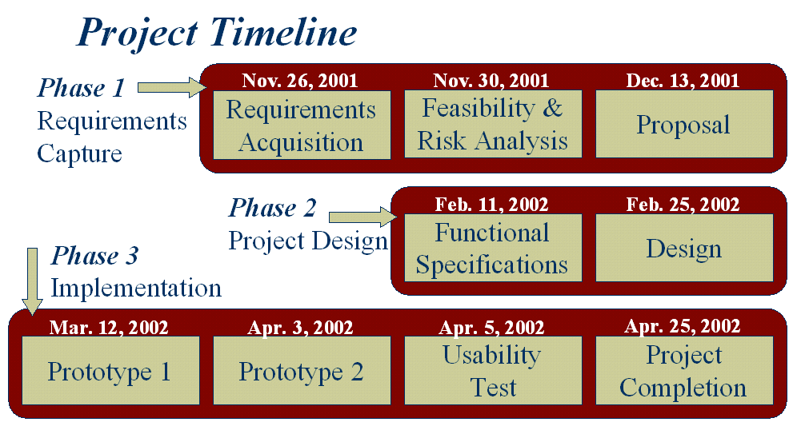

During our project lifetime, significant slippage occurred during the two implementation phases. The main causes of slippage for our project were due to 1) designing a parser for both SML messages and SSL functions and 2) integration of individual program components. Even though this slippage did cause us to cut slightly into the Usability and Project Refinement phases, it did not affect the project outcome because we had originally scheduled several blocks of leeway in our original schedule.
4. Requirements
On November 24, 2001, the ENSCRYPT team visited the clients at their place of business to obtain all of the requirements needed for the program. Several communications via e-mail and telephone were performed after this meeting to obtain further information on specific requirement for the project. A detailed requirements document can be found in the ENSCRYPT notebook or on the ENSCRYPT website.
4.1 Goals
The overall goals of this development effort were to create a project that contained the following features:
- Easy to use Graphical User Interface
- Create SML and SSL scripts
- Ease of adding new messages with evolving technology
4.2 Requirements
The following is a condensed list of the requirements for the project.

Functional Requirements
The following is a list of specific high-level functional requirements that the client has requested from our team.
1. The program must be able to create SML messages from a template
When the need for a new SML message arises our product will provide support with creation of the message. All SEMI standard messages will be able to be created with the use of standard templates for the different messages. As new message standards get introduced, users will be able to manually add-in standard templates of these to the template library.
2. The program must be able to create SSL functions
User will be able to create SSL functions with ease. The structure of the function will be built for the user by the software after the user had provided the necessary basic information such as name of function and function type. Every function that will be created by user will be stored in a library for reuse.
3. The program must be able to create SML files
Users will need to create SML files that contain messages. Users will be able to create a new SML file with messages by transferring previously created or newly created messages to the file. These files can be edited for contents and then saved in a location specified by the users.
4. The program must be able to create Synchronous SSL files
When creating a Synchronous SSL file the users will be able select and add functions from a list of previously created functions. The users will also be able to create new functions that can be added to the file. After performing desired changes the file will be saved in a location specified by the users.
5. The program must be able to create Asynchronous SSL script
Users will be able to create a new asynchronous SSL file. To this file the users will be able to add messages that have previously been created. Every such added message will be used to setup a case structure required to reply to any type of message. After performing any needed changes the users will be able to save the file to a specified location.

Performance Requirements
Given below is a summary of the performance requirements.
- Program should be reasonably fast (assuming a 700 MHZ processor)
- The program must load within 5 seconds
- The program must load all available messages within 10 seconds
- The program must add messages to SML files within 2 seconds
- The program must add messages to SSL within 2 seconds (after utilizing the wizard)
- The program must save file within 2 seconds
- Program should run with no errors.
- The program must not terminate due to run-time errors.
- Program must not contain internal logical errors.
- Program must perform desired functionality.
- Program should not consume excessive memory
- Program should not consume more than 15Mb RAM
- Program should resemble a standard Windows application
- Program must contain standard menu and tool bars.
- Program must contain standard textboxes and user buttons.
- The program must be a standard executable file.

4.3 General Constraints
Our client specified three constraints for this project:
- Cost: This project should be a virtually no cost project.
- Platform: The project should be developed for use on the Windows NT/2000 platform.
- Recommended that project be written in Microsoft Visual C++.
5. Solution Statement
5.1 Overall Solution
At the completion of the project, the ENSCRYPT team has designed a program that provides our client a valuable solution. Our program matches all of the requirements the client has asked of us. Specifically, we have a designed a graphical user interface that can:
- Store all SML Templates
- Manage a library of SML messages
- Manage a library of SSL functions
- Create SML files
- Create Asynchronous SSL Scripts
- Create Synchronous SSL Scripts

Here is a screen shot the shows the Intel Script Editor at its opening screen. Each major function of the program listed above can be found in the tabs provided on the programs main screen.

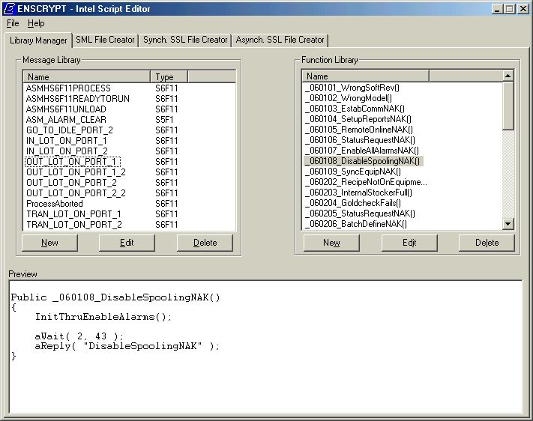
Figure 4: Intel Script Editor Screen Shot
5.2 Functionality Specifications
This section provides the previously listed functional requirements along with the actual outcome of our program.

Requirement | Actual Outcome
The program must load within 5 seconds. | Programs loads in less than 1 second.
The program must load all available messages within 10 seconds | Program loads all messages on startup. Occurs in less than 1 second.
The program must add messages to SML and SSL files within 2 seconds | The add time is unnoticeable to the user. Occurs in less than 1 second.
The program must save file within 2 seconds | The save time of files is unnoticeable to the user. Occurs in less than 1 second.
Program should not consume more than 15Mb RAM | Program uses on average 4Mb RAM.

5.3 Architecture Overview
The architecture of our design is divided into 5 major components, as can be seen in the Architecture Overview diagram below. Since our program is essentially a Database that is accessible through a Graphical User Interface (GUI), the GUI and Library Manager classes are the two most important parts of the architecture.
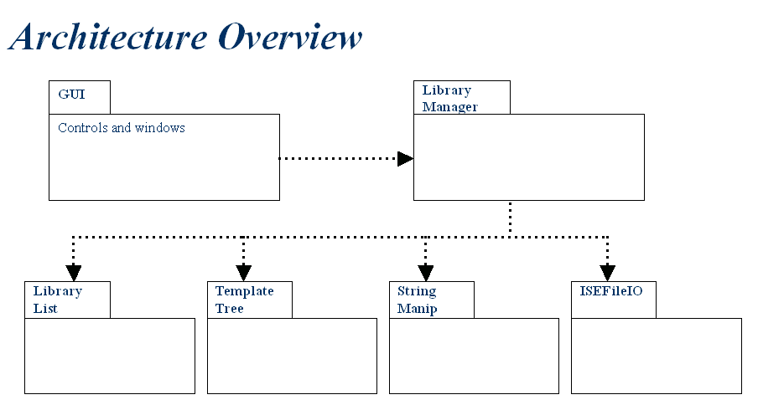

Figure 5: Architecture Overview

GUI: The GUI class is responsible for handling all of the User Interface aspects of the program. The GUI class draws all items to the screen and handles all user interactions, usually making calls to the Library Manager class.

Library Manager: The Library Manager is responsible for storing and maintaining the message template library, the messages library, and the function library as mentioned previously in this document. The user cannot modify the message template library, but can read from the library as necessary. The message and function library have the capability to have items added, edited, and deleted. In order to accomplish its job, the Library Manager uses the following classes.

Library List: The Library List class is simple a linked list data structure for storing the messages and functions. Even though all library items are stored directly to a file, the library elements are also loaded into a dynamic data structure when the program initializes. The loading process occurs quickly and then allows for fast access to the library items when necessary.

Template Tree: Since the message templates are a complex structure, we have devised a way to store every template into a tree structure. Every template stored in the library file can be loaded into a template tree and then can be used by the Library Manager.

String Manip: The String Manip class is a class that is used to manipulate strings. This class is extremely helpful in the tasks of parsing templates, message, and functions in order to get them into their proper data structures.

ISEFileIO: As the name implies, this class is responsible for handling all File Input & Output operations for the program. This includes reading an writing from the three program defined libraries as well as any file the user saves while using the program.

6. Usability Test
To gain more feedback and suggestions on our software, ENSCRYPT performed two different Usability Testing sessions. One session consisting of two Software Engineers in the Components Automation Systems Group at the Intel plant was performed on the 12th of April 2002 at the Intel plant in Chandler AZ. The other session consisting of three Senior Computer Science Engineering students at NAU who have no knowledge of SECS Message Language (SML) and SECS Script Language (SSL) was performed on the 19th of April and took place in Flagstaff, AZ.
6.1 Test Method
The method ENSCRYPT used for performing a Usability Test contains a few steps. Initially we gave the test subjects a pretest Questionnaire. The purpose of this was so we were aware of how knowledgeable the users were on the subject matter. The second step we called a Coaching Method. This is where we briefly explained the User Interface to the test person. We showed the user where certain things were, for example where to create a new SML Message, where to create a new SML file, how to open an Asynchronous SSL File, etc.
After giving the brief overview we gave the user some tasks. These tasks were:

- Create a new SML Message
- Create a new SSL Function
- Create a new SML File
- Create a new Synchronous SSL File
- Create a new Asynchronous SSL File
We then performed an Observation Protocol. This is where we sat back and observed the users as they attempted to complete the five tasks. We recorded times when they seemed to be a little confused or lost. We also recorded how long it took them to complete each task.

When the users had completed the tasks, we then performed a Question and Answer Protocol. This is where questions between the test person and members of ENSCRYPT were exchanged. Mainly the questions that we asked were based on the Interface, to see if they were happy with it in general. Does anything need to be added or omitted? We also wanted to see if the Interface was easy to learn and easy to use. Questions coming from the users were usually suggestions, which were documented for later use.
6.2 Outcomes
During our two usability-testing sessions we collected many suggestions for our program.

Some of these items were minor and some were a little more in depth. One item that we saw as a problem right away was the size of the application. Originally, we had developed this application to fit an 800 by 600 resolution. We noticed that some of the employees at Intel use a 1600 by 1200 resolution, making the application very small on the screen. We did not implement the program to be resizable so this was something we needed to look into. After researching this issue we had found that resizing our window would become quite complex due to our tab control with multiple objects within those tabs. We have documented what exactly needs to be done to get the program to resize and have left it for future development.

Another problem that occurred during these testing sessions was the placement of a carriage return, which would appear on all of our messages and functions. When the user created their files and scripts through our application, they would not compile in SECSIMPro (the software they use to run these scripts). This was an issue that needed to be fixed. To correct this problem, we added some extra functionality that would parse through each file before a save and take out all of the carriage returns so the messages and function would be compilable. In the table below, we have outlined the issues that were brought up at the usability testing sessions along with the result of each one.

Issue | Result
Carriage return on end of output | Fixed problem in Project Completion phase
Ability to Resize | Researched and documented solution, left for future development
Text coloring for keywords | Left for future development
Updating preview after an edit has been done | Fixed problem in Project Completion phase
SSL Syntax pop up menu bugs and additions | Fixed problem in Project Completion phase
Undo and Redo functionality within the rich edit boxes | Left for future development
Tabbing and auto indexing in rich edit boxes | Left for future development
Comment on the first line of SML message bug | Fixed problem in Project Completion phase
Hot key for pop up menu | Researched and documented solution, left for future development
Pop up menu to appear where user right clicks in Rich edit | Left for future development

6.3 Usability Summary
After performing the usability testing sessions, we’ve learned how important this phase is to the completion of a project. We gathered valuable information and ideas for improvement. We believe that our project was a usable application before the testing but it became even more usable after the testing sessions. We were able to modify the program to fit the needs of the client better, with the short time we had left. The items that had not been addressed have been left to be evaluated and fixed in future development phases of this project.
7. Conclusion
Intel is a world-leading company that has advanced in the fabrication automation process. But we feel that the current scripting process is a major weakness in Intel’s machine testing process. Our product eliminates this weakness and helps Intel yield higher profits.

After comparing the initial requirements to the actual result specifications, the completed program functions well beyond the desired requirements. Therefore, as a team, we feel this project was a complete success. Additionally, based on the results from the usability test, our clients have expressed their satisfaction with the program.

It is out sincere hope that this program will be a valuable asset to Intel as they begin using this product in the near future.

