

Technological Feasibility Document
Team Babylon
March 14th, 2026
By Alexander Anthis, Richelle Rouleau, Benjamin Jones, and Charles Haskins

Client
Chris Ortiz Senior Technologist, Rex Jackson Vice President
SanDisk Corp., Engineering & Product Management

Mentor
Jeevana Kalapala

Table of Contents
Table of Contents 1
1 - Introduction 2
2 - Technological Challenges 3
2.1 - Parsing the TLA Language 3
2.2 - Nested Language Support 3
2.3 - Learning the Rust Language 4
3 - Technology Analysis 4
3.1 - Introduction of the Issue 4
3.2 - Desired Characteristics 4
3.3 - Parsers 4
3.3.1 - Introduction 4
3.3.1.1 - TLC SANY 5
3.3.1.2 - Comby 5
3.3.1.3 - ANTLR 6
3.3.1.4 - Tree Sitter 6
3.3.2 - Quantitative Analysis 6
3.4 - Programming Language Analysis 7
3.4.1 - Language Features 7
3.4.2 - Onboarding 7
3.4.3 - Tree Sitter Library Support 8
3.4.4 - Tree Sitter Library Documentation 8
3.4.5 - Performance 9
3.4.6 - Quantitative Analysis 10
3.4.7 - Chosen Programming Language 11
3.5 - Proving Feasibility 11
4 - Technology Integration 12
5 - Conclusion 13

1 - Introduction
Writing TLA+ specifications is a difficult task. Making sure the logic is correct and that everything is working as intended without errors takes real dedication to understanding the core logic. When things don’t work, it can be hard to figure out why they aren’t working, especially when the specification is long and has taken a while to write. Staring at it and hoping to find the problem will probably not be the most helpful.
One of the best ways to find the issue quickly is to ask others for assistance. Of course, it may not be as simple as asking a coworker for assistance, as coworkers may be busy with their own work. Luckily, the TLA+ community is a decent group of people willing to help. The community includes some of the top logicians in the world, brilliant people who have worked with TLA+ for an incredibly long time. This wonderful community can easily be contacted through a Google Group that anyone can access, so anyone can potentially help solve the problem.
Unfortunately, the specifications that are being created may have sensitive data in them, meaning allowing just anyone to view these specs may lead to security issues. This leaves only a few possibilities. The first possibility would be to get one of these logicians to sign an NDA, which is tedious and difficult to ask a stranger on the internet to sign and uphold. The second option relies on the fact that logicians don’t necessarily need to understand the whole context for what they are debugging; they just need to be able to follow the logic and help get the specification to work as intended, so simply changing all the variable names in the specification might just solve the problem.
This seems like a simple solution: just change all the variable names of the section of the specification that seems broken, but once the thread has gotten a response, the responder needs the whole specification to give a concise response. Changing all the names of all the variables in a potentially long specification could potentially lead to breaking it more which, if the specification isn’t too important for security, then posting the whole specification may not be a problem, but definitely not a preferred solution.
The goal of CryPTO is to streamline the process of changing the variable names to hide the contextual purpose of a TLA+ specification while keeping the logic of the original specification so that the whole obfuscated specification could be posted in the Google Group or given to any brilliant logician who could still completely understand what the goal of the specification is without understanding the context of exactly what the specification is meant to be doing.
Some of the future goals of CryPTO are to make it so that a specification that has been obfuscated could be put into a Large Language Model (LLM) and have the LLM hallucinate and not be able to figure out the context for the specification. If CryPTO could obfuscate a specification enough that any outsider could look at the specification and understand the logic without knowing the full context, and having LLMs also not know what the specification’s context is would be useful.

2 - Technological Challenges
Now that we have outlined the purpose and goals of the project, we are ready to examine its technical feasibility in greater detail. This document serves as a Technological Feasibility Analysis that evaluates the key challenges and potential solutions involved in developing an obfuscator that can correctly parse the TLA+ language so that only variable names are changed, and the obfuscated specification keeps the same logic as the original. We began by identifying the primary technological challenges that our team anticipates throughout development. In the sections that follow, we analyze each challenge in depth, explore possible alternatives, and explain the rationale behind our chosen approaches. Finally, we discuss how these design decisions contribute to achieving a reliable, automated, and fully comprehensive testing solution for SanDisk. The first step of diving in depth into the feasibility of this project examines parsing the TLA language.

2.1 - Parsing the TLA Language
There are 3 possible approaches we can take to parse the TLA language:
- Create a set of regular expressions to find and replace the targeted words.
- Write a minimal custom parser from scratch to find and replace the targeted words.
- Find and use an existing parser to find and replace the targeted words.

The simplest method would be to capture strings matched by regular expressions, which are then replaced, though this method is imperfect as regular expressions can result in unintended matches, such as matching variables defined in different scopes along with matching (or not matching) language keywords. Another interesting part of the TLA language that shows why parsing the language is particularly difficult is its nested language support.

2.2 - Nested Language Support
In the TLA+ language, there is an additional language that can be nested inside it called PlusCal, which is nested inside a block comment. This presents challenges as it is another language we must parse, and can cause confusion with a regular block comment. Within this nested language, variables defined before can be reused, which presents mixed-language parsing challenges. This brings us to the type of solution that we would need to complete this problem and our programming language choice.

2.3 - Learning the Rust Language
Rust is universally known to be a very difficult language to learn, with a very steep learning curve. The majority of our team has never used the language before and will encounter many challenges as they come across Rust’s mainline features, such as the borrow checker and lifetimes. We intend to put in our best effort to learn as much as possible over the summer, but there will be inevitable roadblocks as the language is still new to us.

3 - Technology Analysis

3.1 - Introduction of the Issue
The biggest issue of the project is to parse the TLA+ and PlusCal languages. There are several approaches we could use:

3.2 - Desired Characteristics
Our program must:
- Parse through the TLA and PlusCal languages and correctly identify the parts of specifications that need to be obfuscated.
- Obtain a set of approved obfuscation words found within a “dictionary.”
- Create a dictionary mapping file that pinpoints the locations of what was changed, along with their original contents.
- Verify that the logic of the user-provided specifications is the same before and after the obfuscation by checking for the same TLC model checker results.
- Host documentation describing how the program should be used by end users.

3.3 - Parsers

3.3.1 - Introduction
Parsing a language is no small feat as languages are very complex and evolve over time. There are several approaches available to help us identify what elements to obfuscate:
- We could create a series of regular expressions to find and replace a limited set of strings, but that is an imperfect solution, as variable names can be the same as keywords. This means there is a reasonable chance this method would change the logic of the TLA specifications, which is unacceptable.
- We could write our own minimal custom parser to break down the TLA and PlusCal languages and identify the specific words we need to target. The biggest issue is planning and creating the parser, as that is an extraordinary amount of work, which would exceed the workload possible for this project and introduce many human-related oversights and errors.
- We could pass the specifications to a generative AI to handle the work for us. This method, however, opens several issues. First of all, we would have to send specifications to a third party service which may train their own models from the specifications we provide. This defeats the project’s main purpose is to protect sensitive information from entering the open internet. The second issue is that generative AI is known for being imperfect, which is unacceptable for this project as the project’s purpose demands perfection.
- We could use a parser library found online, such as Tree Sitter utilizing a community-made TLA+/PlusCal grammar or the first-party TLC SANY parser to offload the parsing from us so we can focus our work on identifying what strings we need to target rather than finding the strings in the first place. Additionally, tree-sitter boasts extreme fault tolerance, meaning that we can still find our target strings with incomplete and/or incorrect source files. Additionally, there are library bindings for a plethora of languages (Java, Python, and Rust included), which makes our programming language decision-making process very flexible.

3.3.1.1 - TLC SANY
One of the parsers we considered using was SANY, the official parser used for the TLC model checker, because it is used for the TLA+ tool set. Since the TLC model checker is written in Java, we can consider importing only the required parts of the TLC model checker that we need to verify our specifications. The SANY parser allows for XML exports of the Concrete Syntax Tree (CST) generated during parsing, which is very lengthy but includes all the information needed to extract variable names, types, and locations in the original file. However, this parser would be clunky to integrate into a non-Java program, since we would need to require or bundle a Java installation alongside the TLA+ tools.

3.3.1.2 - Comby
Comby is a tool for structural code search/replace that understands nesting (brackets, strings, comments). It's better than regex but less precise than a real parser. It works on syntactic patterns without a full grammar. For simple renames, it might actually work, but it can't reason about scope or variable binding, so we'd risk renaming things we shouldn't. It's also an external tool rather than a library, making Rust integration awkward. Also, finding documentation for any TLA+ grammar seems to be a difficult task on top of not even really finding them; however getting the tool up and working seems to be a relatively simple task. The biggest problem with it is the lack of a useful grammar for our case.

3.3.1.3 - ANTLR
ANTLR is a mature parser generator, but there are no available grammars for TLA+ outside of the parsers that use ANTLR. Those parsers that use it just use the ANTLR-generated parsers. So it would be difficult to find a public grammar that would work for every spec given to it. Meaning we would have to create our own grammar for TLA+ and PlusCal, but there is plenty of documentation from others on how they created grammars for the language. Additionally, the Rust target for ANTLR is experimental and poorly maintained. We would likely face binding issues, limited community support, and runtime overhead from the ANTLR runtime. If we were to choose to write this in Java, it’s possible this would be a choice, but with the lack of a widely supported TLA+ grammar and the high possibility of having to write our own to fit the circumstances, and with the chance of that only working for a set few specs, this tool might just make things more difficult than necessary.

3.3.1.4 - Tree Sitter
Tree Sitter is our parser of choice, which gives us incremental, error tolerant parsing with a concrete syntax tree that preserves exact source positions and whitespace. For a rename-refactoring tool, this is essentially the ideal combination: you need to find identifiers precisely, replace them, and leave everything else byte-for-byte identical. Tree Sitter has a TLA+ grammar available, Rust bindings are mature, and queries let you pattern-match on syntax nodes ergonomically.

3.3.2 - Quantitative Analysis
 | SANY | Comby | ANTLR | Tree Sitter
Difficulty | 3 | 1 | 5 | 4
Reliability | 4 | 0 | 1 | 5
Workload | 2 | 0 | 1 | 5
Total | 9 | 1 | 7 | 14

3.4 - Programming Language Analysis
An important decision for each project needs to be made: What programming language should we program it in? In section 3.3.2, we decided that Tree Sitter was the parsing library we are choosing to use for our project, which allows us to focus some factors into the usability of our chosen library.
We will be limiting our review scope to the languages Rust, Python, and Java. We chose Rust due to its speed and type-safety, Python for its ease of use, and Java for its theoretical increased compatibility with the TLC model checker. Sections 3.4.1 to 3.4.5 rate different factors across the three languages on a scale from 1 (poor) to 5 (great). Each rating will then be compiled into a table in section 3.4.6.

3.4.1 - Language Features
The biggest feature of Rust is its borrow checker, which catches and eliminates most memory bugs in sequential programs. Rust’s type ecosystem, particularly the Result and Option data types, which force the developer to handle errors. These Rust features land the language at a 5/5 rating.
Python is a universally adored programming language as it is a very simple language and is very easy to learn, read, and write in. The Python interpreter is installed by default on UNIX-like operating systems, but needs to be downloaded on Windows. The lack of a static type system is simultaneously one of the language’s biggest strengths, as it makes scripting simple and easy, while also being one of its biggest pitfalls, as it makes it easy for the language to unintentionally break at runtime. The combination of ease of use, while also being too lax, leads us to give Python a 4/5 for language features.
Java is reliable as the language hasn’t changed much in recent years. Using Java would allow for direct inclusion of the TLC model checker and parser, meaning that all the relevant libraries and necessary code could be combined into a single final package. Java is also platform-agnostic due to its JVM, which aims to achieve near-identical behavior on any operating system. However, users are required to install the Java runtime, and developers are required to install their respective Java developer kits. Java’s language features are great, but require some setup from our users, which is why we decided to give Java language features a rating of 4/5.

3.4.2 - Onboarding
Learning Rust is well known for being notoriously difficult to learn. The syntax can be confusing at times, and fighting the compiler and the borrow checker for some time are requirements for learning to write good Rust code. Once the learning curve is passed, the language becomes much easier to use. This difficulty lands Rust at a 2/5 for onboarding.
Python is by far one of the easiest languages to learn, as it is very simple. It comes with a command-line shell that lets you play and experiment with the language. Describing code written in Python is very simple, as it’s closest to human language of the three analyzed languages. These benefits land Python’s onboarding rating at 5/5.
Since Java is very old and very popular, there’s a plethora of guides and tutorials online to learn the language, which makes it very easy to pick up. The biggest problem, however, is setting up the developer environment, as it’s different on each operating system, and the workarounds needed to load libraries can lead to very unpleasant developer experiences. The amount of setup and workarounds needed lands the language at a 3/5 for onboarding.

3.4.3 - Tree Sitter Library Support
Tree Sitter is a library that has bindings to many different languages, including but not limited to Java, Python, and Rust. Python and Rust also include the “tlaplus” grammar as a separate package installable via their respective package managers, while Java requires a compilation of the “tlaplus” grammar to work with TLA specifications, which greatly complicates our build process. Each binding implementation is very similar as they follow the same code pattern, though with slight differences due to integration into their respective languages. This lands Rust and Python at a 5/5 for Tree Sitter library support, while the lack of a tlaplus grammar packaged as a Java library lands Java’s Tree Sitter library support at 2/5.

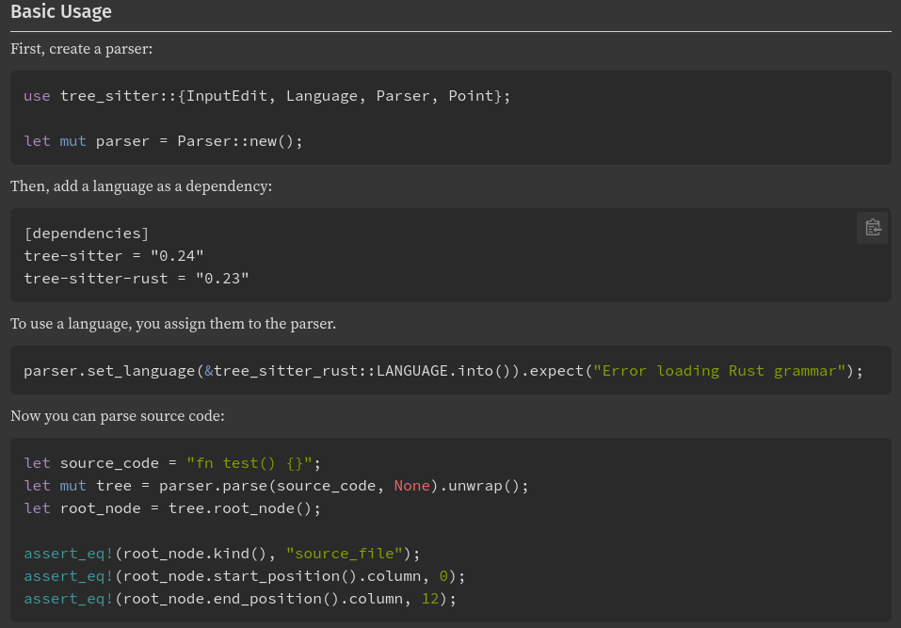
3.4.4 - Tree Sitter Library Documentation
Learning how to use the Tree Sitter library is very important to using the language for the creation of CryPTO. While Tree Sitter has libraries available for Rust, Python, and Java, the documentation for each language significantly differs.
The Tree Sitter documentation for Rust contains definitions for everything the language offers, including modules, structs, enums, constants, traits, and functions. Additionally, the documentation is easy to find as it is hosted on docs.rs and contains a mini-tutorial to get started on its front page. The Rust documentation for Tree Sitter is fantastic, which is why we rate it 5/5.
For Python, the Tree Sitter documentation only shows the language bindings without providing any examples showing how to use them. The documentation for each binding shows good warnings, such as runtime expectations and method alternatives. The documentation is functional, but it might be better to reference another language’s bindings, which is why we rate Python’s Tree Sitter documentation at 2/5.
The Java Tree Sitter documentation is a good middle ground as it mostly contains class and interface documentation, but also consists of a very simple “Basic Usage” demo showing the most basic way to use the library’s Java bindings. The Tree Sitter documentation for Java is good for people already familiar with Java documentation, which is why we would rate Java’s Tree Sitter documentation at 4/5.

3.4.5 - Performance
The performance of each language we are analyzing is an important factor. For this benchmark, the same project was created with AI using opencode with the Big Pickle model with the goal of querying “identifier” and “identifier_ref” nodes and printing the variables along with their start and end locations to the terminal. Once these individual programs reached their goals, each program was benchmarked using the “hyperfine” command-line tool with 100 runs per program. Here are the specifications of the computer on which the benchmarks were run:
- System: Dell XPS 15 9500 (2020)
- CPU: Intel® Core™ i7-10750H (6 cores, 12 threads)
- Operating System: Debian 13
- Power Profile: Performance
- Rustc Version: 1.94.0
- Python Version: 3.13.5
- Java Version: OpenJDK 25.0.2

Note: The graph below depicts execution time in a logarithmic scale due to the great difference in performance scale across languages.

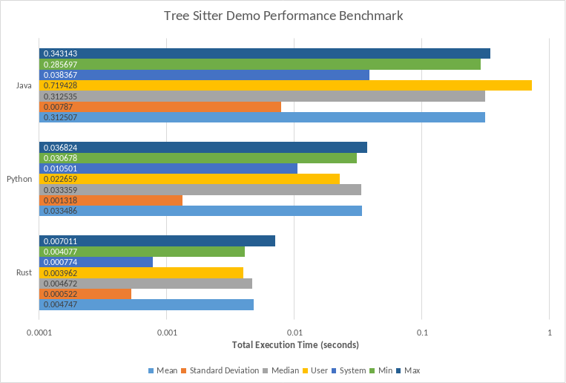

From our data, the Java program was consistently the slowest performer, averaging at a 343.1ms execution time, which can be felt when executing the program manually, especially on lower CPU power profiles. We believe the total execution time is high for Java due to the need to start up the Java Virtual Machine on each execution, taking up the majority of the time. The poor results land the language at a 1/5 for performance.
Python ended up in second place with a very respectable 36.8ms average execution time. We have seen Python become very optimized over the years despite being an interpreted language. This lands Python’s performance rating at a 4/5.
Rust blazes the path by executing its program in release mode at an average execution time of 7.0ms. Rust is known for comparable performance to C, as programs must be compiled to run, and our benchmarks certainly show it. Rust’s exceptional performance gives it a 5/5 rating.

3.4.6 - Quantitative Analysis
 | Rust | Python | Java
Language Features | 5 | 4 | 4
Onboarding | 2 | 5 | 3
Tree Sitter (TLA) Library Support | 5 | 5 | 2
Tree Sitter Library Documentation | 5 | 2 | 4
Performance | 5 | 4 | 1
Totals | 22 | 19 | 14

3.4.7 - Chosen Programming Language
Based upon the ratings described in this section, we have determined that Rust will be our language of choice for CryPTO due to its strict compiler, great Tree Sitter library support, great documentation, and spectacular performance.

3.5 - Proving Feasibility
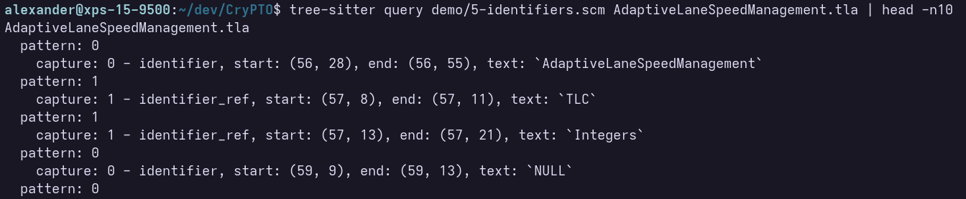Tree-sitter producing a list of identifiers, their location in the original file, and their text
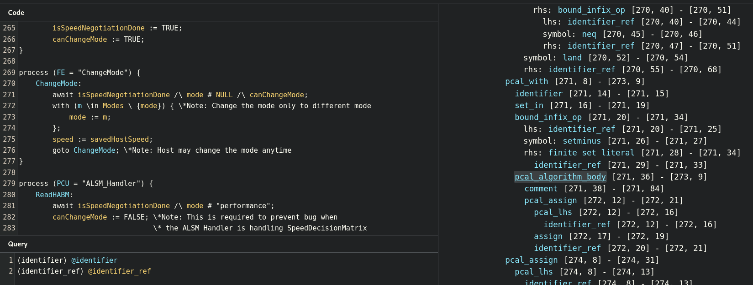
Screenshot of the Tree Sitter playground highlighting identifiers (top-left) as matched by the query (bottom-left)

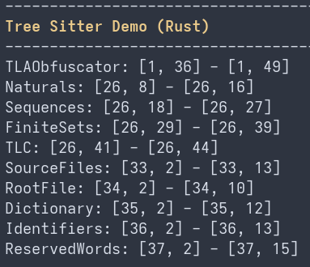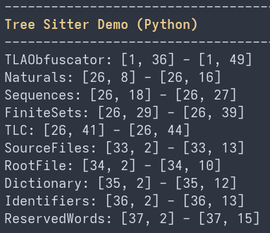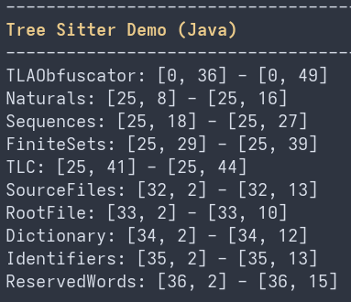
Screenshots of the Tree Sitter library demos in Rust (left), Python (center), and Java (right)

4 - Technology Integration
After analyzing the relevant tools available to us, we’ve decided that CryPTO will be utilizing 2 major technologies: Rust and Tree Sitter.
CryPTO will be a Rust program that reads a TLA+/PlusCal specification along with its dependent specifications, parses each of the specifications with the “tree-sitter” Rust crate while utilizing a community-driven TLA+/PlusCal grammar found in the “tree-sitter-tlaplus” crate, which will create an Abstract Syntax Tree (AST).
We will then be filtering the tree using a tree sitter query to identify the nodes within the AST that we need to target our obfuscation at. Once we have our selected nodes, we can link the nodes that have the same value, then rename the “variables” for each distinct node chain.
The CryPTO program will keep track of the location of the words it has targeted, along with their original and randomly chosen dictionary names. The program will then organize and store the information in a new dictionary mapping file alongside an obfuscated TLA specification generated by CryPTO.

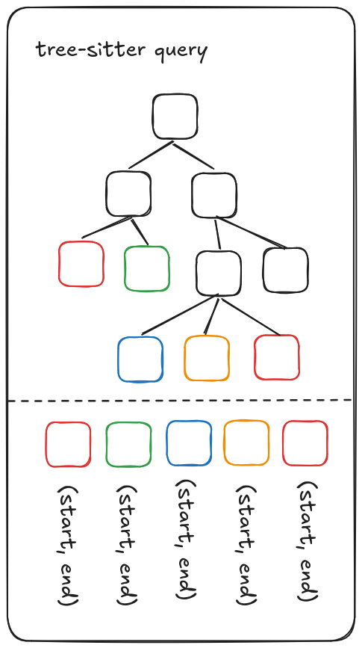
A visualization of Tree Sitter’s generated Abstract Syntax Tree (AST)

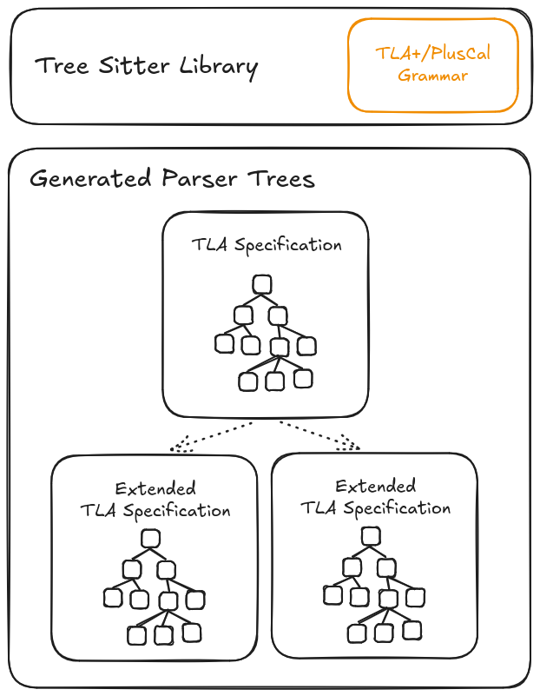
A diagram showing how an AST is generated for each loaded TLA specification
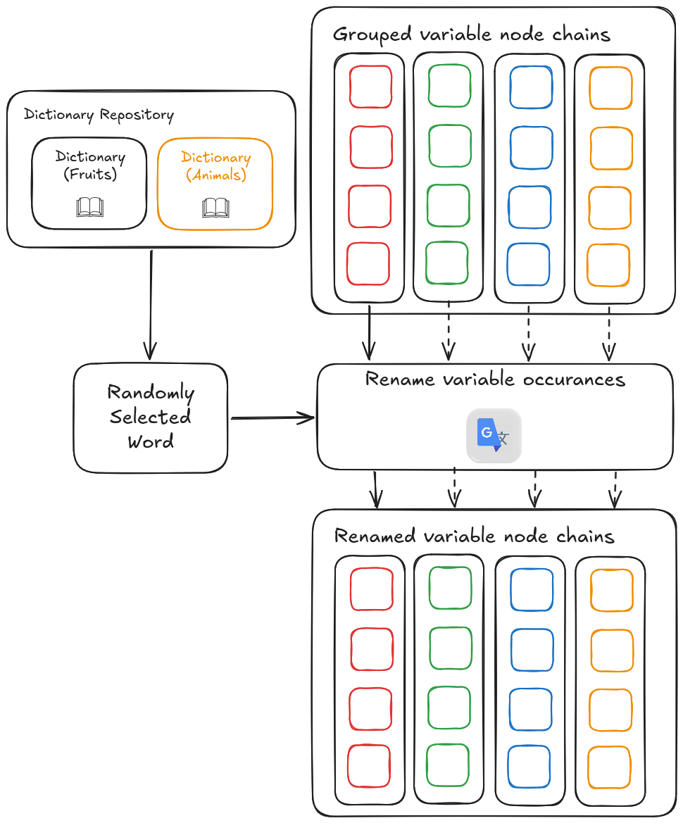
A visual representation of how the obfuscation process occurs

5 - Conclusion
Our primary goal with CryPTO is to build and maintain user trust, as the success of the program depends heavily on it. To do so, we must assemble a program that will correctly obfuscate its specifications reliably, consistently, and quickly. The tools that we have outlined and chosen in this document aim to fulfill this goal.
The biggest focus will be on parsing the TLA+ and PlusCal languages using Tree Sitter with the tlaplus grammar developed by active members of the TLA+ community, which we will use to perform reliable and trustworthy obfuscations. While we work at creating the optimal tree sitter query to make our program work as intended, we will have the power of Rust by our side to help us make sure we cover as many cases as possible while preventing unintended low-level mistakes.
Our program will utilize the power of Tree Sitter and Rust to change only what is needed while preserving program correctness, while also maximizing how robust the program will be. By doing so, we will directly address the needs of SanDisk by automating and speeding up the obfuscation process while preserving information security.

