Tab 1



Requirements Document | Ver. 1
Team Babylon
April 12, 2026
By Alexander Anthis, Richelle Rouleau, Benjamin Jones, and Charles Haskins

Client
Chris Ortiz Senior Technologist, Rex Jackson Vice President
SanDisk Corp., Engineering & Product Management

Mentor
Jeevana Kalapala

Table of Contents
Table of Contents 2
1 - Introduction 3
2 - Problem Statement 5
2.1 - Sponsor Workflow 5
2.2 - Application Context 6
3 - Solution Vision 7
3.1 - Features 7
3.2 - Data Pipeline Model 7
3.3 - Sponsor Impact 8
4 - Project Requirements 9
4.1 - Functional Requirements 9
4.1.1 - Variable Identification & Replacement 9
4.1.2 - Inputs, Outputs, and Machine Permissions 9
4.1.3 - Obfuscation & Deobfuscation 10
4.1.4 - Integrity Verification 10
4.2 - Nonfunctional (performance) Requirements 10
4.2.1 - Usability 10
4.2.2 - Programming Language 11
4.2.3 - Performance 11
4.2.4 - Code Hosting, CI/CD, and Documentation 11
4.3 - Environmental Requirements 11
4.3.1 - Operating System Compatibility 11
4.3.2 - Libraries 12
4.3.3 - Package Management 12
5 - Potential Risks 12
5.1 - User Error 13
5.2 - Product Failure 13
5.3 - Non-product Failure 14
6 - Project Plan 14
7 - Conclusion 16
Glossary 17
Appendices 19

1 - Introduction
The global data storage industry is extremely important to the modern digital economy, especially with the rapidly growing use of AI. The current global AI-powered storage market size was estimated at USD 30.57 billion in 2024 and is projected to grow with the currently increasing use of AI tools and technologies. With the current demand for the storage device market, the competitive and innovation-driven nature of this ecosystem demands that customers have trusted and reliable product solutions and confidence that their data will be maintained with integrity.

Our project sponsor, SanDisk, is one of the leading developers and manufacturers of flash memory storage products in the world. SanDisk is contributing to AI memory storage by developing high-capacity NAND flash solutions that address the “memory wall” in AI inference and training, through High Bandwidth Flash (HBF) and advanced enterprise solid-state drives (SSDs). Focusing on scaling storage capacity, lowering power consumption in data centers, and providing fast, dense storage for AI models. SanDisk has a global outreach and places high value on innovation and manufacturing excellence. SanDisk’s business model is based on producing the highest quality and performance in its engineering and design.

Our project, Cryptic PlusCal and TLA⁺ Obfuscator (CryPTO), is a low-level project that will be utilized quite early and will be used mostly in the design process. Our project deals with a very mathematical language called TLA⁺, which also has a nested language called PlusCal. These languages are used to help create specifications for SanDisk’s products. PlusCal is a bit more like a coding language, whereas TLA⁺ is more mathematical and not quite how all programmers think in terms of any programming language, making it very difficult to learn. However, the community for TLA⁺ is very friendly and always willing to help; one can easily find an online community dedicated to TLA⁺ and get answers from some of the top logicians who work with TLA⁺.

This is very useful for SanDisk, as the majority of people in the company are unfamiliar with the languages, so for those who work with the language at SanDisk, it makes it difficult for those who know the language, as they don’t have a lot of coworkers to go to if they need any help with any given specification they are working on. Therefore, the main source for help with a specification would be the TLA⁺ Google group or other experts outside of the company. The main issue is that this platform is completely public and non-confidential. While this allows many people to access and potentially contribute to the specification, it also creates a significant risk. If a specification containing sensitive SanDisk information is shared in this environment, it could be exposed to individuals outside the company, leading to unintended information leaks. The first thing that comes to mind in this situation would be to find one of these logicions and ask them to sign an NDA, then ask them to look over the specification. The problem with that is NDA’s are really tedious to fill out, plus asking a complete stranger over the internet to sign an NDA, which doesn't make sense for the situation and is also extremely tedious especially if the need for outside experts increases. The second option is to instead manually go through the specification and change out all the variable names to anything different so that company outsiders do not have the context for what the specification is actually used for.

This is where our team comes into the picture. Our project is meant to remove the hassle of having to change all variable names and remove pseudocode, in addition to eliminating the issue of lacking confirmation that the original functionality was untouched after obfuscation. Considering that by manualling doing the task of changing the variables could change the specification and break its functionality before it can be looked at by one of these logicians and fixed, just means that the specification they are seeing isn’t necessarily what was expected for them to even be looked at in the first place. We are removing the issue of accidentally incorrectly changing variable names.

Our project's aim is to replace variable names and other specification-specific documentation with obfuscated variables while maintaining the integrity of the functionality for all files and specifications modified. We will accomplish this using dictionaries of words that we will replace the variables of specification specific code. Through doing this, the context of what the specification is doing, and private company information is removed from the shared documents while maintaining the logical integrity allowing SanDisk to gain assistance on private files without sharing what they contain. The actual output from the specification will remain intact as the original meaning, and debugging the logic will result in the original, but fixed, specification output without losing any data within the company.

2 - Problem Statement

2.1 - Sponsor Workflow
SanDisk is currently implementing TLA⁺ to specify their electronic systems and to identify flaws in design and architecture. Figure 2.1.1 below shows how this is helpful for SanDisk’s workflow. Since this is a recent and ongoing development, and many employees are still familiarizing themselves with the language, SanDisk often has to get help writing and editing specifications by contacting experts in the TLA⁺ community. To do this while avoiding leaking trade secrets or in-development designs, employees must manually rename important variables and remove comments that explain the purpose of the specification before sharing it online. Another option is drafting non-disclosure agreements (NDAs) with these experts and contracting with them to answer questions, but this route is often prohibitively slow and expensive compared to the former option.
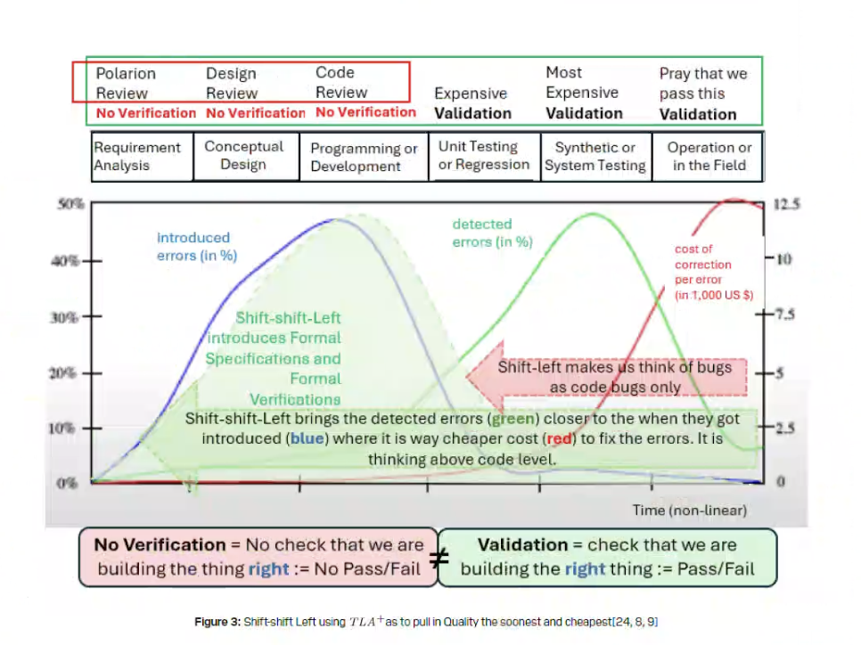
Fig. 2.1.1

2.2 - Application Context
This process is very error-prone, since manual editing can miss occurrences of names and change the logic of the specification. A simple automated solution, such as find-and-replace, might also target TLA⁺ keywords and cause syntax errors. The main problems CryPTO sets out to solve are the following:

- The current process is slow and error-prone
- No easy way to get help with and share TLA⁺ specifications without manual review or leaking potentially sensitive information
- The current process must choose between convenience/speed and security/integrity

3 - Solution Vision
Our proposed solution takes the form of a command-line interface (CLI) program that SanDisk employees can provide with a TLA⁺ specification, where the program then obfuscates that input specification while keeping the logical structure intact and correct.

3.1 - Features
The main features of CryPTO include:

- Parsing of any TLA⁺/PlusCal specification
- Removal of all non-essential text, such as comments
- Obfuscation of variable and module names
- Verification of specification integrity and correctness before and after program execution
- Output of obfuscated specification and proof of correctness, along with a dictionary linking names before and after program execution
- Command-line options to modify name replacement, error handling, verification, nested module parsing, and file outputs
- Deobfuscation given an obfuscated specification and a dictionary file

3.2 - Data Pipeline Model
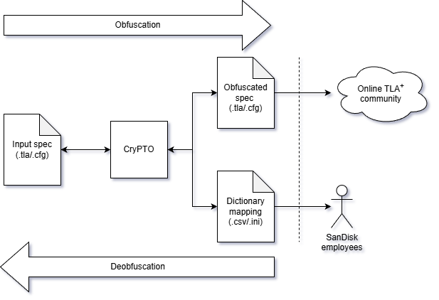

3.3 - Sponsor Impact
CryPTO solves the problems outlined in section 2.2 in the following ways:

Problem: Current process is slow and error-prone
Solution: As an automated tool, CryPTO will make obfuscation much quicker and more reliable.

Problem: No easy way to get help with and share TLA⁺ specifications without manual review or leaking potentially sensitive information
Solution: CryPTO will make it easy to ask for assistance from experts, since it eliminates the risk of information leaking with obfuscation.

Problem: The current process must choose between convenience/speed and security/integrity
Solution: CryPTO will be built with security and integrity in mind, and its features will naturally include convenience and speed, so there is no need to choose.

4 - Project Requirements

4.1 - Functional Requirements

4.1.1 - Variable Identification & Replacement
CryPTO will use Tree Sitter to identify words to be obfuscated. These include variables, constants, and module names. However, there are some keywords that an identified variable may be next to, which must be ignored, such as EXTENDS. The reliability of CryPTO comes from correctly identifying the words that need to be replaced, which is why we plan to use Tree Sitter to help us precisely find the words we are looking for.

The TLA+ language additionally supports nesting the PlusCal language within it, which is why CryPTO must be able to operate on both the TLA+ and PlusCal languages. Luckily, the TLA+ grammar for Tree Sitter also creates an Abstract Syntax Tree (AST) for PlusCal and can differentiate standard comments from the beginning of a PlusCal section.

For each variable identified, CryPTO will replace all occurrences of the variable with a word randomly selected without replacement from a plain-text bank of unique words where each line contains a single word.

In addition to replacing variables with random words, all comments must be removed from the obfuscated specification. It must not mistake nested PlusCal code for a comment.

4.1.2 - Inputs, Outputs, and Machine Permissions
The CryPTO program will read a single TLA specification as input from the user via a command-line argument. As a “.tla” file must have a corresponding “.cfg” file, the program will consider the corresponding configuration file as an input. Additionally, as TLA specifications can recursively import another TLA specification, the specification tree will be considered another input.

The program will output a TLA specification file similar to the input specification, which will be either obfuscated if the program is run normally or deobfuscated in deobfuscation mode. CryPTO will also output an obfuscation key if under obfuscation mode, which will become an input in deobfuscation mode.

4.1.3 - Obfuscation & Deobfuscation
The CryPTO program must be able to both obfuscate and deobfuscate a given specification. The deobfuscation will be triggered by an option set by the user during runtime.

After the obfuscation process, the CryPTO program must create a dictionary file that maps the originally identified variable with the randomly selected word that is replaced with. The key must be in a CSV file, with the columns consisting of the original value and the corresponding randomly selected word. Each line will contain a new entry.

The process of deobfuscation will involve reading the CSV dictionary file and replacing each randomly selected word found in one of the columns with its corresponding original value found in another column.

4.1.4 - Integrity Verification
To assure the user that the specification’s logic remains intact, CryPTO will run the TLC model checker on the originally provided specification and the obfuscated specification, and compare the results of the two. If the results of the TLC model checker are the same, then the integrity of the obfuscated specification has been verified.

The use of the TLC model checker requires that the TLA tools software is included in the code repository and is bundled with the end program. The CryPTO program must call the system-installed Java runtime which is assumed to be installed on the local machine to run the model checker.

If the initial parse and model check fail for some reason, the CryPTO program must not proceed and must instead quit with a descriptive error message, without processing the input specification or creating any output files. This behavior may be modified by the user at runtime.

4.2 - Nonfunctional (performance) Requirements

4.2.1 - Usability
CryPTO will contain a usable and friendly user interface, which includes a help page accessible via the command-line when the user specifies, such as by a flag or similar option. This help page must list out the program’s basic usage and each available flag the user can use with the program, along with a short description of what it does.

4.2.2 - Programming Language
CryPTO will be written in the Rust programming language as it will be the easiest language to work with Tree Sitter in, and is also the language used in the rest of SanDisk’s TLA+ ecosystem. We also plan to take advantage of the features the Rust compiler enforces upon developers, such as the borrow checker, lifetimes (where applicable), Cargo, and programming patterns that force exhaustive code.

4.2.3 - Performance
Formally, the CryPTO program must complete execution within 5 minutes of its start. However, we believe we can complete program execution with a file input tree consisting of 3 500-line specifications in under a second. Good performance is not critical for our project, but it’s a good, nice-to-have.

4.2.4 - Code Hosting, CI/CD, and Documentation
The source code for CryPTO will be hosted on GitHub in a private repository. The repository will be private during development, though its publicity in the future may change depending on the success of CryPTO.

While it is not a necessary part of the project, we would like to automatically build compiled binaries of the program that users can easily click and download. These binaries will be built on a GitHub Actions runner for each platform we will be targeting. Additionally, pull requests to the main branch of the project will trigger a workflow to test the program on every commit to it. Tests for non-main branch merges will be run as required.

Documentation on the usage of CryPTO will be hosted on our GitHub repository page via GitHub Pages and will be written in Markdown. It will describe how users are expected to install or compile the program, and will discuss how to use it as well.

4.3 - Environmental Requirements

4.3.1 - Operating System Compatibility
The CryPTO program primarily targets Windows, with Mac and Linux compatibility being optional targets. CryPTO must also be compiled for x86_64 CPUs primarily, with ARM binaries optionally available.

4.3.2 - Libraries
The external libraries CryPTO will use include tree-sitter and tree-sitter-tlaplus, which are available for the Rust programming language on crates.io. CryPTO will also be using the csv library for generating and parsing the deobfuscation key in addition to the random library which will be used to randomly select words from a dictionary. Additional libraries to improve the development of the program may be added in the future.

4.3.3 - Package Management
Our program will download its libraries using the Cargo package manager, which comes bundled with the Rust programming language. Libraries for CryPTO will be fetched at compile-time and compiled just before the CryPTO project itself is compiled.

5 - Potential Risks
It is important to consider with any product the scope of impact for every possibility that can go wrong. Not only is it important to the stakeholders, but also the users alike, that if there is a major technological failure of any system, it is always necessary to predict the possible outcomes such that worst-case scenarios can be mitigated and contingency plans created. For this project and proposed solution, the scope of impact of a failure in general is quite minimal. There are three types of risks for this particular solution and their subcases, as well as stretch impacts within each type; but on the large scale of consequence pertaining to technological failures, the worst large-scale loss of life, the worst case damage is purely business-related or financial.

The three types of major risks that cover almost all potential failures include user error, product failure, and non-product failure. User error can occur when the delivered product is not used correctly or in its intended manner within the company. Product failure can be defined as any failure within the delivered product when the product is used correctly. Non-product failure, on the contrary, also occurs when the product is used correctly but pertains to all issues that could still occur outside of product malfunction (cases when the user and product both work correctly). The only other relevant risk that will not be covered in the other three categories but is still relevant is competitor products. This will not be covered within the scope of other possible risks, however, because the risk often remains the same across almost all products; a product is created that deems the current delivered solution unusable, inefficient, or too costly for the company, in which case the delivered product is removed from the company, causing chain dependency issues for anything relying on the delivered product.

5.1 - User Error
User error is the most common risk for a product of this type; however, most cases tend to be the least costly of the other major types. User error with our product will most likely look like one of the following; incorrect format of TLA+ input spec, incompatible or out-of-date hardware, rule breaking (README.md will contain all rules for correct use of the product with final delivery), or unintended use. In the cases of incorrect format of TLA+ input spec as well as incompatible or out-of-date hardware, the effects will almost always be contained to the working machine (the program should not be able to run). With the proposed solution, the CLI will throw an error without proceeding, and almost all cases will be resolved. The only edge cases would consist of either a corruption of product output files (non-critical, but likely obvious if product deviates from expected functionality) or an incorrectly formatted TLA+ spec passing through the program correctly, causing undefined behavior and being the only likely case in which a user error could possibly cause outside of their own machine (or possibly through the company) without directly violating documentation rules.

For the cases of rule-breaking or unintended use, the damage will almost always depend on the users. It is difficult to fully scope out the damage that this could cause because it could involve almost anything. The best way this can be mitigated is through reading and following the tool documentation, user-to-user training, and ensuring that any user of the tool must also do so. If this is achieved, then all cases of these particular risks will be mitigated.

5.2 - Product Failure
In almost all cases of perceived product failure, the effects will be noticeable through the product not working at all; containing any potential damage to the costs of product downtime. The only edge cases are where the product either produces incorrect/partially obfuscated output specs, or an incorrect dictionary mapping. In the prior, the worst case possibility is that the TLA+ spec functionality can be determined and is then shared outside the company causing private company information to be leaked. This would be the most drastic case of all perceived product failures where the damage would be dependent on the sensitivity of the leaked data. The latter case however would only cause the output spec to most likely be non-human readable while still preserving the functionality of original spec; meaning after outside help with the spec is implemented onto the obfuscated spec, original variable names and pseudocode could be added back manually with some effort.

5.3 - Non-product Failure
This type of risk is mostly speculative, but could possibly contain more drastic damage than the prior two types. An example of a non-product failure could include anything from incorrect outside assistance to internal company failures. The types that do require acknowledgement with special consideration to the possible damage scale are incorrect outside assistance and possibility of reverse engineering. Due to the primary use case of this product being to obfuscate TLA+ specs for the goal of gaining assistance on their functionality from outside the company, the realistic risk that comes with this use case is the intention or short-comings of the outside help that is received. Although these risks can mostly be covered through company contracts for outsourced work, they should still be addressed due to the amount of damage a corrupted spec could cause if mass implemented; or in the case of reverse engineering either the spec or the obfuscator and the spec, the entire product could be open sourced in addition to a data breach. Although the worst case risks of either of these cases occurring are financial and can be mitigated, they should be addressed and considered with the use of this product.

6 - Project Plan
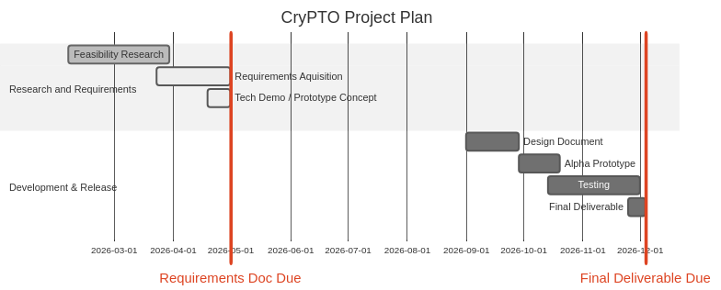
Upon delivery of the full requirements documentation to SanDisk, our team will continue moving forward into the testing phase. Our projected completion of the design document in late September which will contain our full plan for the Alpha prototype will initiate the testing phase and official prototyping. Throughout the development of our Alpha prototype, various prototypes will be deployed, reviewed, tested, and re-deployed until we have a completed working product. Once the first iteration of our working product is completed, which is speculated to be towards the end of October, we will then enter the official testing and review phase where we will formally identify all known issues of the product that have not already been resolved or documented (as well as unpreventable issues) as well as ensure all finalization steps are taken. Our final product is projected to be completed by late November, and officially delivered to the client by early December.

7 - Conclusion
Team Babylon aims to increase the ease with which SanDisk can work with the language TLA+. With the adoption of TLA+ within SanDisk to standardise workflows and project development, there arises a need for TLA+ experts outside of SanDisk to assist within the company without being able to access private company information. The CryPTO project and proposed solution would allow SanDisk to obfuscate specifications written in TLA+. This proposes a solution to leaking company information pertaining to TLA+ specifications when outside help is required to debug or implement solutions that involve the language.

The proposed solution also allows for any other use cases that require obfuscated TLA+ specifications with preserved functionality. The proposed solution of Team Babylon involves creating a CLI that takes an input TLA+ specification, parses it using TreeSitter and produces an obfuscated TLA+ output spec using Rust along with a dictionary key to decipher the obfuscated spec. The importance of this project for SanDisk is foreseen to grow as TLA+ is adopted in a standardised fashion through more departments of the company. With more departments using TLA+, the need for TLA+ experts will also increase and therefore our product.

With the completed documentation and scoping of our proposed solution, our team can now shift focus primarily to production and prototyping shown within the project plan. With the rate our solution is developing, Team Babylon will have completed prototyping by the beginning of September and a final product by the end of November of 2026. For our sponsor, the development of this product will assist in the use of TLA+ throughout SanDisk as well as to utilize it most efficiently while maintaining the confidentiality of their company.

Glossary
CryPTO - Cryptic PlusCal and TLA+ Obfuscator

TLA⁺ - Temporal Logic of Actions, a mathematical specification language used to create and verify mathematical and logical models

PlusCal - High level algorithm language designed to simplify the creation of TLA+ specifications

TLA⁺ specification - a high-level mathematical model used to design, document, and verify complex concurrent and distributed systems

Obfuscation - the deliberate act of making communication, data, or code unclear, confusing, or harder to understand

Deobfuscation - the process of reversing "obfuscation"—the deliberate scrambling of computer code to make it unreadable—back into a functional, human-understandable form

AST - An Abstract Syntax Tree (AST) is a hierarchical, tree-structured representation of source code's logical structure, used by compilers and interpreters to understand program intent

CI/CD - Continuous Integration and Continuous Delivery/Deployment, a DevOps practice that automates the building, testing, and deployment of software to speed up development cycles and increase reliability

Formal Verification - the process of using rigorous mathematical methods to prove or disprove the correctness of a system (hardware or software) with respect to a formal specification, ensuring it behaves as intended under all possible conditions

LaTeX - a high-quality, open-source typesetting system and markup language used to create professional documents

Rust - a multi-paradigm, general-purpose programming language designed for performance, reliability, and safety

SanDisk - prominent American multinational semiconductor company

Appendices
