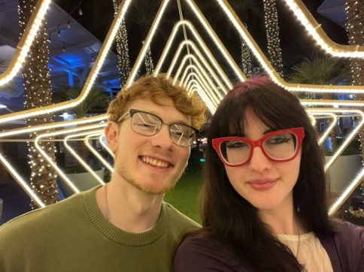
Olivia Vester, orv9@nau.edu
Project Preferences
Dear Professor Shaffer,
I am a senior Computer Science student ready to begin my capstone experience. My main interests are held within jurisdictions regarding the assistance of important communities like firefighters, environmental scientists, researchers etc. Due to my personal alignment with environmental preservation efforts, I have a strong disinterest in working with AI due to its negative environmental impact.

My interests can be summed up as:
- Measurement system development – I currently work for Dr. Vigil-Hayes’ lab where we develop mobile apps for internet measurement. I believe this to be a beneficial tool and that developing such tools is both fun and important; this is what intrigues my involvement.
- Mobile app development – This goes in hand with the interest of measurement system development. A mobile app can be anything and that includes the ability to be a useful tool, which is what I’m interested in.
- Data organization – Something I personally enjoy is the organization of large databases. I have dealt with many situations involving big amounts of unorganized data, especially through campus extracurricular organizations, and I find I have a lot of interest in streamlining overly complex messes, like databases.

My strongest technical skills are in C, Python, and C++ programming. I have helped develop disease tracking systems using the Python language during my NAU/NASA Space Grant internship for one of Dr. Doerry’s labs which highly strengthened my Python skills. Aside from Python, C and C++ are the languages I use most prominently throughout my schoolwork. Extracurriculars have also given me experience in technical aspects that other students may not have.

Overall, my technical skills can be identified as:
- C, Python, C++, C# programming from school and work experiences
- HTML/CSS, Unity, and Linux skills from course work
- Audio, lighting, and radio engineering from KJACK radio and working as a theater technician
- Microsoft Office skills (especially Excel) from various course work and leadership positions

1. My first choice of project is the “Measurement System Automation” with Steve Miller at HeetShield. I have a strong interest in this kind of engineering that crosses over with computer science, especially when it is something that can be beneficial to important communities like fire fighters. I have skills that align with the project’s specifications such as experience with safety procedure regarding industrial equipment and items like power tools. I am also very familiar with Python as a language.
2. My second choice of project is “A Mobile App to Enhance Sustainability Awareness” with OP Ravi at Willow. My interest in this project comes from my desire to contribute positively to environmental conservation efforts. I also have skills aligning with the project’s specifications like C# programming experience, understanding of databases, and mobile development experience from both lab and course work.
3. My third choice of project is “Generative Testing of SSD using TLA+ Model-Simulation” with Chris Ortiz and Western Digital. This project is a little outside my conventional interests, but I know individuals who have worked with the SSD testing in the past and I’ve always been interested in getting to know more about their work. Beyond basic curiosity, I have Python knowledge and the ability to quickly pick up TLA+ understanding and NVMe knowledge.
4. My fourth choice of project is “Migration of MS Access Curatorial Database to Open-Source RDBMS” with Dr. Kayeleigh Sharp here at NAU. This project aligns with my interest in database organization as well as my interest in helping important communities, in this case researchers. I have some skills in interface design as well as user experience and could pick up any of the other necessary skills needed for the conduction of this work.
5. My fifth, and final, project choice is for “Haptic Rendering with Franka Robot” with Dr. Reza Razavian here at NAU. Just the overall concept of working with any sort of robot is cool but one that can recreate touch feelings in a virtual environment is an incredible undergrad opportunity. I have very small amount of experience with robotics, but I do know Python and C++. I can learn, on a quick curve, the other necessary skills for this project.

