DCS Solutions
Don Jackson
N.A.U. Capstone Design Team Leader
1210 S. Lone Tree Road, Apt. C
Flagstaff, Arizona 86001
(928) 779-6924
November 21st, 2006

George Mase
Community Services Administrator
Sipaulovi Village, Hopi Reservation
gmase@ix.netcom.com
(928) 737-2570

cc: Paul Gremillion & Paul Trotta

Dear George Mase:

Attached is our proposal for the constructed wetlands (CW) project to take place at Sipaulovi Village.

The site of the constructed wetland must be approved by the village board. The design of the wetland is intended to be placed on whichever site is selected by the village board. As requested, a constructed wetland will be integrated into the design for the site.

Our design team consists of three engineering students with a diverse background in engineering and surveying. We will be enlisting the assistance of sub-consultants to aide us in the completion of this project. A list of personnel that will be assisting us in this project are listed in Appendix A, along with what role they will perform.

The scope of work proposed is based on the information we have obtained at this time. Actual schedules and costs may be subject to change, with the addition of new information.

We look forward to working with you.
Sincerely,

Don Jackson, Team Leader

Sarah Doyle, Team Member

Chen Kiat Yong, Team Member

Statement of Qualifications
Our Team leader, Don Jackson, has a background in surveying. If DCS Solutions performs the survey for this project, Don Jackson will lead the survey team. Don also has performed grading calculations for projects assigned to the Navajo Tribe, and will do the primary grading for this project.
The primary drafter, Sarah Doyle, has experience generating engineering drawings. Sarah also has done engineering calculations for small-scale on-site sanitation systems, including Wisconsin mounds, aerobic treatment, drip irrigation, and septic.
Chen Kiat Yong has experience in analytical laboratory procedures, and is knowledgeable in the study of Environmental Engineering.
Work references for Don Jackson, Sarah Doyle, and Chen Kiat Yong are listed below:
Don’s Surveying & Grading:
Lucy Yazhe, The Navajo Tribe
Design & Engineering
P.O. Box 610, Window Rock, AZ, 86515
(928) 871-6095

Sarah’s Wastewater Design & Drafting:
April 14th, 2006 through August 26th, 2006
Christine Laguna, P.E.
President of Civil Design & Engineering
P.O. Box 30836, Flagstaff, AZ, 86004
(928) 522-9287

Chen’s Water Quality Analysis:
Terry Baxter, P.E.
NAU Professor
Civil and Environmental Engineering Department
P.O. Box 15600, Flagstaff, AZ, 86011
(928) 523-2008

The following is a rubric of skills which the design team possesses that will be necessary for the completion of this project. Any skill not listed below, that is pertinent to the project, will be possessed by one of the technical experts listed in Appendix A. 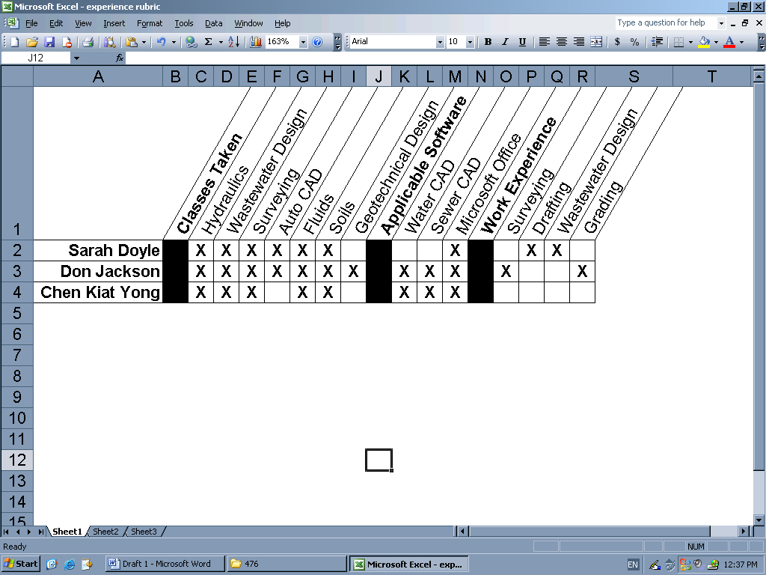
Project Understanding and Approach
Sipaulovi, Arizona currently has three wastewater lagoon sites in operation. Each lagoon services a different area of the village. The existing system is fully functional, but has limitations that will make it undesirable in the future. As the village grows, the lagoons may not be able to treat the increased volume of wastewater. The odor problems from the lagoons will become more of a problem for the residents of Sipaulovi, since newly developed areas will border the land where the lagoons are located. Indian Health Service (IHS) would like the village to combine the four separate wastewater treatment systems into one central sewer system and one treatment facility.
The client would like the design of the treatment facility to incorporate a constructed wetlands, which would allow for water reuse. The constructed wetland is intended to treat the wastewater to a degree that allows for the effluent to be used to irrigate non-edible crops, such as gourds, and livestock fodder.
A completed survey of the facility site is necessary before design calculations can be performed. Until all necessary data is gathered, design specifics can only be approximated. Approximated calculations incorporate distance values obtained from the topographic map presented in James Janecek’s report: “Village of Sipaulovi Wastewater Treatment Alternatives Research”.
The final facility design will be able to treat wastewater flow from Sipaulovi, the public school located at Sipaulovi, and flow from future development.
The design recommended by IHS is an Advanced Integrated Wastewater Pond System (AIWPS). An AIWPS system is a simplistic treatment process which provides aerobic and anaerobic treatment to wastewater. AIWPS are commonly followed by a constructed wetland, where the water is evaporated and further aerobically treated. AIWPS systems are loosely based on the design manual created by Dr. W.J. Oswald, and may be modified from the basic design in order to accommodate a variety of wastewater treatment applications (Mead, 2006). If properly designed, an AIWPS system can reduce or eliminate odor problems. The lagoon systems, which have been installed at Sipaulovi, only use evaporation and aerobic degradation to treat the wastewater.
The team will also incorporate, if possible, four additional features to the wetlands design. They are:
- Erosion prevention of the earthwork on site
- Installation of a manually-cleaned bar screen to aid in prevention of blockage from the incoming raw wastewater
- Flow meters
- Flow equalization/sedimentation basin early in the pipeline, before the treatment facility
The following list describes the services that DCS solutions will provide to the client:
  - Topographic survey of the approved project site
  - Hydraulic calculations
  - Collection system design and calculations
  - Route of pipeline from existing treatment facility to proposed CW
  - Primary treatment design and calculations
  - Wetland design and site plan
  - Cut and fill calculations
  - Construction cost proposal
Approval of the final CW design is given by IHS and the Environmental Protection Agency. Progress reports will be provided to the client, as the design is developed. The design that DCS Solutions proposes will meet the needs of the client, and will follow the design guidelines provided by IHS.

Scope of Services
Client Communication
The design team met with our client on October 6th, and November 3rd, 2006. Additional meetings will be set up with the client, as needed, prior to beginning the design, in order to better understand the needs of the client. The group leader will interact with the client periodically to inquire further details on their needs and to acquire information that was not available during the first in-person meeting.
The design team will need to know the actual project location that is approved for this project. Interaction with the Village board will be necessary to determine the actual location of the project. Our design team, along with Paul Gremillion who is one of our technical advisors, will approach the Village board in order expedite the approval of the land to be used in the project.
Communication with Sellwyn Sekaquaptewa will be necessary to understand the design elements that aide in the successful operation of a constructed wetlands.
Jason Nieto will be the primary operator of the Sipaulovi Village constructed wetlands, and will have a great deal of input into the design of the treatment facility.
In addition, the design team will consult with the client to discover any restraints regarding culturally sensitive aspects of the design.
Site Visit
The design team made a tour of the existing constructed wetland at Kykotsmovi Village on October 6th, 2006. Additional tours of this or other similar sites are expected in the future.
Trips to Indian Health Services on the Hopi Reservation may be necessary to obtain information relating to permit requirements for the constructed wetlands. Erika Schoen will be our main person in contact for more accurate information of permit requirement.
Design Documentation
The client will be provided with a copy of all engineering calculations and drawings associated with this project.
Survey
The survey team will locate the property boundary of the site where the constructed wetland will be built. The survey is expected to be completed by the end of January. The survey will be conducted by DCS Solutions, or by Land Information Service. Benchmark controls for the survey will be provided by Erika Schoen or Mark Cox at Indian Health Services.
Evaluation & Cost estimate
The final report of the project will include an estimate of construction cost. Construction cost is independent of engineering design cost. The report and calculations will show if a constructed wetlands is appropriate for this site. All calculations and cost will be approved by the client and Indian Health Services.
Project Tasks
Team member responsibilities
- Don Jackson (design team leader) is responsible for scheduling, contacting clients, grading, leading survey team, and evaluating the design.
- Sarah Doyle is the team AutoCAD drafter and editor for documentation/deliverables.
- Chen Kiat Yong is in charge of research and evaluation of the performance and efficiency of the design, and for checking permits and regulations relating to the design.
General tasks may include calculations, documentation, contacting technical experts, compiling data, and organization of deliverables.
Parameters consideration
Before calculations and design can be initiated, certain design parameters must be obtained. Population size will need to be determined.
Pipes and pumps are required for the delivery of sewage from wastewater collection systems to the wetlands site. Distance from the collection system to the wetlands, and elevation change over that distance will be determined by use of the topographic map provided by Janecek and Mead, unless other means are discovered.
Permitting restraints will be evaluated to determine if a constructed wetland can be implemented at the site. Research will be done to determine if the client’s requested design aspects, such as water reuse, can be implemented per applicable regulations.
List of equipment and tools
All of the following tools necessary to complete the design of the constructed wetland are provided by the design team:

Surveying equipment
- Total station
- GPS
- Data logger
Software
- Haestad Method Hydrology software is the main design tool for the hydraulic analysis. This software includes SewerCAD, WaterCAD and few essential modeling softwares which will prove useful for the design.
- AutoCAD will be used to draft the map of the site.
Documentation
- Microsoft Office: Excel, Word, and PowerPoint.

Schedule Requirements
Although the design work is not scheduled to begin until January first of 2007, some tasks, such as a survey of the site and research of the topic will have to be completed before February. Two site visits were made prior to the completion of this proposal, and it is expected that more site visits will be done before the January starting date. Below is a tentative schedule* for the completion of tasks, beginning in January:

January 1-8 | At-Home research
January 9-14 | At-Home research
January 15-21 | School Starts-Group Meeting/Planning
January 22-28 | Begin Design Calculations
January 29-February 5 | Calculations
February 6-11 | Finish Design Calculations
February 12-18 | Begin Drafting
February 19-25 | Drafting
February 26-March 4 | Drafting
March 5-11 | Finish Drafting
March 12-18 | Begin Presentation Preparation
March 19-25 | Editing and Approval (IHS & Client)
March 26-April 2 | Finalize Project
April 2-8
April 9-16 | Presentation of Project
*This schedule is subject to change as more information is available to the group

References
Coduto, Donald P. ‘Geotechnical Engineering – Principles and Practices’, Prentice Hall, Upper Saddle River, NJ, 1999.

Eddy and Metcalf. ‘Wastewater Engineering’, 4th Edition, McGraw-Hill, New York, NY, 2003.

Environmental Protection Agency http://cfpub.epa.gov/npdes/regs.cfm?program_id=0

Haested Press, ‘Computer Applications in Hydraulic Engineering’, 6th Edition.

Haested Press, HECRAS software.

Hammers, Mark & Mark Jr. ‘Water and Wastewater Technology’, 5th Edition, Pearson Prentice Hall, Upper Saddle River, NJ, 2004.

Hopi Water Resources Department, The Hopi Tribe, P.O. Box 123, Kykotsmovi, AZ 86039. (928)734-3712.

Janecek, James A., et. al. ‘Village of Sipaulovi Wastewater Treatment Alternatives Research’, Sustainable Water Resources Alliance, P.O. Box 15600, Flagstaff, AZ 86011. (928)523-2167. Dec. 4, 2005.

Kavanaugh, Barry F. ‘Surveying with Construction Applications’, Prentice-Hall Inc., Inglewood Cliff, NJ 07632. 1989.

Lawrence, John. Environmental Engineering Graduate Student, NAU – Department of Civil & Environmental Engineering. (928)606-7075.

Mays, Larry. ‘Water Resources Engineering’, 1st Edition, John Wiley & Sons, 1999.

Appendix A

Paul Gremillion, PhD, P.E.
NAU Professor
Civil & Environmental Department
*Main consultant w/respect to project parameters

Christine Laguna, P.E.
Civil Engineer
President of Civil Design & Engineering
*CAD consultant

John Mead
Wastewater Technical Specialist
Institute for Tribal Environmental Professionals
*Main consultant w/respect to systems developed for Tribal villages

Jason Nieto
Certified Operator
Sipaulovi lagoons
*Main consultant for existing wastewater treatment procedures at Sipaulovi Village
*Consultant w/respect to design recommendations

Erika Schoen, E.I.T.
Environmental Engineer
Indian Health Services – OEH&E, Hopi Health Care Center
*Main consultant for regulations applicable to tribal villages
*Final Design approval

Sellwyn Sekaquaptewa
Certified Operator
Kykotsmovi wetlands
*Consultant w/respect to pro’s and con’s of wetland system
*Consultant w/respect to design recommendations

